Peace Pod Events
2015
Anna Stam
World Peace Foundation
22-5-2015

NHTV Breda University of applied sciences
Academy for leisure

Bachelor thesis
Submitted to obtain an degree of

Bachelor business administration
In international leisure management

By
Lienke Anna Roeliena Stam

Technical information

Thesis company / organization
Name thesis organization | World Peace Foundation
Post address | 39 Habichtweg, 51429 Bergisch Gladbach
Country | Germany
Phone number | New York: +1 917 675 4780  Monaco: +33 677 49 97 47  London: +44 20 3239 6236  Germany: + 49 2204 4739 288
Email address | executive@tom-oliver.com
Website | http://www.tom-oliver.com/world-peace-foundation/

Company supervisor
Name of the company supervisor | Tom Oliver  (United States) | Mark Turrell  (Berlin) | Saurabh Matta  (Dubai)
Function | Visionary  supervisor | Researcher expert  supervisor | Project leader  Supervisor
Skype contacts | Tomoliver2 | Mark_turrell | Saurabhmatta28
Email Address | tom.oliver@me.com | mark_turrell2000@yahoo.com | matta.saurabh28@gmail.com

Student information
Student name | (Lienke) Anna Roeliena Stam
Address | Dubbeldamseweg Zuid 101
Country | Netherlands
Nationality | Dutch
Phone number | 0031 639 766 096
Email address | lienkestam@msn.com & 101265@edu.nhtv.nl
Education | International Leisure Management
Minor | Creative Industries

Information university
Contact information university | NHTV Breda University of Applied Sciences
Post address | Postbus 3917, 4800 DX Breda
Visitor address AFL | Archimedes straat 17, 4816 BA, Breda
Country | The Netherlands
Phone Number | 0031 765 332 203
Fax | 0031 765 552 247
Website | www.nhtv.nl

Information supervisor
Name | Margo Rooijackers
Phone number | 0031 765 332 899
Email address | Rooijackers.M@nhtv.nl

General information

Disclaimer

I, Lienke Anna Roeliena Stam, hereby declare that this thesis report and the work presented in it is a result of my own effort taken during the graduation period. The use of secondary research data has been acknowledged and clearly attributed. Additionally jointly found results have been marked equivalently.

Dordrecht, 22 – 5 – 2015

Lienke Anna Roeliena Stam

Preface

I am Lienke Stam a student of the NHTV Breda studying International Leisure Management a bachelor in business administration. In order to graduate students need to write a bachelor thesis in year 4 which in my case is this research report. I was searching for a topic that would be meaningful to not only me, the university and the organization but a greater cause.

I have looked at many charity organizations but the World Peace Foundation stood out because off the simple methods they offer for individuals to prevent and resolve conflicts through ongoing educational materials, booklets, and through workshops and seminars at the world peace festival. The organization comes up with practical methods that do not cost a lot of time or money and which any individual can do independently.

This report includes a research up on a new practical tool that the WPF likes to develop and which should motivate people to take action and contribute towards world peace. This report is not a solution to world peace but could contribute towards a better world and provides an opportunity for individuals around the world to answer the question “What can I do to support world peace?”

One of the main sources I have used was the book from Alexander Osterwalder & Yves Pigneur called “Business model generatie”. This book provided me with insides in how to build up business models and how to analyse the success of these models that has been used to develop a business model for this specific tool. Furthermore the digital influence report of Technorati media (2013) provided many insides up on the social media and played a crucial role within this research.

When reading this report one can gain inside into how online tools can contribute to a better world by bringing people together, communicate effectively and efficiently and by the amount of people it is able to reach. Furthermore information is provided up on how individuals can contribute individually or together towards a better world starting within their own community.

I have learned a lot when writing this report and working together with this particular project group. First of all it was great to work with people around the world although the cultural differences and the online communication was challenging. Furthermore I learned how to be more efficient and effective in meetings although I am still learning and last but not least I learned a lot about research and the limits and challenges that one faces during the research period.

In the end my goal was to satisfy my commissioners and to create a concrete concept of Peace Pod Events that could be taken over by a new group of people who can start with the implementation and start to think about the details of the concept. In the future I hope still to be involved but in a less time consuming way and by providing guidance were needed.

Additionally I like to thank the team I got to work with. First of all I like to thank Tom Oliver who was a great inspiration with a clear vision and who guided me through this process. I also like to thank Saurabh Matta who was of great help and always ready to provide me with feedback and discuss the developments. Furthermore he also is a great motivator who made sure that I kept on going. At last Mark Turrell also contributed to the process and provided me with more research based advice on how to approach this challenge.

Furthermore I like to thank all the survey respondents and experts who have contributed to this research and finally I also like to thank my supervisor Margo Rooijackers for putting me back in place when I wanted to take on too much and making me aware of the timeline and its limitations.

Table of content
Technical information 2
General information 3
Disclaimer 3
Preface 4
List of tables & Images 7
List of abbreviations 7
Executive summary 8
1. Research plan 10
1.1. Introduction 10
1.2. Background / justification 11
1.2.1. The commissioner 11
1.1.2. TEDX 12
1.1.3. Ice Bucked Challenge (IBC) 12
1.2. Problem analysis 13
1.2.1. Current peace situation worldwide. 13
1.2.2. Human Needs 13
1.2.3. Global trends & developments 14
1.2.4. Peace foundations. 15
1.2.5. Events 16
1.2.6. Virtual world 16
1.2.6.6. Business models 18
1.3. Problem definition 19
1.4. Research objective 19
1.5. Research questions 19
2. research approach 20
2.1. Theoretical framework 20
2.1.1. Co creation 20
2.1.2. Attitude, 21
2.1.3. Social media 21
2.1.4. Online platforms 21
2.1.5. Media hype 21
2.1.6. The canvas model 22
2.2. Methodology 28
2.3. Validity and reliability 30
3. Research findings 31
3.1. Research question 1 31
3.1.1. Desk research 31
3.1.2. Field research 32
3.1.3. Summary 34
3.1.4. Conclusions 35
3.2. Research question 2 36
3.2.1. Trends & Developments 36
3.2.2. Internet 36
3.2.3. Online tools 36
3.2.4. Social media usage 39
3.2.5. Summary 44
3.2.6. Conclusion 45
3.3. Research question 3 46
3.3.1. Trends & Developments 46
3.3.2. The online co creative platforms 46
3.3.5. Summary 77
3.3.6. Conclusions 79
3.4. Research question 4 80
3.4.1. Field research 80
3.4.2. Summary 82
3.4.3. Conclusion 83
3.5. Overall summary 84
3.6. Overall conclusions 87
4. Research integration 88
4.4. Recommendations for the framework of Peace Pod Events 88
5. Additional information 89
5.1. Bibliography 89
5.2. Appendix 94
5.2.1. Survey questions 94
5.2.2. Email survey 97
5.2.3. Survey results in SPSS 98
5.2.4. Email experts 147
5.2.5. Item list expert interviews 147
5.2.6. Results expert interviews 148

List of tables & Images

Table 1.0. (Internet usage) (Statistics I. w., 2014)…………………………………………………………………………………...19
Table 2.0 (canvas model) (Pigneur, 2010)………………………………………..23
Table 3.0 (online tools description) (several sources/ self made) ………………………………….……………….36-37
Table 4.0 (Usage of social media tools) (Technorati Media, 2013)…………………………………………………..38
Table 4.1 (activity of social media tool) (Technorati Media, 2013)……………………………………………………38
Table 4.2. (functionality of social media tool) (Technorati Media, 2013)………………………………………….39
Table 4.3. (reason to follow social media tool) (Technorati Media, 2013)………………………………………..40
Table 4. 4 (elements social media hype) (Technorati Media, 2013)………………………………………………….41
Table 4.5 (factors social media hype) (Technorati Media, 2013)………………………………………………………41
Table 5.0 (canvas model) (Pigneur, 2010) ……………………………………….46
Table 5.1. (channels) (Pigneur, 2010) ……………………………………………...49

Image 0 (Front Page) (Tumblr, 2015)………………………………………………………………………………………0
Image 1.0 (current peace situation) (Withnall, 2014)……..……………………………………………………………….15
Image 1.1. (Current peace situation) (Withnall, 2014)………………………………………………………………………15

List of abbreviations

WPF World Peace Foundation
SPF Sasakawa Peace Foundation
FB Facebook
IBC Ice Bucket Challenge
TEDx Non-Profit event organization

Executive summary

This is a research report commissioned by the World Peace Foundation who wanted to develop another tool that could be organized by the general public called Peace Pod Events. Peace Pods should be local events which would support local communities worldwide and which should stimulate communities around the world to spread awareness for world peace and to enable them to take action. The WPF wanted to have a mediator function by making this tool available through an online platform for the general public and provide guidance were needed. The aim of this research was to provide recommendations on what kind of elements should be included within the framework of Peace Pod Events. Based up on the aim and objective of this research four research question have been developed including:
1.What is the attitude of potential creators of peace Pod Events towards world peace and Peace Pod Events?
2.What are the most effective online marketing tools to spread awareness for Peace Pod Events?
3.What kind of elements do the best practices of online platforms include?
4What is the vision of potential stakeholders of Peace Pod Events towards the concept?
The research has been set up out of several chapters including the research approach which exist out of the theoretical framework, methodology, validity & reliability. The theoretical framework includes the ABC modelof attitude, the CANVAS business models and several definitions. The methods include both desk and field research including an online survey to gain insight into the attitude of potential creators of Peace Pod Events, desk research up on online marketing tools in order to spread awareness, an extensive analysis up on the best practices of online platforms in order to distinguish crucial elements of a succesful online platform and expert interivews with four experts located around the world with different specialization in order to gain several perspective of potential stakeholders / sponsors of Peace Pod Events and to improve the concept where needed. The most important outcomes of each research questions and the overall answer will be mentioned beneath.

The first research question shows that most people have a positive attitude towards the topic peace and the concept of Peace Pod Events but are unaware of many peace or charity related projects. Furthermore their participation will highly depend on the support that will be providing by the WPF. The ways people like to contribute differ from one to another and therefore several possibilities should be available.

The second research question reveals that online marketing tools have a wide reach since 42% of the people worldwide have access to the internet and are therefore appropriate to be used for this initiative. The online marketing tools which should be used to spread awareness highly depend on the objective / goal of the organization and therefore a social media strategy should be written out. Furthermore social media hypes can help to spread awareness and can be linked to the online platform. The social media hypes success depends on many factors which are mentioned in chapter 3.2.4.2.

The third research questions provides insides into the elements of the best practices of online platforms which includes an analysis of trends and developments, the goals of the organizations, guidelines, business models and use of social media. Building your online community plays a big role within the success of the tool and therefore a plan should be made on how to build up and sustain this online community. Furthermore people are willing to contribute to these platforms and it is possible to co create on these platforms as well, additionally guidelines for the online community need to be provided which should include about +/- 6 steps that explain how to join or start a Peace Pod. It is also crucial that the aim of the initiative is clearly communicated. Besides all online platforms make use of social media and often have more than two social media tools they make use of. One can also divide the online community into several sub groups so that there is a higher chance all wishes will be met. Furthermore the online platforms try to use entertainment as a motivation factor to get people to join the online community. In addition there are several ways to stand out as an online platform including cost limitations, risk limitations, network opportunities, accessibility, user friendliness and personalized services. Problems that often occur include communication because people that normally would not meet or talk suddenly do, and people do not tend to listen and build up on each other’s ideas therefore most platforms offer detailed guidelines or rules to provide a positive atmosphere. At last all online platforms are able to make money which is done by sponsoring, subscription fees and selling services / products.

The last research question includes the view of possible stakeholders or experienced experts who are able to provide advice up on the concept. The experts either specialize in the virtual world or within peace projects and are located in a variety of places including the Netherlands, Africa, America and India. The experts agreed that a communication plan should be in place between the online community and the online platform as well as the individuals of the online community. Also they agreed that activities should be efficient and effective (people have limmited time and money), there should be networking opportunities, people should be able to receive or provide materials and or money and people should be able to share knowledge and experiences. Furthermore the online platform should include personal stories, movies and photo’s in order to attract people. In addition they agreed that the online platform would be a great start but the mobile phones coul be a great support for the less fortunate countries. With regards to the guidelines they believed that they should be simple and fun and the innitiative should be targeted at youngsters. At last they agreed that spreading awareness is always a real challenge and should include pilots, possibly seminars, the online platform, social media and social media hypes. In addition a plan should be made on how to sustain the awareness and activity and how to follow this up possibly by searching for cooperations with other organization who wanted to send out a similar message.

At last one can conclude that the framework should include a specification of the target group,
clear guidelines, clear message, plan to build an online community, support on the online platform by an online community, activities that are efficient and effective (limiting time and spendings), Promotion strategy, business plan/ financial strategy , several content elements, online community building strategy, Sustainability strategy, several service elements and a communication strategy.

Research plan

Introduction

The WPF believes that people are now more motivated than ever to take responsibility and contribute to a better world and got inspired by the Ice Bucked Challenge and the TEDx events. The WPF believes that when combining these two phenomena’s and creating the connection with world peace a new tool could be created that support communities, organizations and individuals from around the world to spread awareness for world peace and to enable them to take action.

The World Peace Foundation came up with the idea of developing initiative they like to call Peace Pods Events. Peace Pod Events would be local events that support local communities and help them to spread peace. These events can involve any kind of content from volunteer project in Africa to stimulating a peace program in an university in Berlin. It should be designed to answer the question “What can I do to support world peace?” and is an initiative that would be for the people, off the people and by the people. The Peace Pod Events would be supported by a framework but should be further designed by self-driven people, furthermore one should not count on financial contribution from third parties and preferable be projects that could be carried out without spending any money or by obtaining money from local sponsors. The WPF wish to make use of the internet to be able to spread the awareness of the tool and reach people worldwide. They would like to create an active online community through an online platform where one can share their experiences, ideas and knowledge and where people can work on content developments and project execution together. Therefore the research report will provide advice on framework could look like for the initiative called Peace Pod Events.

This report is build up out of five sections being research plan, research approach, research findings, research integration and additional information.

The research plan exist out of 5 Chapters. First of all this includes the background and justification where information has been provided about the current situation, who the commissioner is, what the management or marketing problem and some information about topics crucial to the commissioner and why this research should be carried out. Next up is the problem analysis which includes an analysis of the problems mentioned in the background to clarify the main problem. The main problem gets translated into the problem definition which then are transformed into objectives. Based up on the objectives and main problem the research questions are established. The research questions function to provide a guideline towards the research that need to be done in order to solve the main problem for the commissioner.

The section research approach includes 3 chapters, theoretical framework, methodology and validity and reliability. The theoretical framework includes theories and models that can be used by the researcher the conduct the research including an explanation of how to apply these theories and or models. Furthermore the chapter methodology contains information about how the research will be approached including information about how the data will be collected and analyzed in order to answer the research questions. Research findings is a chapter which presents all the research findings/ results. Answers on the research question can be found here which will lead to the overall conclusions that will answer the main problem of the commissioner. Research integration exist out of recommendations and an example of implementation. This chapter is based up on the research findings and provide advice to solve the main problem for the commissioner. Finally the chapter called additional information can be found which includes the bibliography and appendixes. All sources and additional and more detailed information can be found which the report will sometimes refer to for further explanations.

Background / justification

Background information expands upon the key points stated in the introduction but is not intended to be the main focus of the paper. Sufficient background information helps the reader determine if the writer has the basic understanding of the research problem being investigated and promotes confidence in the overall quality of the analysis and findings. This information provides the reader with the essential context needed to understand the research problem and its significance.

The commissioner

World Peace Foundation
World Peace Foundation is a nonprofit, non-partisan international acting organization with the aim to systematically initiate and foster processes for worldwide peace building. The United Nations office and United Nations department of public information offer support to the WPF. The WPF makes use of long standing practical knowledge from peace building experts and try to inspire and empower people around the world to be more at peace with themselves others and the environment. They want to create a global community that is actively working towards peace and believe that one by one and together we can make a difference.

The World Peace Foundation offers simple methods for individuals to prevent and resolve conflicts through ongoing educational materials, booklets, and through workshops and seminars at the world peace festival. One of their objectives is to empower projects and people who have passion and purpose. (Foundation W. P., 2014)

“Peace Pods inspiration”
The Peace Pods idea is inspired by TEDX events and the Ice Bucked Challenge. While TEDX has an international and general focus Peace Pod Events are meant to be local and focused on very specific subjects relevant to their community. The WPF would like to make the Peace Pod Events a virtual experience like TED x events or like the Ice bucked challenge. The Peace Pod Events would function as an co-creative offline gatherings that will be supported with an online platform which together will supports an worldwide online community and enable the WPF to answer the question of the people “What can I do to support world peace?”. The IBC will function as an inspiration to spread awareness of this new tool. Overall the Peace Pod Events would have two main functions:
- Enable and making it easy for people to take action and contribute to world peace by solving problems in their area through local initiatives.
- Spread awareness of the local initiatives and ways people have contributed to stimulate others to stand up and do the same.
They asked me to develop this idea and find out what these Peace Pod Events would look like and how it could be spread worldwide.

The management problem:
To create a tool (“Peace Pod Events” )that stimulates communities, organizations and individuals from around the world to spread awareness for world peace and to enable them to take action.

TEDX

The organization
TED is a non-profit, non-partisan foundation devoted to spreading ideas, usually in the form of short, powerful talks. TED began in 1984 as a conference where Technology, Entertainment and Design converged, and today covers almost all topics — from science to business to global issues — in more than 100 languages. Meanwhile, independently run TEDx events help share ideas in communities around the world. TEDx is designed within the spirit of TEDx mission “ideas worth spreading”. The organization is a global community, welcoming people from every discipline and culture who seek a deeper understanding of the world. TED believes passionately in the power of ideas to change attitudes, lives and, ultimately, the world.

TED X events
TEDx events are designed to help communities, organizations and individuals to spark conversation and connection through local TED-like experiences. (TEDX, 2015)

Ice Bucked Challenge (IBC)
The IBC is the most famous media hypes in 2014. It was a challenge to chuck a bucked full of water and some ice cubes over your head, post it on your Facebook within 24 hours and challenge your friends to do the same. It was up to the individual to donate and also decide on the amount of the donation. Due the fact one was not forced to donate but was able to contribute to promotion by carrying out the challenge people were more likely motivated to support the cause. 150 countries have joined the IBC which was a huge success. One of the reasons was the fact that they had created a “cult” which is a mini subculture that is all about breaking rules and codes and thinking and moving in different ways than usual. These mini subculture are based up on epic meanings, things that are bigger than a human being, product, service or organization in this case it had to do with an illness called ALS. (Arjan van der Knaap, 2 – 10 – 2014)

Problem analysis

This chapter will provide a clear overview of the problems, goals and solutions of the management problem and function to determine the content of the research, the research design and prevent loss of time during the process.

Management problem:
To create a tool (“Peace Pod Events” )that stimulates communities, organizations and individuals from around the world to spread awareness for world peace and to enable them to take action.

Current peace situation worldwide.
According to a think – tank which produces one of the world’s leading measures of “global peacefulness” and covers 162 countries by the institute for economics and peace (IEP’s) latest study shows that just 11 countries were not involved in conflict of one kind or another. The world as a whole has been getting less peaceful every year since 2007- sharply bucking a trend that had seen a global move away from conflicts since the end of the second world war. The image 1.0 shows the countries that have no internal conflict in dark green. The image 1.1 shows the countries that are not involved in external conflicts which have let to more than 25 deaths in green. (Withnall, 2014)

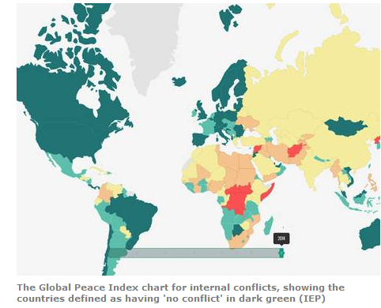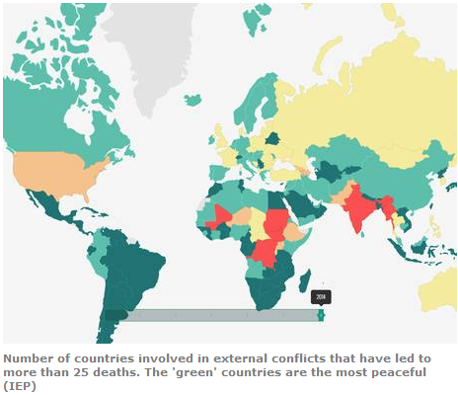
Image 1.0 (current peace situation) Image 1.1. (current peace situation)

Human Needs
According Maslow the needs of a human being in general can be divided into five characteristics. These five characteristics all have a certain importance and should be placed in the following order:
- Physiological needs = basic needs that are vital to survival (example: air, water)
- Security needs = Safety & security are important for survival but not as demanding as physiological needs. (example: steady employment, safe neighborhoods)
- Social needs = needs for belonging, love and affection.
- Esteem needs = needs for things that reflect on self-esteem personal worth, social recognition and accomplishment.
- Self – actualizing needs = people are self-aware, concerned with personal growth, less concerned with the opinions of others and interested fulfilling their potential. (Expert, 2014)

Global trends & developments
The following chapter includes six trends of 2014 that are relevant to this research. Each trend will include an explanation of why this would be relevant and what the trend includes.

- Responsible towards (the environment, community & guilt free status)

In 2014 a trend popped up, people wanted to take responsibility towards their environment and community. These people wanted to feel guilt free and already took action by buying products that are taking these responsibilities. (Trendwatching, 2014) Therefor one could conclude that the WPF was right, people are willing to take action and contribute towards a better world.

- Mychiatry
Secondly the rapid technology innovations creates a smart mobile world, quantified self-product like smart watches continuing to grow. (Trendwatching, 2014)This trends could play an important role within creating awareness and an effective way of communication. Almost all countries now benefit from the benefits of technology and if it would continue to grow the world can be reached through technology.

- Value creation
Create meaning within your brand(organization) is becoming more and more important. (Marketing Facts, 2014) (Maltnight, 2013).The World peace foundation will be able to use this trend to their advantage since they are a meaningful organization that wants to contribute towards the environment and communities and therefore create great value to individuals.

- Real sustainability honesty
Sustainability and honesty are considered to be more important. (Marketing Facts, 2014)This is another trend which suits the World Peace foundation perfectly since they want to contribute to a better word and are a nonprofit organization. They want to create a tool that creates a sustainable relationship between like-minded people and enable them to take action.

- Video/ visuals become leading
Visuals are becoming leading within advertising. (Marketing Facts, 2014). The World Peace Foundation can take this trend into consideration while developing their events and thinking about creating awareness around this tool. It could play an important role within the online platform.

- Storytelling becomes trendy
The importance of storytelling is becoming even more important. (Marketing Facts, 2014)Marketing facts (2014). Storytelling will provide added value to Peace Pods and is therefore an interesting trend to take in to consideration when developing such a project.

Peace foundations.
There are many peace foundations out there which is why it is crucial to look into what has already been done and what the current initiatives are of these similar organizations. Beneath seven peace organization have been briefly analysed to gain an inside in to how current organizations are approaching the same problem and what it is the WPF could or is doing differently.
The following organizations have been included and all these peace organization are non-profit organization, voluntary based and provide a service for people around the world:
- Foundation for peace. (Foundation For Peace, 2014)
- Global peace foundation. (organization, 2014)
- The peace foundation te tuapapa rongomau o aotearoa.
(Foundation T. p., 2014)
International peace foundation. (Foundation I. p., 2014)
- Sydney peace foundation. (Foundation S. P., 2014)
- P.E.A.C.E. (P.E.A.C.E, 2014)
- The Tim Parry Jonathan ball. (Ball, 2014)
- Sasakawa Peace Foundation (The Sasakawa Peace Foundation, 2014)
Based up on the websites of each organization one could conclude that all of the above mentioned organization except for the SPF, think of projects themselves and allow people to be part of it by volunteering or donating money, while the SPF and the WPF want to let the initiatives come from the people around the world (bottom up) and stimulate co creation.
Almost all organization mention provide the services below:
- Donation opportunities
- Educational programs
- Volunteer projects which one can join
- Economical supporting projects
- Developing peace building models
- Offer support for the vulnerable
- Networking opportunities within events.
- Create cultural awareness
- Promote peace by finding representatives, partners and projects
The SPF is one organization which has more in common with the WPF. The SPF mission: Through activities that foster international interaction and cooperation the Sasakawa Peace Foundation seeks to contribute to the welfare of humanity the development of sound international community and thus world peace. (The Sasakawa Peace Foundation, 2014) The SPF offers grants for projects and has a focus on the implementation of problem resolving methods in society. They create partnerships and promote just like the organizations above but also provide an opportunity from people around the world to take initiative.

The idea of creating Peace Pod Events is similar to what the SPF is offering only one could question their strategy for promotion and support to make it simple for people to contribute. The SPF does not make use of social media and does not offer clear guidelines on how to set up an initiative, it is focused on experts who already know what they are doing.

Furthermore the World Peace Foundation separates itself by creating actual tools that can be used by anyone everywhere. The tools can be used within daily life and help you solve an argument with your partner but also will be able to contribute to solving a war. (Foundation W. P., 2014).The WPF create strategies and action plans to make sure that all people are able to get involved and contribute towards world peace and this would be what makes the WPF different from the SPF and all other organizations.

Events
What is meant by “events”. An event can be described something that happens or is regarded as happening; an occurrence, especially one of some importance or could be defined as something that occurs in a certain place during a particular interval of time. Events can according to event education be classified on the basis of their size, type and context. (Sharma, 2009) Peace Pod Events will have different sizes, types and context each time which will make it challenging to create a guideline that will not limit an organizers creativity.

Virtual world

Communities
The term community is used extensively in almost all areas of our lives like community service, community care and so on yet everyone seems to have a fairly common understanding of what is meant by community. There are many kind of communities in this research the following communities are used. (OHCC-CCSO, 2014)

The reason why social media has such an big impact is due the fact that virtual communities are established. Virtual communities are groups of people that primarily interact through communication media rather than face to face. If the mechanism is a computer network, it is called an online community. Online communities are "social combinations that emerge from the internet when people carry on those public discussions long enough, with sufficient human feeling, to form webs of personal relationships". Additionally there are communities of interest are sometimes referred to as "communities within communities". Members of these communities choose to associate with each on the basis of a common interest or shared concerns. Sometimes communities are formed by self-identified members of a reference group based on characteristics outside of their control, e.g. a disability, ethnic group, or low income, which give them a sense of common identity and shared concerns. In this case a virtual community can function to
- Spreads awareness.
- Support individuals, communities and organizations to take initiative.
- Enable individuals to have a bigger impact that one could have on its own.
(OHCC-CCSO, 2014).

Internet
As mentioned earlier an online platform could play a crucial role when creating awareness. Creating awareness is not always easy especially when one is trying to reach people around the whole world. Both TEDx and the IBC are making use of the internet and the IBC proves that that the internet can function as a great tool to spread awareness worldwide but how many people actually have access to the internet.
Table 1.0 (internet usage)
World internet usage and population statistics June 30, 2014 – Mid Year Update
World regions | Population  (2014 Est.) | Internet users  Dec 31,2000 | Internet users latest data | Penetration (% Population) | Growth  2000 - 2014 | Users % of Table
Africa | 1,125,721,038 | 4,514,400 | 297,885,898 | 26,5% | 6,498,6% | 9,8%
Asia | 3,996,408,007 | 114,304,000 | 1,386,188,112 | 34,7% | 1,112,7% | 45,7%
Europe | 825,824,883 | 105,096,093 | 582,441,059 | 70,5% | 454,2% | 19,2%
Middle East | 231,588,580 | 3,284,800 | 111,809,510 | 48,3% | 3,303,8% | 3,7%
North America | 353,860,227 | 108,096,800 | 310,322,257 | 87,7% | 187,1% | 10,2%
Latin America/ Carribean | 612,279,181 | 18,068,919 | 320,312,562 | 52,3% | 1,672,7% | 10,5%
Oceania / Australia | 36,724,649 | 7,620,480 | 26,789,942 | 72,9% | 251,6% | 0.9%
World Total | 7,182,406,565 | 3690,985,492 | 3,035,749,340 | 42,3% | 741% | 100%
(Statistics I. w., 2014) As shown above 42% of the world population has access to the internet which are 3690,985,492 people. This means that almost half the population worldwide can be reached through the internet and although not everyone has access, all continents have some internet users who would be able to spread the idea further through different communication tools within their area. One can conclude that internet is a great tool to reach out to a big part of the world.

Social media
The WPF as mentioned before likes to create an online platform and gather an online community around it. TEDx and IBC as mentioned before in chapter 1.2 background & justification made use of social media and therefor this also will play an important part within this research.

Social Media is the future of communication, a countless array of internet based tools and platforms that increase and enhance the sharing of information. This new form of media makes the transfer of text, photos, audio, video, and information in general increasingly fluid among internet users. Social Media has relevance not only for regular internet users, but also for businesses. Platforms like twitter, Facebook, and LinkedIn have created online communities where people can share as much or as little personal information as they desire with other members. The result is an enormous amount of information that can be easily shared, searched, promoted, disputed, and created. Social Bookmarking tools and news sites such as Digg, Delicious, reddit, and countless others make finding specific information, images, or websites increasingly simple by assigning or “tagging” individual sites with searchable key words. Applications that have developed within and around these platforms, websites, and tools are endless in number and functionality, but all make online sharing and searching easier in some fashion, regardless of their niche. As nearly every type of business has an association in the non-digital world, the internet also offers an endless number of niche social communities where members can gather around a common topic. Topics both general and specific now have living homes on the internet; anything from colon and digestive health to security and compliance can and do have active social media communities. Another advantage of social media is that it does not have to involve huge investments. Currently social media marketing is embraced and on the same level as traditional media. Social media is no longer a hype but here to stay. (Roald van der Aart, 2014)

Media hype
When looking at social media and spreading information it is almost impossible to not look into media hypes. A Media hype creates an unusual amount of attention for a specific topic within the media and is news that spreads itself without adding on new facts. (Taal, 2014) It would be a great way to look into media hypes to stimulate spreading awareness of the future Peace Pod Events. (Knaap, 2014)

Definition of a media hype: A Media hype creates an unusual amount of attention for a specific topic within the media and is news that spreads itself without adding on new facts. (Taal, 2014)

Online marketing platforms
Online marketing platform (OMP) is an integrated web-based platform that combines the benefits of a business directory, local search engine, search engine optimisation(SEO) tool, customer relationship management (CRM) package and content management system (CMS).

A platform is a “stage” that gives you and your message leverage and visibility.
It’s how you make your work matter, how you change lives. (Goins, 2015)

Business models
When creating an online community there needs to be some kind of online platform. An possibility would be to create a website like TEDx and support this website by social media. The website of TEDx is the online platform where the online community is build up on. To be able to create a platform a business model will be needed simply to make sure that this online platform can be sustained.

Definition of Business model:
The plan implemented by a company/ organization to generate revenue and make a profit from operations. The model includes the components and functions of the business, as well as the revenues it generates and the expenses it incurs. (Ovans, 2015)

A website's business model might not be as clear as a business model for a restaurant, as there are many ways in which these types of companies can generate revenue therefore it will be interesting to look more into the business models behind websites to get inspired and think of possibilities for the online platform for Peace Pod Events.

Problem definition
The problem statement is the central question in your research which is a logical consequence of the problem analysis.

What kind of element should be included in the framework of Peace Pod Events in order to stimulate communities organizations and individuals from around the world to spread awareness for world peace and to enable them to take action.

Research objective
To gain insight into the attitudes of people towards world peace and Peace Pod Events, online marketing tools, the best practices of co-creative online platforms and views of experts with an expertise in peace and or the virtual world in order to provide the World Peace Foundation with recommendations on which elements the online platform and Peace Pod Event guidelines should include.

Research questions
- What is the current attitudes of potential Peace Pod creators towards world peace and Peace Pod Events?
a. Cognitive (knowledge)
b. Affective (emotions/ feelings)
c. Behavior (intention / expectations)

- What are the most effective online tools to spread awareness for the Peace Pod Events?
- Social media
- Online platforms
- Social media hypes

- What kind of elements do the best practices of online co creative platforms include?

- What are the thoughts of potential stakeholders towards the concept Peace Pod Events?

research approach

Theoretical framework

The theoretical framework functions to gain insight into the central concepts of your research. Based up on the research questions the following theories and models should be taken into account.

Co creation
Co creation is a business strategy focusing on customer experience and interactive relationships. Co-creation allows and encourages a more active involvement from the customer to create a value rich experience. Co creation can be used within the concept of Peace Pod Events since people would be able to work together and create value together within their area. There are four types of co-creation, club of experts, crowd of people, coalition of parties and community of kindred spirits. In this particular case only the community of kindred spirits will be used. The community of kindred spirits is when people are developing something for the greater good, a group of people with similar interests and goals can come together and create. (Experiential, 2009) Furthermore the five guiding principles in co-creation are:
- Inspire participation: Trigger people to join your challenge: open up and show what’s in it for them.
- Select the very best: You need the best ideas and the best people to deal with today’s complex issues.
- Connect creative minds: You have to enable bright people to build on each other’s ideas, both on- and off-line.
- Share results: Giving back to people – and finding the right way to do it – is crucial.
- Continue development: Co-creation is a longer-term engagement, in- and outside your company. Only then it will deliver results. (Experiential, 2009)
These five principles can function as a guideline for the final guidelines that should be produced. As mentioned before the WPF wants to create a tool that will become for the people, by the people and of the people. In this case the co creation will not happen inside the company or between the WPF and the people but outside the company between the people who are willing to take action and create awareness for world peace. Co creation can play an important role with regards to creating successful Peace Pods Events since people can work together and improve their local area with their local community.

Attitude,
To be able to organize Peace Pod Events which is meant to be designed and or orgnaized by people who want to contribute towards peace it will be important to know what the current attitudes are of people towards peace and Peace Pod Events. Attitudes are something that has been learned, it is consistent, can predict behaviour and object related. This would mean that the WPF would be able to gain inside into the willingness of people to contribute / support and or organize Peace Pod Events. If people have a negative attitude towards peace or the concept the reseach might have to be adapted due the fact that this innititiave should be carried by the people

An attitude can have three functions:
- Instrumental function: attitude delivers an reward (example acceptance of a group)
- Ego defensive function: an attitude can protect the image one might have of their selves, an example could be in a situation of frustration one can search for an external factor that will be the cause.
- Value expressive function: people can express their identity with an attitude.
These functions are important to take into account to motivate them to create a positive attitude towards the Peace Pod Events. A model that can help to measure the attitudes of people is the ABC model.

The ABC model can be used when collecting knowledge about the attitudes of individuals towards the Peace Pod Events. The ABC model is based up on the following components
- Cognitive components: the knowledge of the customers of the attitude of the object. (example does the consumer know about the statements of people about the characteristics of the object)
- Affective components: the feelings / emotions of the consumer towards the object.
- behaviour components: the behaviour intention and expectations of the consumer towards the object. (Hoogers, 2011)

This would mean that the models would reveal the current knowledge people have of peace and peace projects, the feelings an emotions they have toward peace and the concept and their intentions and expectations for the future. This model is therefore chosen to confirm the willingness towards taking responsibility with a particular focus on peace and Peace Pod Events in order to make sure that there are individuals who want to take action and make use of this tool. To gain insight into the attitude of people towards these concept surveys could be carried out and the model could funcation as a guidelines for the survey questions.

Social media
The definition of social media within this report will be the following: “Websites and applications that enable users to create and share content or to participate in social networking” (Oxford Dictionaries, 2015)

Online platforms
The definition of the online platform that will be used within this report is the following:
“A system that can be programmed and therefore customized by outside developers -- users -- and in that way, adapted to countless needs and niches that the platform's original developers could not have possibly contemplated, much less had time to accommodate” (Andreessen, 2007)

Media hype
As mentioned on page 18 “Media hypes”the definition that will be used within this report will be the following:
A Media hype creates an unusual amount of attention for a specific topic within the media and is news that spreads itself without adding on new facts. (Taal, 2014)

The canvas model
To be able to carry out an analysis of best practices there will be set elements that will be compared. For this the CANVAS business model can be used since it shines light up on all elements of the “business/ organization”.
The canvas model is a business model that exist out of 9 building blocks: customer segments, value proposition, channels, customer relations, income streams, key resources, key partners, core activities and cost structures. According to the book “business model generatie” this model includes all elements that a business model would need, offers an clear overview of a business in general and is easy to redesign. Therefor this model will be useful to compare all elements and can also function as a basis for the framework of the online platform of Peace Pod Events.
In table 2.0 all elements are shown including the questions one should be able to answer for each element to be able to rebuild / redesign this business model.
Table 2.0 (canvas model)
Key partners  Who are our key partners?  Who are our key suppliers?  Which resources do we get from our partners?  Which key activities do our partners preform? | Core activities  Which activities do we need to preform to develop value?  Distribution channels?  Relation management?  Profit? | Value proposition  Which added value do we deliver to the customers?  Which problems do we help them solve?  What do we offer for each customer segment?  Which need of our customers do we satisfy? |  | Customer relations  Which relationships do we need to take on with our customers ?  Which problems do we help them solve?  Where are we at in the business model?  What are the costs? | Customer segments  For who do we add value?  Who are our most valued customers?
Channels
Which channels do we use?
What do we do now?
How do our channels integrate?
What are the best channels?
What are the cheapest channels?
Integration customers?
Key resources
Which resources do we need for our proposition?
Distribution channels ?
Relation management?
Profit?
Cost structures  Which costs are the biggest in our business?  Which resources are most expensive?  Which activities are most expensive? |  |  | Income streams  Where do we want to let our customers pay for?  What do they want to pay now?  How do they pay  How do they want to pay  How much does each customer contribute to the entire income?
(Pigneur, 2010)

Key partners
This building block describes the network of suppliers and partners that enable the business model to work. Companies can have many reasons to work together examples are to divide risk and responsibility, optimize services and financial advantages.
There are four partnerships that can be distinguished:
- Strategic alliances between non competitors
- “coöptatie” a strategic partnership between competitors
- Join ventures (to develop new business models)
- Buyer – suppliers relationships to improve the trust worthiness of suppliers.
One can also distinguish three motivations of why people work together
- Optimizing and size benefits (this mostly is done to limit costs and often includes outsourcing activities or sharing the infrastructure)
- Limit risk and insecurities (sometimes competitors work together within a certain element but compete within another element they offer)
- To optimize their own strengths (this also includes outsourcing not many companies have all resources within their company and trust up on other companies so that they can focus on a specific part to stand out. (Pigneur, 2010)
Questions:
- Who are our key partners?
- Who are our key suppliers?
- Which resources do we get from our partners?
- Which key activities do our partners preform?

Core activities
This building block described the most important activities that a company needs to carry out in order to let their business model function. Core activities can be categorized as followed:
- Production
These activities have to do with designing, producing and delivering products of services in either massive amounts of great quality. The production activities would include the dominating activities in order to make the business model work.
- Problem solving
The core activities of this type include coming up with new solutions for individual client problems. These activities often require knowledge management and constant training. Examples are hospitals, companies that provide advice and other service organizations.
- Platform / network
The core activities of this type include platform management, service management and platform promotion. This requires maintaining and developing your platform / website constantly in order to keep up.
Questions:
- Which activities do we need to preform to develop value?
- Distribution channels?
- Relation management?

Value proposition
This building bock will provide an inside into where the value is created or a specific client segment.
The value proposition is the reason why customers want that particular company instead of the competitor.
Value propositions can be qualitative(client experience) and quantitative (price, speed of service etc)
The following element can contribute to the client value
- New (thinking of needs that customers did not even realized they had, this often is connected to technology)
- Performance (improving a product or service)
- Customization (personalize services or products on individual needs)
- Taking over ( to take over a particular task that nobody wants to do)
- Design ( is hard to measure but can make a difference in value)
- Brand / status
- Price
- Cost limitation ( help customers safe money)
- Risk limitation (minimizing the risk for customers)
- Accessibility ( making services and products available for people that could not get to them before)
- User-friendliness (making is easy and simple to use the product/ service)
Question:
- Which added value do we deliver to the customers?
- Which problems do we help them solve?
- What do we offer for each customer segment?
- Which need of our customers do we satisfy?

Customer relations
Customer relationships describes the kind of relation the company has with a specific client segment.
These relationships can vary from personal to atomized.
The following motivations can be used to guide client relationships
- Client acquisition (trying to let someone buy or do something)
- Client retention (ability to remain loyalty)
- Stimulating purchase (Upselling)
The following categories can be distinguished
- Personal support (human interaction during the selling process or after. This activity can be done on location but also by email, call or other ways of communication)
- Assigned personnel support (most intimate personal relationship mostly used for longer term processes)
- Self-service (no direct relationship with the client)
- Automated services (this also can be considered to be self-service only online)
- Communities (companies make use of communities who share knowledge and solve each other’s problems and is also often used to help companies to understand their customers)
- Co creation (companies also involve customers these days either to design, provide feedback or in other ways)
Question:
- Which relationships do we need to take on with our customers ?

Customer segments
The building block customer segments defines the different groups or organizations that a company tries to reach or serve. Companies need to make a conscious decision on which segments they want to reach. It is important to be aware of your segment since:
- Each segment might require an unique/ different offer and are the justification also might be different
- The distribution channels might not all be the same but differ for each segment
- Each segment might require a different relationship
- Each segment might have a different influence on the profitability of the company
- Each segment might have a preference on what kind of aspect of your offer they like to pay for.
Furthermore there are several client segments
- Mass market (companies can choose to not distinguish any client segments)
- Niche market (companies who focus on specific and specialized client segments)
- Segmented market (companies that distinguish different market segments and other needs and problems, they are comparable but have slight differences and require a different approach)
- Divers market (companies who offer two segments a service or product which are not similar at all)
- Multi sided platforms (companies that offer two or more independent client segments)
Questions:
- For who do we add value?
- Who are our most valued customers?

Channels
This building block describes how a company communicates with its client segments and how they reach them in order to provide value. Communication, distribution and sales are the platform of a company with its clients. Channels have several functions:
- Awareness (grow awareness by clients about products or services of a company)
- Evaluation (Helping clients to judge the value proposition of a company)
- Purchase (To make it possible for clients to buy specific products and services)
- Delivery (To deliver the value proposition to customers)
- After sales (Offering client support after a purchase)
There are five different phases.
Table 4.1. (channels)
Channel type |  |  | Channel phase
Personal | Direct | Sales | Awareness  How do we create awareness for our products/ services | Evaluation  How do we help customers to judge our value proposition | Purchase  How do we make it possible for clients or buy a specific service or product | Delivery  How do we deliver value proposition to our clients | After sales  How do we offer client support after their purchase
 |  | Web sales
 | Indirect | Personal stores
Partner |  | Partner stores
 |  | Whole sale
Questions:
- Which channels do we use?
- How do our channels integrate?
- What are the best channels?
- What are the cheapest channels?
- Integration customers?

Key resources
The Building block key resources describes the important assets that are needed to make sure that the business model will function. Key resources can be physical, financial, intellectual or human resources they can belong to the company but also be leased or given by partners.
Key resources can be categorized:
- Physical (examples are buildings, transportation and machinery)
- Intellectual (examples are knowledge, copyrights, partnerships and client base)
- Human resources (people are needed within knowledge intensive companies or creative sectors)
- Financial ( financial resources of guarantees like cash and credit limits)
Questions:
- Which resources do we need for our proposition?

Cost structures
All costs that are made to make the business model work.
Low cost structures are important for some business models but less important for others although of course everyone tries to keep their costs as low as possible. Therefore it can be useful to make a distinguish cost structures and value structured business models. A lot of businesses are somewhat in the middle.
- Costs structures
These businesses focus on minimizing costs (Easy Jet and Ryanair are typical examples)
- Value structures
These businesses focus on the value creation and less on the costs (example luxurious hotels)
Costs structures ken include the following characteristics:
- Fixed costs
Costs that do not change no matter what the volume will be (examples wages for employees and rent)
- Variable costs
Costs that differ depending on the volume that is produced.
- Size advantages
Cost advantages one can experience when the output increases. Example: big companies often get better deals because they buy a lot while smaller companies will have to pay more because they are making use of less products.
- Scope advantages
Cost advantages one can experience thanks to bigger scopes of activities. A bigger company will be able to make use of the same marketing activities to support more than one product.
Questions:
- Which costs are the biggest in our business?
- Which resources are most expensive?
- Which activities are most expensive?

Income streams
Income streams represent the cash that a company generates for each client segment.
A business model can have two different kinds of income streams:
- Transaction incomes (onetime payment)
- Frequent incomes ( frequent payments)
There are several ways to generate income streams:
- Selling goods (selling ownership rights of a physical product, examples selling books)
- Selling services (selling a service this can include a hotel which makes them pay for the amount of night a customer stays or a delivery service for each delivery)
- Contracts ( constant access to a service an example can be contracts for gyms or on mobile phones)
- Leasing / Renting ( providing the temporary rights of a particular product to a particular person for set amount of time)
- License fee (to allow clients or customers to make use of intellectual property by letting them pay a certain fee, this way they will also keep their copyright)
- Brokerage fees (income streams that come from mediator services like real estate agents and credit card providers, for each thing they sell they get commission)
- Advertisement (advertising for someone)
Questions:
- Where do we want to let our customers pay for?
- What do they pay for now?
- How do they pay?
- How do they want to pay?

Methodology

This chapter will contain information on how the research will be carried out and why the research is carried out a certain way.

This research will contain both field research and desk research. Field research is research that is carried out in the field like surveys, expert interviews or discussion groups. Desk research includes finding information online or offline which already exist like former research reports, books about certain subjects and websites that contain relevant information.

During this project also both qualitative and quantitative field research will be used. Qualitative research includes research methods that aims to collect qualitative information like discussions groups or experts interviews. It is not representative for a big population but can provide deeper insides into the human mind. Quantitative research is methods are used to represent a big population and to gain an inside into general views and opinions.

This project will start off with both desk and field research. The field research will exist out of an survey. This survey will be quantitative field research that is used to gain an inside into the general attitude of possible Peace Pod creators around the world towards peace and the concept Peace Pod Events. This will be used to get an idea what the major obstacles are and what the current knowledge, feelings and emotions and intentions/ expectations are of the individuals towards peace and the concept of Peace Pod Events. Furthermore it will provide insides into the target group. Currently the WPF has no further charactertistics except for people who are willing to contribute towards peace. The survey will be build up based up on the ABC model of attitudes as mentioned earlier in the theoretical framework.
Due the time limit of twenty weeks the aim will be to reach out to three hundred people.

The survey will first of all include demographic questions to provide into the target group and possibly create relations between certain elements. Secondly the importance of peace will need to be measured by making use of the emotions and feelings towards peace in general and if there is a need for this tool. Additionally the survey should include questions that gain information up on the current knowledge of peace in general and the current action that people take to support peace. Furthermore more detailed information about will need to be gathered to gain inside into the attitude towards the concept, manners they like to contribute in and the intentions and expectations towards the concept.

The survey will be an online survey because the WPF wants to reach people worldwide and to be unable people around the world to fill in this survey. The survey will be spread by means of social media, each project member will post the survey on their personal page of Facebook and LinkedIn and if needed send out personal messages. The reason for this is that all project members are located within different places including (Dordrecht) the Netherlands,(Berlin) Germany, (Dubai) India and (New York) America. All project members have an international network due work, school or other experiences and because it will be shared on social media it will enable friends to share this again and again to gain a variety of responses with different cultural backgrounds. Furthermore all project members are unique since the educational backgrounds, the cultural backgrounds and the job experiences are very divers. Because the concept needs to be carried by the people and is meant to be off the people, from the people it is important that in general they have a positive attitude towards the concept of Peace Pod Events.

The online survey tool that will be used is called survey planet this tool has been picked after reviewing several other tools this tool seemed most suitable since it offered unlimited survey questions, unlimited responses, no data mining or information selling, anonymous data & responses, twenty languages available and the data would be safed for about two years. At last there has been chosen to keep the respondents anonymous to prevent them from giving social acceptable awnsers.

The desk research will be carried out within the virtual world since the online platform will be the basis of the tool called Peace Pod Events. Although the Peace Pod Events will be offline events the creation and possibly organization can be done on the online platform. Additionally the promotion and creating awarenss around the project will also take place online. Therefore this research will have the main focus on the virtual world rather than event management. The desk research will provide insight into the opportunities and possibilities the internet offers.The desk research will include information up on online platforms, social media and media hypes .

Furthermore an extensive analysis will be carried out up on online co creative platforms. This has been done to gain inside into the online platform that would be created around the concept to make the concept available to the general public and to spread awareness and gather an online community. This analysis will provide insides into the pros and cons of such platforms and provide more insides into the guidelines, business models and social media usage of such platforms.

At last the insides of experts will be used to finalize and improve the concept of initiative called Peace Pod Events. These insides will be gained by carrying out expert interviews. The experts will be considered to be people who have and or had experience with organizing and or being involved with projects around social causes and or technology in order to cover both elements. Technology to create a succesfull online platform and peace to create a peace initiative that will be usefull to the people. Furthermore the experts should vary with regards to expertise on the ground or theoretical experiences, and cultural background to cover several perspectives. The aim is to carry out at least 3 till 4 expert interviews which will be held through skype calls. These skype calls will if possible/ allowed be recorded and take about 30 till 45 minutes otherwise notes will be taken. Each project member will responsible to bring in an expert and due the fact that each project member has a different background the chances are high that this will be accomplished by all bringing in one individual. These expert would provide us with their opinions and ideas on the initiative and what they considered to be important.
Further desk research will be done to support findings that might arise from research that has been carried out.

The findings of the field and desk research will be used to provide advice up on the elements that need to be included when creating the framework of Peace Pod Events within the form of an online platform.

The end product that will be produced will be a draft of an online platform including the content of Peace Pod Events which could be used for the implementation phase.

Validity and reliability

The world keeps changing and so do the attitudes of individuals, therefore the research findings and recommendations within this report will not be reliable for a long term period and updates need to be taken into consideration when using these results or recommendations any time later then 2016.

The research has been carried out for the world peace organization WPF but can be applied by many other peace organizations. Peace organizations all over the world could possibly work together and make use of the tool that could be established and improve and adapt the tool within their area.
Other organizations who are looking into establishing online communities or online marketing are possibly able to make use of some of the information out of this research report but have to take into account that this research has been carried out with the focus up on a nonprofit peace organization.

The field research of this report included several limitations. First of all the research needed to be carried out wihtin twenty weeks. This leaded towards a limitation with regards to the amount of respondents that could be collected within this time limit. Furthermore although the aim of 300 people was mett which already was not a great amount to represent the population worldwide the variety within the respondents also became limited. Most respondents were people from the network of one project member which led to a lot of students and people within the EU, which possibly also influenced the age group. Therefore these results should not be used as facts but can still function as a guideline to gain insides into the attitudes towards peace and the concept.

Furthermore the expert interviews that have been held are done with individuals which are located around the world. This included for instance individuals who represented Africa, India and United States but also from people who carried out work related to social causes or technology and with a variety of on the ground workers and technical minds. This variety has been used to make sure that most cultural perspectives are considered and practical and intellectual perspectives have been analyzed. Also due the variety both the Peace Pod Event guidelines and the online platform have been discussed on a level of expertise.

It might be that the results of the research are not always clearly formulated and therefore this could lead to misunderstandings. By having several people, being fellow students and the commissioner who have read this document objectively, the chances of misunderstanding have been brought back to a minimum amount.

In order to prevent un valid answers most findings are based up on at least two sources.

Research findings

Research question 1
What is the attitudes of potential Peace Pod creators towards world peace and Peace Pod Events?
a. Cognitive (knowledge)
b. Affective (emotions/ feelings)
c. Behavior (intention / expectations)

This chapter includes information up on the attitude of potential Peace Pod creators towards Peace pod Events. To measure the attitude desk and field research has been carried out as mentioned in the methodology. The desk research include trends & developments, the human needs by Maslow and the current situation which is related to charity and or peace. Additionally field research has been carried out to link back to the desk research findings which exist out of an online survey.

Desk research

Trends and developments
As mentioned in the problem analysis the trend responsibility which means that people want to be responsible towards the environment and community to gain a guilt free status, (Trendwatching, 2014) can be linked towards a positive attitude for peace or charity. The trend could suggest that people would have a positive attitude towards peace and the concept and are willing to take action to establish a better world by taking responsibility and helping their community.

Secondly the trend called “real sustainability and honesty” (Marketing Facts, 2014) has been taken from the problem analysis. This is another trend which suits the World Peace foundation perfectly since they want to contribute to a better world and are a nonprofit organization. They want to create a tool that creates a sustainable relationship between like-minded people and enable them to take action. This could suggest that by creating a sustainable tool the attitude of individuals could possibly be positive towards the concept Peace Pod Events.

Human Needs by Maslow
In the problem analysis the pyramid of Maslow (Expert, 2014) is mentioned which also relates back to this research question. These needs can be used as a guideline to motivate the individuals to support the concept of Peace Pod Events and suggest that according to the needs they possibly would have an positive attitude towards the concept.

Current peace situation worldwide
Next to the trends and developments and the humans needs of Maslow there has been looked in to the current situation worldwide with regards to peace in the problem analysis. Due the fact that of the 162 countries only 11 countries are not involved with conflicts one could suggest that there is a need for a more peacefull world and this could be considered to be a problem which is recognized in many parts of the world, therefore it might also lead towards a more positive attitude towards peace and the concept. (Withnall, 2014)

Volunteering
At last there is mentioned that there has been a drop within the number of volunteers comparing 2013 and 2014 which would suggest that although people might want to take responsibility this does not neccecarely lead to a higher number of volunteers or people who actual take action. (Statistics B. O., 2015)

Field research
The online survey has been posted on all the personal Facebook and LinkedIn pages of the project members, which include 600 personal messages that have been send out on the social media pages and about thirty have been send out by email to volunteers from the WPF. The survey questions and the explanation for each question can be found in the appendix on page 93. Additionally the emails that have been send out to the data base of volunteers of the WPF can be found in the appendix on page chapter Appendixes. Furthermore the results of the survey in SPSS can also be found in this chapter starting from page 1.

Survey results
An online survey has been filled in by 304 people to measure the attitudes of people towards peace in general and the concept of Peace Pod Events. About 70% of the people that have filled in this survey where located within the EU while only 10% was located in Africa and less that 6% was located in Asia, South America and Australia. Furthermore most respondents were either employed for wages (38%) or students (38%). Only 10% of the individuals were self-employed and 6% was unemployed another 6% retired and 1% unable to work. Additionally 70% of the respondents were college graduates or already obtained an advance degree.Next to that less than 6% never attended school or elementary,18% were high school graduates and 5% dropped out of high school or college.

The rating of the importance of peace was a question that faced some challenges which made the outcome unreliable. The question was stated “How important is world peace to you on a scale from 1 – 10? 10 being really important and 1 not important at all”. While the questionnaires were filled in there was noticed that the middle rate was rarely used while the very important or not important at all were often used. Some respondents were asked about the question and their rate and it turned out many never realized that 1 meant not important at all and shared that in their opinion it would be logical if it was ranked the other way around. Therefore the results will be shared but should not be taken to serious. 17.9% ranked rate as really important and 37.7 % as important. That leaves 37.9% of the people who found peace was not important or not important at all and 1.6 % did not fill in this question.

The survey showed that almost 30% is not aware of any peace projects and another 35% is not currently aware of peace projects but has been in aware of peace projects in the past. About 30% of the individuals who filled in this survey were able to name at least one peace project and only 8% were able to name more.

Furthermore the survey revealed that 25% of the people had supported peace in the past while 75% did not supported peace before. If one would contribute towards peace or charity projects the most popular way to do this is by volunteering 62% found this an appropriate way to contribute. Furthermore donating also was popular and about 39% of the respondents would contribute by means of donations. Additionally 33% of the respondents would like to share their knowledge and 24% would like to take initiatives. Only 6% did not wanted to contribute and about 2% replied with specific wishes including donation of knowledge, anything which does not involves costs, anything as long as it would not be unsafe and or donate if corruption could be prevented.

With regards to the concept of Peace Pod Events 32% of the people liked the concept while 50% was curious but needed more information and about 8% said the concept was not clear to them. Only 10% of the individuals said they did not like the concept.

The survey also asked the respondents to let us know which expectations they had with regards to support from the WPF when organizing an Peace pod Events. About 60% of the respondents pointed out that they needed clear guidelines, 58% also wanted to have support from an online and or offline community and about 20% did not considered to ever organize a Peace Pod Event. Furthermore 5% did not wanted any support and about 4% mention other specific elements they felled were needed including stories about experiences o others, clarity about what these Peace Pod Events are all about and time for most people is a struggle so they should be able to contribute in a effective and efficient way. Furthermore the respondents were asked what they would like to do when or if they contributed to charity or peace pod projects.

In the end the respondents were asked if they would be willing to organize a Peace Pod within their area about 17% said yes while 42% would consider to organize a Peace Pod depending on the amount of support that would be provided by the WPF. Additionally 36% would not consider to organize an event and 5% replied with specific wishes or expectations that needed to be met including the amount of time it would involve, the amount of inspiration provided, if it would be possible to co create and it it would not involve high costs.
Within SPSS a program that helps to interpret the results of surveys there has been looked into the relations between certain elements. In this case that can be done by means of a chi square test who is meant to find associations between ordinal and nominal values. This can be done by means of cross tabulation but within this particular research there has been decided to not procude these result. This has to do with the fact that the survey population is not representable although it can be used as a guidelines to measure the attitude towards the concept and peace, relations should not be made based up on this sample.

Summary
This research question exists out of desk research including trends & developments, analysis of the current situation and the human needs. Additionally field research has been carried out including an online survey that has been promoted through social media by all project members and through emails.

First of all a few trends have been discovered which suggest that people are wanting to take responsibility for their environment and community and gain a guild free status and sustainability and honesty within companies is highly appreciated by customers. Furthermore when looking at the human need pyramid by Maslow safety is one of the top priorities of any individual and therefore could possibly be linked to the concept. Additionally there was found that out of the 162 countries only 11 countries are not involved with any kind of conflicts therefore one can say world peace is a worldwide problem. At last there is mentioned that there has been a drop within the number of volunteers comparing 2013 and 2014 which would suggest that although people might want to take responsibility this does not necessarily lead to a higher number of volunteers or people who will take action.

The online survey that has been filled in by 304 people around the world states that the variety of respondents was not as great as hoped for because most people where located in the UK and students or employed for wages furthermore most of the respondents were college graduates or already obtained an advance degree.

The rating of the importance of peace was a question that faced some challenges which made the outcome unreliable. Respondents were asked about this particular question and their awnser and it turned out many did not read the question properly which suggested that the question was misleading and therefore can not be taken into account. The survey did show that almost 75% was unaware of any current peace/ charity projects. Furthermore the survey revealed that 25% of the people had supported peace in the past. Additionally if people would or when they contributed to charity or peace projects they preffered to volunteering, donate and or share knowledge.

With regards to the concept Peace Pod Events 32% of the people liked the concept while 50% was curious but needed more information. Furthermore most respondents expected from the WPF to provide clear guidelines, support from an online or offline community, stories about experiences of others, clarity about what these Peace Pod Events are all about and time was for most people a struggle therefore there was a need to contribute in an effective and efficient way.

At last people were asked if they were willing to organize a Peace Pod within their area about 17% said yes while 42% would consider organizing a Peace Pod depending on the amount of support that would be provided by the WPF.

Due the fact that the sample was less representable then expected no relation has been made between variables.

Conclusions
The conclusion that can be drawn up on these results has been divided into the three aspects of the attitudes:
- Cognitive (knowledge)
- Affective (emotions/ feelings)
- Behavior (intention/ expectations)
With regards to the cognitive attitude one can say that many people are unaware of peace or charity projects which is why promotion is needed and will play an important role when activating the Peace Pod Events.

Furthermore when looking into the emotions and feelings no conclusions can be made due the lack of information.

Additionally when looking at the expectations and intentions based up on the online survey one can say that if the right elements are provided like clear guidelines, support form an online or offline community, efficient and effective activities (time limited), sharing stories and experiences, clarity of the goal of the events, to unable the people would be happy to take action. Although one can question this since the number of volunteers has droped and only 25% of the respondents had contributed before. Furthermore when people would contribute they preffered to either volunteer, donate or share knowledge. Secondly based up on the trends that have been found like taking responsibility and a high appreciation for sustainable and honest organizations one also would take action.

Moreover a more than half of the respondents had a positive attitude towards peace and the concept since they were willing to organize Peace Pod Events if their wishes would be met.

Research question 2
What are the most effective online tools to spread awareness for the Peace Pod Events?

This chapter only contains desk research up on trend & developments, internet, social media, online tools, social media usage, social media measurements, online communities, social media hypes including examples, cults, effects, opportunities and risks.

Trends & Developments
Based up on the trends mentioned earlier in the problem analysis the trend called “Mychiatry” which is a trend that mentions that the rapid technology innovations create a smart mobile world, quantified self-product like smart watches continuing to grow (Trendwatching, 2014) ,is highly appropriate within this research question. This trends could play an important role within creating awareness and an effective way of communication. Almost all countries now take advantage of the benefits of technology and if it would continue to grow the world can be reached through technology. Because the WPF wants to reach people worldwide this trend is crucial in order to spreading awareness of the concept around the world. This trend is one of the reasons why one should take a better look into the opportunities the technology provide the WPF. Within this chapter with a specific focus on the effective online marketing tools.

Internet
Both TEDx and the IBC are making use of the internet and the IBC proves that that the internet can function as a great tool to spread awareness worldwide but also the usage of the internet confirms this fact. Due the trends mychiatry as mentioned above many people have access to the internet these days. (Statistics I. w., 2014) As shown in table1.0 (Internet usage statistics) chapter 1.2.6.2 in the problem analysis 42% of the world population has access to the internet which are 3690,985,492 people. This means that almost half the population worldwide can be reached through the internet. Although not everyone has access it does suggest that the internet could function as a tool to reach out to a large part of the population worldwide and could be used as a starting point.

Online tools
To discover which online marketing tools are most effectively first of all one needs to know what kind of online tools are out there. There are so many online tools on the internet that can be used by an organizations or companies and each tool has a different strengths or purpose. Therefore several websites have been analysed to find which tools are well known and often used and to find specific descriptions about each tool. For each tool an description has been written out and behind each description one can find the source where this description came from. Furthermore all tools are categorised in networking platforms, online platforms, community platform, video sharing, blogging.
The networking platforms are tools with a specific function to network closely related to community platforms although these are focussing on bonding and forming an community while networking platforms are more looking towards the individual. The online platforms are platforms that allow individuals to create their own platforms which can for instance be networking platforms or community platforms. Furthermore the tool that are categorized under video sharing are focused on sharing images and visuals as the name already tells you and the blogging tools are focused on sharing text in particular which can be supported by visuals or images. This division is made in order to create a clear division between the goals and or function of each tool.

Table 3.0 (online tools description)
Social media tool | Category | Description
Facebook | Networking platform | Social network platform focusing on expanding networks and sharing content. (GC fleernfree, 2015)
LinkedIn | Networking platform | Social network platform focused on expanding your business networks. (What is linkedIn, 2015)
Myspace | Networking platform | Social network platform to expand networks. (Safko, 2014)
Instagram | Networking platform | Instagram provides a way to share your life with friends through a series of pictures. It is meant to involve others within your passions and build up networks. (Instagram, 2015)
Pinterest | Networking platform | Pinterest is an online pin board, a visual take on the social bookmarking site. Unlike other social bookmarking sites, such as Digg and StumbleUpon, content shared on Pinterest is driven entirely by visuals. In fact, you can’t share something on Pinterest unless an image is involved. (Pinterest, 2015)
Twitter | Networking platform | Twitter is an online social networking service that enables users to send and read short 140-character messages called "tweets".  Registered users can read and post tweets, but unregistered users can only read them. Users access Twitter through the website interface, SMS, or mobile device app. (Twitter, 2015)
Ning | online platform | Online social networking service that allows users to create their own social network websites that other Ning members can then join. Once a member joins your community he or she can then create a profile page for that network. Ning is the leading online platform for the world’s organizers, activists and influencers to create their own social network. Design a custom social experience in under 30 seconds giving you the power to mobilize, organize and inspire. Ning (which means “peace” in Chinese) currently provides by a wide margin the best platform for setting up fully functional and visually appealing social networks from scratch. Ning holds your hand from start to finish as you construct your social network. (Safko, 2014) (Betonio, 2013)
Kickapps | Online platform | KickApps is a SaaS-based solution like Lithium that is extensively widgetized for maximum integration flexibility into existing Web sites  KickApps provides solutions that enable the creation and management of next generation web experiences. KickApps solutions consist of a suite of hosted media applications and services that are used by some of the world’s largest websites and brands to grow & engage their online audiences and foster deeper relationships with customers. KickApps also provides the most robust set of widget creation tools, which is intended to help affiliates promote their networks through viral marketing. KickApps is targeted at web developers (Betonio, 2013) (Dion Hinchcliffe for Enterprice web, 2008) (Hendrickson, 2007)
CrowdVine | Online platform | CrowdVine provides the simplest, most basic solution for those looking to set up their own social network. The main features of CrowdVine are member profiles, blog posts, and public messaging. You won’t find any rich media sharing capabilities, such as photo and video, in the basic package because it is intended to be all about connecting people and not about sharing their forms of self-expression. The platform has appealed mainly to conference organizers and attendees, alumni (of businesses and schools), intranet users, and professionals. (Hendrickson, 2007)
GoingON | Online platform | An online platform where one can build interactive communities around their most important initiatives and benefit from the open and compatible “network of networks” environment. GoingOn, the self-described “network of networks”, maintains a shared user base for its hosted networks. Unlike Ning, however, it explicitly plans to take advantage of this shared authentication system by providing networks within networks. For example, teachers at one point may be able to join a nation-wide network that contains sub-networks for the country’s school districts. The possibility of nesting networks may give GoingOn the edge with hierarchical organizations. (Hendrickson, 2007)
Joomla | Content management system & community platform | Joomla is used all over the world for different purposes from simple, personal homepages to complex corporate web applications.”  Joomla is one of the most widely used content management systems and community platforms. It includes the usual page posting, discussion, blogs, polls, etc. Joomla has an extensive community of its own and the number of 3rd party plug-ins is very extensive, with over 3,700 currently listed, making it one of the richest community ecosystems in existence widely used content management systems and community platforms. (Dion Hinchcliffe for Enterprice web, 2008)
Drupal | community platform | Equipped with a powerful blend of features, Drupal can support a variety of websites ranging from personal weblogs to large community-driven websites. It's a highly capable, mature, and extremely popular community platform that includes the usual features as well as a workflow subsystem, support for OpenID, granular user security, and much more. Drupal is developed in PHP, is open source, and has several thousand 3rd party modules available for it as well. (Dion Hinchcliffe for Enterprice web, 2008)
Go Lightly | community platform | GoLightly provides communication and collaboration solutions for community-minded organizations. The social networking tools gives members the ability to interact with the organization and each other in powerful new ways. (Web Strategist, 2007)
Vimeo | Video sharing | Vimeo is a video sharing platform that was launched in 2004 by a group of filmmakers. Since then, the platform has grown to over 14 million members – most of them artists in film, animation, music and other works of art – who’ve been able to use Vimeo as a way to share and promote their work. (focused on art) (Vimeo, 2015)
YouTube | Video sharing | YouTube is a video-sharing website bought by Google. The site allows users to upload, view, and share videos, and it makes use of Adobe Flash Video and HTML5technology to display a wide variety of user-generated and corporate media video. Available content includes video clips, TV clips, music videos, and other content such as video blogging, short original videos, and educational videos. (YouTube, 2015)
Vine | Video sharing | Vine is a video-sharing app. It is designed in a way for one to film short, separate instances so they can be linked together for a total of six seconds. Each short video plays in a continuous loop, and are viewable directly in Twitter’s timeline or embedded into a web page. (Vine, 2015)
Blogger (google) | Blogging | Blogger is Googles free tool for creating blogs. Blogs, short for web-logs, are a form of online journal. (Karch, 2015)
WordPress | Blogging | Wordpress is a tool that provides blog hosting services ranging from free till paid packages. (Safko, 2014)

Social media usage

How is social media currently used to promote/ spread awareness.
To gain an insight into the usage of the virtual world the online marketing tools and the way they are currently used or viewed needs to be analyzed. An report called “2013 digital influence report” has shown the current situation by comparing a few well known social media tools and typical website. These online marketing tools are analyzed based up on trustworthiness, most used by individuals, most shared online services and most influential to pursue someone to make a purchase.
Table 4.0 (Usage of social media tools)
Social media tool | Online service most trusted | Online Service most use | Online Services shared form | Online service most likely to influence a purchase
Facebook | 32% | 74% | 57% | 30.8%
Twitter | 15% | 34% | 18% | 8%
Youtube | 29% | 80% | 40% | 27%
Pinterest | 9% | 21% | 9% | 12%
LinkedIn | 5% | 24% | 5% | 27%
Blogs | 29% | 45% | 26% | 31.1%
Instagram | 4% | 13% | 4% | 3%
Google + | 26% | 47% | 25% | 20%
Groups / Forums | 24% | 31% | 16% | 28%
Online Magazines | 22% | 15% | 8% | 20%
Brand Sites | 21% | 19% | 4% | 34%
News Site | 51% | 36% | 26% | 7%
Retail sites | 31% | 50% | 13% | 56%
(Technorati Media, 2013)

One can see that Facebook in general is one of the social media tools that is scoring high on all four items, most trust worthy, most used, most shared and most likely to influence a purchase.
YouTube also scores relatively high on all four items, followed by Blogs and Google +.
Furthermore there can be concluded that it will heavily depend on the goal or objective one has for the social media tool which tool would be most appropriate to use.

When companies make use of social media one also like to measure their success. Within the research report of (Technorati Media, 2013) several companies measure their campaigns success by increased activity and traffic on FB, Twitter and on their website. This is done by looking at Facebook likes, website traffic, Facebook friends, Twitter followers, landing page visits, retweets, comments, repins, Pinterest followers and email activity.

Additionally there has been looked into the activity on certain social media tools. Beneath one can view a table which shows how many people have an account on a social media tool and how much one uses their account.
Table 4.1 (activity of social media tool)
Type | I have an account | I post more than once per week
Facebook | 92% | 83%
Twitter | 88% | 71%
LinkedIn | 76% | 27%
YouTube | 74% | 7%
Google+ | 74% | 26%
Pinterest | 50% | 18%
Instagram | 37% | 14%
(Technorati Media, 2013)
As one can see Facebook has the highest score this does not necessarily mean that when one makes use of such a tool they will obtain the best results. As mentioned before this does completely depend on the goal, for instance when a Facebook account would be created and a company would post advertisement on their Facebook page they also have to take into account that many other companies will do so as well, therefore there will be a lot of competition.

Next to that research has been done up on the functionality of the social media tool in particular.
Table 4.2. shows that when one for instance wants to generate revenue, Facebook and Twitter are highly recommended while Instagram does not has a large influence in either generating revenue, sharing or creating referrals.
Table 4.2. (functionality of social media tool)
Type | Creates the most referrals | Creates the most shares | Generates the most revenue
Facebook | 45 | 40 | 42
Twitter | 35 | 33 | 31
LinkedIn | 8 | 7 | 16
YouTube | 3 | 3 | 12
Google+ | 3 | 5 | 10
Pinterest | 2 | 3 | 3
Instagram | 1 | 1 | 1
(Technorati Media, 2013) This information can be used to argue why a certain social media tool would work for the concept particularly.

Additionally one can think about the financial aspect of the online marketing tools. Within social media money is often made in the following manners:
- Banner advertising (61%)
- Text ads (51%)
- Affiliate programs (41%)
- Producing brands sponsored content (24%)
- Producing brand sponsored product reviews (19%)
- Posting brands content (19%)
- Ecommerce (17%)
- Other (10%)
- Collecting subscription fees (7%)
- Gating content (3%)
- N/A (3%)
(Technorati Media, 2013) This knowledge provides the opportunities that can be used to gain money while using these tools although it is meant for a nonprofit organization money will be needed to sustain and or create the online platform.
At last there has been looked into the reasons why people keep up with the organizations or companies on social media. The table 4.3 shows us that the main reasons are to keep up with activities, learn about products and services, find sweepstakes and promotions, join community of brand fans, provide helpful feedback, make purchases or to complain about a product and or service.

Table 4.3. (reason to follow social media tool)
 | Facebook | Twitter | Pinterest | YouTube | Instagram
Keep up with activities | 66% | 68% | 54% | 62% | 59%
Learn a/b products / service | 55% | 48% | 60% | 60% | 41%
Sweeptakes / promotions | 51% | 37% | 37% | 24% | 20%
Join community of brand fans | 37% | 32% | 38% | 30% | 43%
Provide helpful feedback | 32% | 30% | 28% | 24% | 28%
Make purchases | 20% | 17% | 20% | 19% | 23%
To complain about the product/ service | 19% | 24% | 7% | 13% | 13%
(Technorati Media, 2013) This information can be used to take these motivational reasons for individuals into account while making use of social media tools.

IBC analysis ( social media hype)
An interesting example of a social media hype was the Ice Bucket Challenge who lasted way longer than 3 weeks which is the maximum amount of time a media hype usually lasts. The IBC is one of the most famous media hypes in 2014 and 150 countries have joined this hype. (Knaap, 2014)
Crucial factors for a media hype
Based up on the IBC the following factors play an important role towards success.
- Social media (to create awareness)
- Unique (to create attention)
- Storytelling (to become unique or and to connect with your crowd)
- Visuals (to connect to your crowd)
- Location (for accessibility reasons)
- Time(for accessibility reasons)
- Satisfy the general news values
- Contain some violation of norms (creates attention)
- Be suitable for public debate (Everyone will be able to join or say something about it)
- It must be possible for the media to cover the event from a variety of perspectives.
(Knaap, 2014)

Cult
Next to that the Ice Bucked Challenge became a cult which some also suggest plays an important role to make a media hype successful. A “cult” is a mini subculture which is about breaking rules and codes and thinking and moving in different ways than usual. These mini subculture are based up on epic meanings, things that are bigger than a human being, product, service or organization in this case it had to do with an illness. (Knaap, 2014)

Risks of a media hype
The risk based up on the facts of the IBC of a social media hype are the following.
- 53% did not know what cause IBC was supporting
- 56%did not donate afterwards (after participating IBC)
- 16% donated between £1 and £3 towards ALS
- 3% donated £10 or more towards ALS
- 15 million people have posted, commented or liked the IBC on FB according to FB
- Challenge really took of 31July after Frates posted his IBC.
- Boston was the most active city within the IBC
- 26% of the IBC videos did not mention ALS 74% did.
- 20% of the IBC videos did mention making donations while 80% did not.
- Challenge takers who mentioned ALS in their videos donated money 25% of the time compared to just 5% people who did not mention ALS.
- The IBC raised 10’s of millions (Meyers, 2014) (Saul, 2014)
Why are the following elements of importance.
Beneath one can find the reasons why a certain element would be of importance for the success of a media hype. These reasons also represent the function of a certain element one could say and therefore the relevancy of this factor could be linked back the concept of the Peace Pod Events.
Table 4.4 (elements social media hype)
Element | Reason
Social media | To create awareness
Unique | To create attention
Storytelling | To become unique or and to connect with the crowd
Visuals | To connect to your crowd
Location | For accessibility reasons
Time | For accessibility reasons / pressure
Contain some violation of norms | Creates attention
Suitable for public debate | Everyone will be able to join or say something about it
Cover the event from various perspectives | For extra media attention, gain critics to talk about it more
Values that connect to now | The event needs to meet the values of people

The cause of the stimulating factor
Beneath one can find a table which shows us how a certain stimulating factor can be accomplished. To stimulate the audience to join your media hype elements like peer pressure, possibility to spread awareness fast, simplicity and many more play an important role. Therefore all elements based up on the IBC are mentioned beneath and in the table next to it there is an explanation how this can be accomplished.

Table 4.5 (factors social media hype)
Stimulating factor | Created by
Peer pressure | Created by social media (FB)
Possibility to spread awareness fast | Created by social media
Simple | When it is simple everyone can join
Authentic stories | strengthen the uniqueness of the IBC
Celebrities | in all sectors joined the IBC this started because one celebrity who could relate to the illness that the IBC was standing for decided to join.
Critics | The critics discussed the connection between the challenge and ALS (the organization) which helped them to create awareness of the cause of the challenge and created extra attention.
Storytelling | it is important to keep it inspirational and creative within the IBC the moves in the end all looked alike and this resulted into a decrease of attention.
Entertainment factor | The IBC is fun to watch
Did not provoke anxieties | Like spiders or heights would have
Time pressure | 24 hour rule stimulates spreading
Constant feed | Constant FB feed was given by entering the challenge and showing of your video.

Critical points of media hypes based up on the IBC.
One can say that based up on the IBC there are certain risks or limitations towards media hypes.
The following limitations have been found:
- This IBC is not something sustainable or long term oriented.
- It did not stimulate long term commitment.
- Most people forgot the cause (Meyers, 2014) (Saul, 2014)

Summary
This chapter includes information that awnsers the question: What are the most effective (online) marketing tools to spread awareness for the Peace Pod Events? Research has been carried out on trends and topics related to the virtual word and online marketing tools.

First of all the trend mychiatry (as mentioned before the quick developments of technology) (Trendwatching, 2014) is a crucial part within this concept. The trend supports the assumption that an online platform could be usefull for the WPF to support the initiative and spread awareness. Additionally research has been done up on the usage of the internet. About 42% of the world population which are 3690,985,492 people make use of the internet. (Statistics I. w., 2014) which means that many people can be reached by using an online platform.

Social media can be considered to be one of the most effective online tools but there are many versions. Therefore research has been carried out up on the tools: Facebook, LinkedIn, Myspace, Instagram, Piinterest, twitter, Ning, Kickapps, Crowdvine, GoingOn, Joomla, Drupal, Go lightly, Vimeo, Youtube, Vine, Blogger and World Press. Research shows that based up on trust worthiness, most used, most shared and most likely to influence purhcases is Facebook followed by Youtube, Blogs and Google + (Technorati Media, 2013) Furthermore one can conclude that based up on the goal or objective the organization or business has one should pick a social media tool because each tool has a different strenghts and or weakness. Additionally the success can be measured in several ways by looking at activity a traffic on the website, number of likes, friends, folllowers, retweets/ shares and or comments
To generate revenue Facebook and Twiter are highly recommnended. At last the reason why people are online and following businesses or organizations is often to keep up with activities, learn about the products/ services, find sweeptakes and promotions, join communities of brand fans, provide helpful feedback, make purchases and or complain about the service and or product. (Technorati Media, 2013)

Social media is a tool that does not involve any cost but money can be made. People make money in the online world by banner advertising (top of the list), text ads, producing brands sponsored content, sponsored product reviews, posting brand content, and e commerce. At last and less popular some also gain revenues by subscription fees. (Technorati Media, 2013)

Based up on the IBC, social media hypes also have been included within this research. The IBC has been analyzed into detail. Media hypes can be succesful depending on many factors. Based up on the desk research that has been carried out the following factors can be distinguished: social media, opportunity to grow fast, uniqueness, storytelling, visuals, location, time, satisfying general news values, contain a form of violiation of norms, suitable for public debates, possible to cover the topic from several perspectices, peer pressure, simplicity (easy for anyone to do/ use), time pressure, constand feeds and not provoking any axieties. Other factors that can influence the success are the involvement of celebrities, critics and authenticy of the stories. Important was to note that there are also some difficulties with social media hypes. The IBC for instance found it difficult to communicate the message clearly since not all people who were joining realized the purpose of the activity. Furthermore the IBC did not provoke a long term commitment and was therefore not long term oriented.

Conclusion
Based up on the findings one can conclude that the most effective online tools are to spread awareness include social media, online platforms and media hypes. Furthermore one can conclude that the social media tools depend on the goal / aim of the organization. Facebook is most likely to suit the wishes but can be supported by other social media tools. Additionally to be able to spread awareness in the most effective way one needs to brainstorm about how to meet all the factors that make it a succesfull social media hype and combine this with a social media strategy and the vision of the WPF.

Moreover one can conclude that these are the most important factors for succesfull media hype which should be taken into account when developing the concept.
- social media,
- opportunity to grow fast,
- uniqueness,
- storytelling,
- visuals,
- location,
- time,
- satisfying general news values,
- contain a form of violiation of norms,
- suitable for public debates,
- possible to cover the topic from several perspectices,
- peer pressure, simplicity (easy for anyone to do/ use),
- time pressure
- constand feeds and not provoking any axieties.
Other factors that can influence the success are the involvement of celebrities, critics and authenticy of the stories. Addtionally it is also important to note that there a clear message (good communication) can be challenging and social media hypes are not long term oriented and therefore not sustainable.
Also money can be made by making use of banner advertising, text ads, producing brands sponsored content, sponsored product reviews, posting brand content, e commerce and subscription fees.

Research question 3
The best practices regarding (developing) online co creative platforms?

This chapter is based up on desk research and extensive analysis made by the research up on the desk research. The desk research include trends & developments and co-creative online platforms while the analysis is based up on the comparison of each co creative online platform that could function as an example for the online platform of the future Peace Pod events.

Trends & Developments
First of all the trend called “value creation” could play an important role. Creating meaning with your organization is increasingly important and makes your organization unique. (Marketing Facts, 2014) (Maltnight, 2013). The World peace foundation will be able to use this trend to their advantage since they are a meaningful organization that wants to contribute towards the environment and communities and therefore create great value to individuals. Furthermore video/ visuals are become leading within advertising. (Marketing Facts, 2014). This trend can easily be linked to the possible online platform and be one of the elements the platform would require. Additionally storytelling is becoming trendy again. The importance of storytelling is becoming even more important. (Marketing Facts, 2014). The trend storytelling can be combined with the effective online marketing tools to provide added value to Peace Pods and is therefore an interesting trend to take in to consideration when developing a strategy.

The online co creative platforms
The co-creative online platforms have been compared up on several elements. First of all the guidelines of how these tools should be used independently by the virtual community, the social media that has been linked back to the co-creative online platform and the business model that has been used as explained earlier in the theoretical framework and methodology.

TEDX

What is it?
TED is a non-profit devoted to spreading ideas, usually in the form of short, powerful talks (18 minutes or less). TED began in 1984 as a conference where Technology, Entertainment and Design converged, and today covers almost all topics — from science to business to global issues — in more than 100 languages. Meanwhile, independently run TEDx events help share ideas in communities around the world. TED also offers an online conversation on their website.

How does it work?
Anyone can browse TED Conversations, but to start or join a conversation, you'll need a free TED.com member account. If you already have an account, simply sign in. Our list of featured conversations is a great place to begin browsing what's here. With the word "conversation," they mean a page where you and the TED community can discuss a specific idea, issue or question. Since every conversation lives on its own page, you can always link to it and share it with friends.
Ted offers a few basic ways to find conversations that interest you:
Featured conversations: The list of Featured conversations on the Conversations homepage are our team's selections of the most intriguing conversations happening right now.
Conversation listings: You can browse all recently added conversations, or browse by conversation type: Ideas, Questions or Debates. Any listing can be sorted by "Recently added," "Recently commented," "Most active," "Ending soon" and "Ended."
By topic: Anywhere topics are visible -- within conversations, in the tag cloud at left -- you can click the topic to jump to a listing of all conversations tagged with that topic. You can also view a list of all topics.
Via search: You can search by topic, keyword or by the name of someone who's started or participated in a conversation. Find the conversation search tool at the bottom left of any page within the "Conversations" section of TED.com.

Conversation come in one of three types: Ideas, Questions and Debates.
Conversation types are chosen at the point the conversation is created.
Idea: Idea conversations are focused on improving a fresh idea, through thoughtful and constructive comments and criticism -- a brainstorm with the global TED community. Of course, how you use the community's feedback is up to you, but if you choose to start (or join) an Idea conversation, it's important to maintain a polite attitude toward what's working and what needs fine-tuning.
Question: The TED community's knowledge and curiosity spans the philosophical, the practical, the expressive, the scientific ... but here's one thing all TEDsters have in common: they'll gravitate toward Questions that are crisp, candid, provocative and relevant.
Debate: Enter a debate with an open mind, and you're sure to leave with a better understanding of the world: That's the spirit of Debate, a type of conversation where any issue, large or small, is up for a TED community-wide grilling. Bring your best facts, evidence and reasoning, but be prepared for a challenge, and be willing to change your mind if you encounter a persuasive viewpoint.

TEDx guidelines
Due the fact that the TEDX guidelines are very detailed and not all the information is relevant only the topics that are described are mentioned to provide a guidelines for the guidelines of the Peace Pod Events.
- What are TEDX Events
Within this chapter the vision of TEDX events was described including the standard format, examples of TEDX events, often made mistakes to look out for and general rules and regulations and
- Event types
Within TEDX events there are several types one can choose from, these types are extensively described in this chapter.
- Before you start
Before you start was a chapter that contained the TEDx organizer guide, TEDx rules, license agreement and license application.
- Guidelines on how to manage these events.
- Volunteers & staff
Build your team (roles were described and also guidelines for each role)
- Team management
(Including examples, planning, project plans, ets)
- Venue & spaces
  - Select a venue ( sizes, requirements often needed etc)
  - Design the experience (design of the venue, often made mistakes, tips, rules relevant)
  - Social spaces
- Event production ( production needs, logistics, equiment and crew, technology, the day, electricity tips) Detailed production guide included
- Speakers & program (how to find speakers, how to create a program etc)
- Branding & promotion
  - Logo and design
  - Your event page
- Required fields (Your event date, Venue location, Ticket price (with approval by TED)
(Webcast URL (if you plan on providing a webcast), Speakers and bios, General information about your event description and theme, Your event website, Social media profiles, after your event, rules to remember, licences, etc) website content (eventname, date, theme, venue, city, background of you and your TEDX team, list of speakers/ performers, session schedule, sponsors)
  - Social media ( creating a Facebook page, Twitter account, other social media sites, istagram, tumblr, rules to remember,
  - Promotion and press (create a blog, email updates, create a TEDx trailer)
  - Promote your talks (optimize your views, creative headlines, detailed descriptions, transcribe, translate, promote your talks on social media, get personal, target your audience, time your promotions,
  - Social media + event page ( sponsors, facebook, twitter, emails,other social media channels, youtube, event page)
- Audience, experiences,
  - Invite attendees(ideal audience checklist, applications, application form, open ticketing, rejecting an application, ted tips,
  - Pre event engagement (build community, engage on social media, send email updates, get them talking, host an adventure,
  - Event experience ( create a tedx experience, foot traffic, registration, badges, gift backs, food and drinks, networking, after parties
  - Post event engagement (get their feedback, keep your community active, share your talks, email updates/ news, stay active on social networks)
- Sponsors & Finances,
  - Create a budget (create a categorized list (checklist), cash and in kind donations, manage your money, non-profit status, be accountable, know where to put it, tips)
- Sponsors + partnerships
- About partnerships (partner philosophy, principles, steps to sponsors ships, rules to remember)
- Approaching sponsors (how to reach out for sponsors, find the right contacts and timing, send a letter, what to communicate, use the TEDX sponsorship slide presentation, what to say, create sponsorship packages)
- Relationship management ( managing your partnerships, work out the details early, keep communication consistent, attend to them at the event, follow up and asses impact)
- Video & photography
  - Video
  - Photography
- Post events & renewal
  - Post event checklist (fill out the organizer survey, send out the TEDx attendee survey, upload your photos on Flickr, upload your videos on Youtube, add highlight and links to your own TEDX event page, share this with the community)
- Renew your event (completing your post event requirements, planning for the future events,
Choose a few people who would be best qualified to take over, practice leadership opportunities, bring them to a TED conference, applying for renewal)

Business model
Key partners
Who are our key partners?
Website | Key partners
TEDx | Online community  Businesses/ organizations  Sponsors

Who are our key suppliers?
Website | Key suppliers
TEDx | Individuals who create TEDx events, event related partners, sponsors, speakers.

Which resources do we get from our partners?
Website | Key resources from our partners
TEDx | Speakers, customers for the event, TEDx events, promotion for the event, input for discussions/ ideas etc.

Which key activities do our partners preform?
Website | Key activities of our partners
TEDx | Organize/ execute events  Share knowledge & ideas

Core activities
Which activities do we need to preform to develop value?
Website | Activities that develop value
TEDx | Production (producing events) & networking (community were ideas/ experiences and content can be shared)

Distribution channels?
Website | Distribution channels (delivering products to the customer)
TEDx | Online platform

Relation management?
Website | Relation management for partners
TEDx | supplier & buyer (people who buy tickets for the TEDx events and the organizer) & Strategic alliances (a partnership between the designer (TEDx), and producer (independent TEDx organizers)

Value proposition
Which added value do we deliver to the customers?
Website | Added value customers
TEDx | Accessible for anyone, user friendly, brand/ status can be used when organizing events, customization (one can decide on the topic), risk limitation (by following clear guidelines the risk will be limited for an event organizer)

Which problems do we help them solve?
Website | What kind of problem is getting solved for customers
TEDx | Share ideas, content and experiences

What do we offer for each customer segment?
Website | Offers for customer segments
TEDx | Independent TEDx organizers  Status, risk limitation, cost limitation, opportunity to share new ideas.

Which need of our customers do we satisfy?
Website | Customer need that is satisfied
TEDx | Need to socialize  Need to share ideas, knowledge and experiences  Need to help others

Customer relations
Which relationships do we need to take on with our customers?
Website | Kind of relationship with the customer
TEDx | Automated services, personal support

Customer segments
For whom do we add value?
Website | For who do we add value (target group)
TEDx | Niche market (for the individuals who want to share ideas)

Who are our most valued customers?
Website | Valued customers
TEDx | Independent TEDx organizers

Channels
Which channels do we use?
Website | Channels used
TEDx | Direct and indirect personal web sales through the online platform and social media. Personal sales through events and other unknown

How do our channels integrate?
Website | Integration of our channels
TEDx | The channels enable to reach their target group and be easy to be contacted or find.

What are the best channels?
Website | Best channels
TEDx | Website, online platform and social media

What are the cheapest channels?
Website | Cheapest channels
TEDx | Social media (free)

Integration customers?
Website | Integration of the customers
TEDx | The customer is integrated due the user friendliness of the tool and the guidelines needed to fulfil their needs.

Key resources
Which resources do we need for our proposition?
Website | Resources
TEDx | Physical (software for the platform), intellectual (for starting new initiatives) human (organizing/ implementing the event) financial (ticket sales)

Cost structures
Which costs are the biggest in our business?
Website | Biggest costs
TEDx | Sustaining the website / online platform.
Which resources are most expensive?
Website | Expensive resources
TEDx | Physical resources (Software)

Which activities are most expensive?
Website | Expensive activities
TEDx | Sustaining the website

Income streams
Where do we want to let our customers pay for?
Website | Customers pay for
TEDx | / (possible event costs)

What do they pay for now?
Website | Costs
TEDx | / (possible event costs)

How do they pay?
Website | Way of pay
TEDx | Offline & online

How do they want to pay?
Website | Way of pay
TEDx | Offline & online

Mijnbuurtje.nl (My Neighbourhood)

What is it?
Mijn buurtje.nl is online platform that should support people to share and experience more things together in order to feel safer and happier. This tool can make all activities in your neighbourhood visible and offers the opportunity for people to connect. The ultimate goal of this specific website is to get the community/ neighbourhood connected. It is an initiative supported by municipality of Dordrecht.

How does it work?
The website is supported by local connecters. Local connecters are people appointed by the municipality who support neighbourhoods who are less fortunate. These local connecters support this process and step in where needed. Communication between for instance municipalities, businesses and local inhabitants can be challenging and time consuming. Furthermore the website contains an online “dorpsplein” translated this means the online village square. This is a place on the website where people can ask for help, offer help, share news & materials.

To join this online platform one first needs to become a member. Every member can post something but in order to post something you do need to create a profile where one has to share personal information in order to keep people from commenting/ posting in a negative way.

Business can also place information about their services and promote their self but an individual is also free to post that they have lost a cat and ask if anyone has found it. The variety makes this online platform lively. Less fortunate individuals often have many ideas to improve the neighbourhood but are missing skills, material or money which a local business might be able to provide. This platform offers the opportunity to communicate these needs to each other.

Mijnbuurtje Guidelines
The following steps need to be undertaken to become a part of this online platform:
1. Get your municipality signed up
2. The Municipality pays a fee
3. The individual can sign up (become a member)
2. Comment / post anything related to your neighbourhood.

Business model
Key partners
Who are our key partners?
Website | Key partners
Mijnbuurtje.nl | Municipality  Connectors  Local community

Who are our key suppliers?
Website | Key suppliers
Mijnbuurtje.nl | Local Community  Municipality

Which resources do we get from our partners?
Website | Key resources from our partners
Mijnbuurtje.nl | Content  Financial support  Communication support
Which key activities do our partners preform?
Website | Key activities of our partners
Mijnbuurtje.nl | Providing advice on communication between the municipality & local community  Providing content

Core activities
Which activities do we need to preform to develop value?
Website | Activities that develop value
Mijnbuurtje.nl | Problem solving & platform/network.  First of all to connect people and provide the opportunity to build a network and secondly to communicate with each other and together solve local problems

Distribution channels?
Website | Distribution channels (delivering products to the customer)
Mijnbuurtje.nl | Online platform

Relation management?
Website | Relation management for partners
Mijnbuurtje.nl | Strategic alliances (a partnership between non competitors, the municipality, the connectors and the online platform)

Value proposition
Which added value do we deliver to the customers?
Website | Added value customers
Mijnbuurtje.nl | New, customized for each community, cost limitation indirectly, by providing a network, user friendliness the service is easy to use and at last accessibility although your municipality and neighbourhood need to be willing to participate.

Which problems do we help them solve?
Website | What kind of problem is getting solved for customers
Mijnbuurtje.nl | Social and communication problems. (we help them to communicate/ build a network and therefore also support them to solve problems within their local community)

What do we offer for each customer segment?
Website | Offers for customer segments
Mijnbuurtje.nl | There are two customers segments  - Municipality  Improve the quality of life within their area.  - Local inhabitants  A tool to communicate and build up a network with your local community and therefore also support problem solving within this community.

Which need of our customers do we satisfy?
Website | Customer need that is satisfied
Mijnbuurtje.nl | Need to communicate / socialize  Need to improve their local neighbourhood  Need to support others surrounding them

Customer relations
Which relationships do we need to take on with our customers?
Website | Kind of relationship with the customer
Mijnbuurtje.nl | Municipality:  (automated services, personal support) the platform would be considered to be the automated service but they are able to contact a human being for questions or difficulties)  Local inhabitants:  (communities, automated services) The automated service would be the platform and the communities are created within the platform.

Customer segments
For whom do we add value?
Website | For who do we add value (target group)
Mijnbuurtje.nl | (Segmented market) Municipality & local inhabitants.

Who are our most valued customers?
Website | Valued customers
Mijnbuurtje.nl | Both local inhabitants and the municipality because they require both the financial support from the municipality as well as the participation from the local inhabitants.

Channels
Which channels do we use?
Website | Channels used
Mijnbuurtje.nl | Direct and indirect personal web sales through the online platform and social media.  Personal direct sales by the company employees to promote/ communicate the ideas to the municipality (specifics unknown)

How do our channels integrate?
Website | Integration of our channels
Mijnbuurtje.nl | Since a lot of people are on the internet they are able to reach out to their target group within the Netherlands.
What are the best channels?
Website | Best channels
Mijnbuurtje.nl | Online platform in combination with the social media. (direct personal web sales)

What are the cheapest channels?
Website | Cheapest channels
Mijnbuurtje.nl | Social media (free)

Integration customers?
Website | Integration of the customers
Mijnbuurtje.nl | The customer is integrated due the user friendliness of the tool and by fulfilling their needs.

Key resources
Which resources do we need for our proposition?
Website | Resources
Mijnbuurtje.nl | Humans are needed to make the business model work and indirectly the intellectual and financial resources also will need to be in place.

Cost structures
Which costs are the biggest in our business?
Website | Biggest costs
Mijnbuurtje.nl | Sustaining the website / online platform.

Which resources are most expensive?
Website | Expensive resources
Mijnbuurtje.nl | Man power (working on the website/ promoting the idea)  Physical resources (Software)

Which activities are most expensive?
Website | Expensive activities
Mijnbuurtje.nl | Sustaining the website

Income streams
Where do we want to let our customers pay for?
Website | Customers pay for
Mijnbuurtje.nl | Municipality  Service sustaining the platform (Monthly fee)  Selling goods, the creation of the tool.  (One-time payment)

What do they pay for now?
Website | Costs
Mijnbuurtje.nl | Municipality  Service sustaining the platform (Monthly fee)  Selling goods, the creation of the tool.  (One-time payment)

How do they pay?
Website | Way of pay
Mijnbuurtje.nl | Online

How do they want to pay?
Website | Way of pay
Mijnbuurtje.nl | Online

Threadless

What is it?
Threadless is an online platform based on design. Artists from around the world are able to submit designs. The Threadless community scores each design weekly and the best designs are printed and sold. The winning artists can in some cases win big cash prices or benefit in other ways.

How does it work?
As a member one can participate just by looking at designs and scoring designs that have been created or submit designs. One does have to become a member to be able to comment, score or submit a design.

Threadless Guideline
If one likes to submit an design within this online platform the following steps can be undertaken:
- Come up with an idea (first get inspired come up with the most creative idea ever created)
- Submit your design (place your design on a template, give it a sweet title and upload it)
- The community scores it (watch the comments and scores roll in while you promote your design all over the internet)
- Win cash prized & fame (if you design is chosen for print you will get cash and the world gets to buy your art)

Business model
Key partners
Who are our key partners?
Website | Key partners
Threadless | Artist from around the world  Buyers

Who are our key suppliers?
Website | Key suppliers
Threadless | Artists from around the world

Which resources do we get from our partners?
Website | Key resources from our partners
Threadless | Designs

Which key activities do our partners preform?
Website | Key activities of our partners
Threadless | Provide designs

Core activities
Which activities do we need to preform to develop value?
Website | Activities that develop value
Threadless | Production (produce the designs made by artists) network / platform to sell the work.

Distribution channels?
Website | Distribution channels (delivering products to the customer)
Threadless | Online platform

Relation management?
Website | Relation management for partners
Threadless | Strategic alliances (a partnership between producer and designer)

Value proposition
Which added value do we deliver to the customers?
Website | Added value customers
Threadless | Performance (since people can influence the demand by submitting and voting on products) taking over since they produce the designs, cost limitation for the designers because they produce them, risk limitation for the designers because they do not need to worry about if it will get sold, accessibility (any designer can join this platform) user friendly (easy to use the platform)

Which problems do we help them solve?
Website | What kind of problem is getting solved for customers
Threadless | Designer:  The problem of selling your unique designs and ideas. Promoting yourself as an artists.  Customer:  Be unique and different by buying unique products  Influence the offer.

What do we offer for each customer segment?
Website | Offers for customer segments
Threadless | Designer:  Possibility to  - Promote their self  - Sell your designs  - Produce your designs  - Limit your costs  - Limit your risks  Customer:  A tool that allows customers to buy unique products and influence the offer.

Which need of our customers do we satisfy?
Website | Customer need that is satisfied
Threadless | Need for uniqueness  Need for building up a network

Customer relations
Which relationships do we need to take on with our customers ?
Website | Kind of relationship with the customer
Threadless | Communities, co creation (artists design, customers vote, company produces) automated services and personal support for problems.

Customer segments
For who do we add value?
Website | For who do we add value (target group)
Threadless | Multi sided platforms (for the designers and buyers)

Who are our most valued customers?
Website | Valued customers
Threadless | Both designers and buyers

Channels
Which channels do we use?
Website | Channels used
Threadless | Direct and indirect personal web sales through the online platform and social media.

How do our channels integrate?
Website | Integration of our channels
Threadless | The channels enable grow off the online community/ network

What are the best channels?
Website | Best channels
Threadless | Online platform in combination with social media

What are the cheapest channels?
Website | Cheapest channels
Threadless | Social media (free)
Integration customers?
Website | Integration of the customers
Threadless | The customer is integrated due the user friendliness of the tool and by fulfilling their needs.

Key resources
Which resources do we need for our proposition?
Website | Resources
Threadless | Physical (software for the platform) humans and intellectual (designs) resources are needed to make the business model work

Cost structures
Which costs are the biggest in our business?
Website | Biggest costs
Threadless | Producing the designs.

Which resources are most expensive?
Website | Expensive resources
Threadless | Production resources

Which activities are most expensive?
Website | Expensive activities
Threadless | Producing the designs

Income streams
Where do we want to let our customers pay for?
Website | Customers pay for
Threadless | The product

What do they pay for now?
Website | Costs
Threadless | The product

How do they pay?
Website | Way of pay
Threadless | Online

How do they want to pay?
Website | Way of pay
Threadless | Online

Quirky

What is it?
Quirky is an online platform where general ideas are shared.

How does it work?
Quirky covers a lot of topics which is why they have made categories of subjects and prices in which one can search. The consumer can either go and shop and find new inspiring products or participate and design new products. The consumer can also rank and evaluate ideas, all ideas are welcome on this page.

Quirky guidelines
When an individual wants to participate by sharing their ideas the following steps need to be followed:
- Submit the idea
- Help quirky to decide & earn
- Quriky makes it real (produces)
- The world prospers

Business models
Key partners
Who are our key partners?
Website | Key partners
Quirky | Designers  Buyers

Who are our key suppliers?
Website | Key suppliers
Quirky | Designers

Which resources do we get from our partners?
Website | Key resources from our partners
Quirky | Designs

Which key activities do our partners preform?
Website | Key activities of our partners
Quirky | Design

Core activities
Which activities do we need to preform to develop value?
Website | Activities that develop value
Quirky | Production (produce the designs made by artists) network / platform to sell the work.

Distribution channels?
Website | Distribution channels (delivering products to the customer)
Quirky | Online platform

Relation management?
Website | Relation management for partners
Quirky | Strategic alliances (a partnership between producer and designer)

Value proposition
Which added value do we deliver to the customers?
Website | Added value customers
Quirky | New that any kind of idea can be produced, customization (the people can vote and influence the offer), taking over (taking over the costs, and risks of the people who come up with the idea) accessibility for anyone and user friendly

Which problems do we help them solve?
Website | What kind of problem is getting solved for customers
Quirky | Influence what is on the market  Sell/ promote/ produce designs

What do we offer for each customer segment?
Website | Offers for customer segments
Quirky | Designers  Enable them to share their ideas and make them reality  To make money  To promote their self  Buyers  To buy unique products and influence the offer.

Which need of our customers do we satisfy?
Website | Customer need that is satisfied
Quirky | Influence what is on the market  Sell/ promote/ produce designs  Need to be different / unique  Need to make a difference
Customer relations
Which relationships do we need to take on with our customers ?
Website | Kind of relationship with the customer
Quirky | Community (who can buy, vote submit ideas), automated services (tool/ website)

Customer segments
For who do we add value?
Website | For who do we add value (target group)
Quirky | Multi sided platforms (for the designers and buyers)

Who are our most valued customers?
Website | Valued customers
Quirky | Both designers and buyers

Channels
Which channels do we use?
Website | Channels used
Quirky | Direct and indirect personal web sales through the online platform and social media.

How do our channels integrate?
Website | Integration of our channels
Quirky | The channels enable grow off the online community/ network and therefore also improve the sales

What are the best channels?
Website | Best channels
Quirky | Online platform in combination with social media

What are the cheapest channels?
Website | Cheapest channels
Quirky | Social media (free)

Integration customers?
Website | Integration of the customers
Quirky | The customer is integrated due the user friendliness of the tool and by fulfilling their needs.

Key resources
Which resources do we need for our proposition?
Website | Resources
Quirky | Physical (software for the platform and machinery for production), intellectual (for generating ideas, human (for producing the products)

Cost structures
Which costs are the biggest in our business?
Website | Biggest costs
Quirky | Producing the designs

Which resources are most expensive?
Website | Expensive resources
Quirky | Production resources

Which activities are most expensive?
Website | Expensive activities
Quirky | Producing the designs

Income streams
Where do we want to let our customers pay for?
Website | Customers pay for
Quirky | The product

What do they pay for now?
Website | Costs
Quirky | The product

How do they pay?
Website | Way of pay
Quirky | Online

How do they want to pay?
Website | Way of pay
Quirky | Online

Cut On Your Bias

What is it?
Cut On Your Bias is also an online platform where clothing designs are co-created.

How does it work?
Professional designers post their designs who the customers of Cut On Your Bias can adapt to their liking. Therefore the professionals and customers co create the designs that later on will be sold on the website. One can decide to either co create and get involved with designing clothes but there is also a possibility to vote and when one has voted on the winning product a discount is given.

Cut On Your Bias Guidelines
The following steps need to be taken by an individual who would like to co create an design with designer professionals.
- Professional designers provide the options
- Customers view collections
- customers create the styles
- Choose a piece: 1 select silhouette + 2 choose colour & fabric = review your design.
- End of each week the collection will be available exclusively available on cut on your bias.
- If the individual vote wins, one will receive rewards

Business model
Key partners
Who are our key partners?
Website | Key partners
Cut On Your Bias | Professional designers  Amateur designers  Buyers

Who are our key suppliers?
Website | Key suppliers
Cut On Your Bias | Professional and amateur designers

Which resources do we get from our partners?
Website | Key resources from our partners
Cut On Your Bias | Designs

Which key activities do our partners preform?
Website | Key activities of our partners
Cut On Your Bias | Design

Core activities
Which activities do we need to preform to develop value?
Website | Activities that develop value
Cut On Your Bias | Production (produce the designs made by artists) network / platform to sell the work.

Distribution channels?
Website | Distribution channels (delivering products to the customer)
Cut On Your Bias | Online platform
Relation management?
Website | Relation management for partners
Cut On Your Bias | Strategic alliances (a partnership between producer and designer)

Value proposition
Which added value do we deliver to the customers?
Website | Added value customers
Cut On Your Bias | New (it is new that customer can influence their purchase), customization (they can influence the product they buy), taking over (take over the risk, costs and production for designers) accessibility(any designers can join, user friendliness.

Which problems do we help them solve?
Website | What kind of problem is getting solved for customers
Cut On Your Bias | Influence what is on the market  Sell/ promote/ produce designs

What do we offer for each customer segment?
Website | Offers for customer segments
Cut On Your Bias | Professional designers  To personalize their designs and improve their sales  Amateur designers  To adapt/ personalize the designs to their taste  Buyers  To buy unique designs and influence the offer

Which need of our customers do we satisfy?
Website | Customer need that is satisfied
Cut On Your Bias | Influence what is on the market  Sell/ promote/ produce designs  Need to be different / unique  Need to make a difference
Customer relations
Which relationships do we need to take on with our customers ?
Website | Kind of relationship with the customer
Cut On Your Bias | Automated services (website), co creation (opportunity to adapt designs) , community (who can buy, vote and submit ideas)

Customer segments
For who do we add value?
Website | For who do we add value (target group)
Cut On Your Bias | Multi sided platforms (for the designers and buyers)

Who are our most valued customers?
Website | Valued customers
Cut On Your Bias | Both designers and buyers

Channels
Which channels do we use?
Website | Channels used
Cut On Your Bias | Direct and indirect personal web sales through the online platform and social media.  Personal direct sales towards the professional designers (specifics unknown)

How do our channels integrate?
Website | Integration of our channels
Cut On Your Bias | The channels enable grow off the online community/ network and therefore also improve the sales

What are the best channels?
Website | Best channels
Cut On Your Bias | website in combination with social media

What are the cheapest channels?
Website | Cheapest channels
Cut On Your Bias | Social media (free)

Integration customers?
Website | Integration of the customers
Cut On Your Bias | The customer is integrated due the user friendliness of the tool and by fulfilling their needs.

Key resources
Which resources do we need for our proposition?
Website | Resources
Cut On Your Bias | Physical (software for the platform and machinery for production), intellectual (for generating ideas, human (for producing the products)

Cost structures
Which costs are the biggest in our business?
Website | Biggest costs
Cut On Your Bias | Producing the designs

Which resources are most expensive?
Website | Expensive resources
Cut On Your Bias | Production resources

Which activities are most expensive?
Website | Expensive activities
Cut On Your Bias | Producing the designs

Income streams
Where do we want to let our customers pay for?
Website | Customers pay for
Cut On Your Bias | The product

What do they pay for now?
Website | Costs
Cut On Your Bias | The product

How do they pay?
Website | Way of pay
Cut On Your Bias | Online

How do they want to pay?
Website | Way of pay
Cut On Your Bias | Online

Open IDEO

What is it?
Open IDEO is an open innovation platform for social good.

How does it work?
Open IDEO is a global community that draws upon the optimism, inspiration, ideas and opinions of everyone to solve problems together. Open IDEO is another co creative online platform based on concept creation used to support others to find a great way of supporting their community. Each individual can contribute to the problem that is provided by a sponsor. Together the community build up on each other’s ideas and come up with a solution.

Open IDEO Guidelines
The following steps are taken by the online community, Open IDEO and the commissioner during each project/ initiative:
- The big question.
Every challenge starts with a big question from a sponsor posted by Open IDEO. It’s like a newspaper headline and a call to action, with the challenge brief offering or details about the issues being tackled.
- Research.
The challenge gets started by sharing existing stories, tools, case studies and examples. These serve as inspirations to gain a collective understanding around the challenge topic and to inspire new solutions. The more visual the better.
- Mission:
Missions like collecting inspiring examples, conducting an interview or researching analogous experiences, help us gain more insight and perspective on the topic.
- Ideas:
This is the idea phase how would you solve this problem. Together everyone is posting solutions and collaborate by building on each other’s ideas. During the ideas phase an missions will be used in areas of opportunity where new ideas might flourish to spark our creative efforts.
- Applause
They applaud and comment on the favourite ideas to help Open IDEO and the sponsor choose a subset of ideas for the challenge shortlist.

- Refinement
Together they collaboratively strengthen iterate and prototype the shortlisted ideas helping prepare them for even greater impact.
- Evaluation:
Next one rate and comment on the concepts that should solve the problem best, based on key criteria. This helps Open IDEO and the sponsor select the winning ideas
- Winning:
Winning ideas usually 10 diverse solutions are announced. These decisions are based on a mix of community evaluations and expert feedback
- Impact:
The impact phase is where one showcases stories of implementation and realisation after a challenge ends. These initiatives can be led by the challenge sponsor or by the community members who want to bring challenge ideas to life. Impact both big and small is celebrated.

Business model
Key partners
Who are our key partners?
Website | Key partners
Open IDEO | Sponsors  Online community

Who are our key suppliers?
Website | Key suppliers
Open IDEO | Online community

Which resources do we get from our partners?
Website | Key resources from our partners
Open IDEO | Challenges

Which key activities do our partners preform?
Website | Key activities of our partners
Open IDEO | Provide current problems

Core activities
Which activities do we need to preform to develop value?
Website | Activities that develop value
Open IDEO | Problem solving & networking  The community solves the problems that are posted, and networking because it helps the sponsors to find the people who want to solve it.

Distribution channels?
Website | Distribution channels (delivering products to the customer)
Open IDEO | Online platform

Relation management?
Website | Relation management for partners
Open IDEO | Strategic alliances (a partnership between non competitors, the sponsor and online community)

Value proposition
Which added value do we deliver to the customers?
Website | Added value customers
Open IDEO | Take away risks, and overseen costs for the sponsor, created a tool that is accessible for anyone to join and contribute to solving a problem, user friendly, customization by letting the sponsor decide on the question/ challenge, taking over (solving problems).

Which problems do we help them solve?
Website | What kind of problem is getting solved for customers
Open IDEO | Solve social problems

What do we offer for each customer segment?
Website | Offers for customer segments
Open IDEO | Sponsors  To solve a problem  Online community  To contribute to a social cause

Which need of our customers do we satisfy?
Website | Customer need that is satisfied
Open IDEO | Need to contribute toward social causes

Customer relations
Which relationships do we need to take on with our customers ?
Website | Kind of relationship with the customer
Open IDEO | Co creation (solve problems and build on the online communities ideas who they together co create), community (who submit ideas, experiences knowledge, vote), automated services (online platform).

Customer segments
For who do we add value?
Website | For who do we add value (target group)
Open IDEO | Multi sided platforms (for the sponsors and online community)

Who are our most valued customers?
Website | Valued customers
Open IDEO | Both sponsors and the online community

Channels
Which channels do we use?
Website | Channels used
Open IDEO | Direct personal web sales through the online platform and social media. Personal direct sales towards the sponsors (specifics unknown)

How do our channels integrate?
Website | Integration of our channels
Open IDEO | The channels enable grow off the online community/ network and therefore also improve the amount of sponsors that will be attracted and the quality of the solutions

What are the best channels?
Website | Best channels
Open IDEO | Online platform in combination with social media

What are the cheapest channels?
Website | Cheapest channels
Open IDEO | Social media (free)

Integration customers?
Website | Integration of the customers
Open IDEO | The customer is integrated due the user friendliness of the tool and by fulfilling their needs.

Key resources
Which resources do we need for our proposition?
Website | Resources
Open IDEO | Physical (software for the platform), intellectual (generating ideas)

Cost structures
Which costs are the biggest in our business?
Website | Biggest costs
Open IDEO | Sustaining the website / online platform.

Which resources are most expensive?
Website | Expensive resources
Open IDEO | Physical resources (Software)

Which activities are most expensive?
Website | Expensive activities
Open IDEO | Sustaining the website

Income streams
Where do we want to let our customers pay for?
Website | Customers pay for
Open IDEO | The solution

What do they pay for now?
Website | Costs
Open IDEO | The solution

How do they pay?
Website | Way of pay
Open IDEO | Online

How do they want to pay?
Website | Way of pay
Open IDEO | Online

Meetups

What is it?
Meetups is a website where one can find and create groups / communities for specific activities.
An example would be:
Subject: outdoor friends:
Activity: hiking, biking & outdoors
Location: (country) NL (city) Dordrecht
Time: Every Thursday night at 18:00

How does it work?
The customer can either join a group or create a group. When one joins a group they can view the location, time, topic description, picture and who do they know here (link to facebook). To join the individual just have to simply click on join a group.

Meetups guidelines
If one wants to create a group they need to take the following steps:
- Find people (through Facebook)
- Think of the location
- Topic that the group shares for instance outdoors
- Topics related if needed
- Group name
- Agree to a standard policy agreement
- Create a group description to attract new members
- Think of a name for your members
- Fill in personal details like your name, email and password.

Business model
Key partners
Who are our key partners?
Website | Key partners
Meetups | Online community  Sponsors

Who are our key suppliers?
Website | Key suppliers
Meetups | Individuals who create groups

Which resources do we get from our partners?
Website | Key resources from our partners
Meetups | Content / network

Which key activities do our partners preform?
Website | Key activities of our partners
Meetups | Create content (start groups), socialize/ network , promote

Core activities
Which activities do we need to preform to develop value?
Website | Activities that develop value
Meetups | Networking

Distribution channels?
Website | Distribution channels (delivering products to the customer)
Meetups | Online platform

Relation management?
Website | Relation management for partners
Meetups | Strategic alliances (a partnership between non competitors, the designer (meetups) and the customer who uses it (online community)

Value proposition
Which added value do we deliver to the customers?
Website | Added value customers
Meetups | Accessible for anyone , user friendly, customization (anyone can start any kind of group and socialize in ways they prefer), brand/ status (trustworthy image a lot of people know the brand which enables the customer to build up their network easily)

Which problems do we help them solve?
Website | What kind of problem is getting solved for customers
Meetups | Socialize / connect with people

What do we offer for each customer segment?
Website | Offers for customer segments
Meetups | Online community  To build a network

Which need of our customers do we satisfy?
Website | Customer need that is satisfied
Meetups | Need to socialize / connect with people

Customer relations
Which relationships do we need to take on with our customers ?
Website | Kind of relationship with the customer
Meetups | Automated services(website)

Customer segments
For who do we add value?
Website | For who do we add value (target group)
Meetups | Niche market (for the individuals who want to network)

Who are our most valued customers?
Website | Valued customers
Meetups | The people who create the groups

Channels
Which channels do we use?
Website | Channels used
Meetups | Direct and indirect personal web sales through the online platform and social media.

How do our channels integrate?
Website | Integration of our channels
Meetups | The channels enable grow off the online community/ network

What are the best channels?
Website | Best channels
Meetups | Online platform in combination with social media

What are the cheapest channels?
Website | Cheapest channels
Meetups | Social media (free)

Integration customers?
Website | Integration of the customers
Meetups | The customer is integrated due the user friendliness of the tool and by fulfilling their needs.

Key resources
Which resources do we need for our proposition?
Website | Resources
Meetups | Physical (software for the platform) human (for creating content/ start up groups/ join groups)

Cost structures
Which costs are the biggest in our business?
Website | Biggest costs
Meetups | Sustaining the website / online platform.

Which resources are most expensive?
Website | Expensive resources
Meetups | Physical resources (Software)

Which activities are most expensive?
Website | Expensive activities
Meetups | Sustaining the website

Income streams
Where do we want to let our customers pay for?
Website | Customers pay for
Meetups | To create your activity group and sometimes to join a group

What do they pay for now?
Website | Costs
Meetups | To create your activity group and sometimes to join a group
How do they pay?
Website | Way of pay
Meetups | Online

How do they want to pay?
Website | Way of pay
Meetups | Online

SPFF

What is it?
The SPF (The Sasakawa Peace Foundation) is an organization who promotes world peace.

How does it work?
Their goal is to promote international exchange, international cooperation and international understanding. One of the opportunities the SPF offers individuals is to start projects and apply for grants. One can also decide to join a project.

SPF Guidelines
If you want to join a project you can first view the following
- Project name
- Implementing agency
- Type
- Year
- Budget
If you like to create a project:
- Project title
- Project description
- Background
- Objective
- Target group of people
- Project schedule
- Participants, products
- Budget plan

Business model
Key partners
Who are our key partners?
Website | Key partners
SPF | Universities world wide  Online community  Sponsors

Who are our key suppliers?
Website | Key suppliers
Meetups | Individuals who create groups
Wisdom 2.0 | Sponsors, event related partners
SPF | Individuals who start projects

Which resources do we get from our partners?
Website | Key resources from our partners
SPF | Project initiatives (from individuals)  Financial support (from our sponsors)

Which key activities do our partners preform?
Website | Key activities of our partners
SPF | Design project initiatives,  Provide financial support

Core activities
Which activities do we need to preform to develop value?
Website | Activities that develop value
SPF | Problem solving (enable project managers to start a project around world peace)

Distribution channels?
Website | Distribution channels (delivering products to the customer)
SPF | Personal website

Relation management?
Website | Relation management for partners
SPF | Strategic alliances (a partnership between non competitors, the sponsor (SPF) and producer (project manager)

Value proposition
Which added value do we deliver to the customers?
Website | Added value customers
SPF | SPF provides financial support and therefore limits costs for the project manager furthermore anyone can apply to start a project so it is accessible and user friendly. At last one can decide up on what kind of project it will be so it is customized.

Which problems do we help them solve?
Website | What kind of problem is getting solved for customers
SPF | Startup projects around peace

What do we offer for each customer segment?
Website | Offers for customer segments
SPF | Project managers  To start an initiative around peace

Which need of our customers do we satisfy?
Website | Customer need that is satisfied
SPF | Need to take initiatives  Need to be creative  Need to support social causes

Customer relations
Which relationships do we need to take on with our customers ?
Website | Kind of relationship with the customer
SPF | Automated services (website), Personal support (when applying for the project it will become personal)

Customer segments
For who do we add value?
Website | For who do we add value (target group)
SPF | Niche market (for the individuals who want to start a project around peace)

Who are our most valued customers?
Website | Valued customers
SPF | Project managers who start a project around peace

Channels
Which channels do we use?
Website | Channels used
SPF | Website

How do our channels integrate?
Website | Integration of our channels
SPF | The channels enable to reach their target group and be easy to be contacted or find.

What are the best channels?
Website | Best channels
SPF | Website

What are the cheapest channels?
Website | Cheapest channels
SPF | /

Integration customers?
Website | Integration of the customers
SPF | The customers can find the website easily and there are clear guidelines to support them to take action

Key resources
Which resources do we need for our proposition?
Website | Resources
SPF | Physical (software for the website), intellectual (for starting new initiatives)

Cost structures
Which costs are the biggest in our business?
Website | Biggest costs
SPF | Providing financial support for projects

Which resources are most expensive?
Website | Expensive resources
SPF | Production resources (money)

Which activities are most expensive?
Website | Expensive activities
SPF | Providing money to projects

Income streams
Where do we want to let our customers pay for?
Website | Customers pay for
SPF | / (possible project costs)
What do they pay for now?
Website | Costs
SPF | / (possible project costs)

How do they pay?
Website | Way of pay
SPF | /

How do they want to pay?
Website | Way of pay
SPF | /

Social media on online platforms
To gain an insight into which social media is often used on online platforms the nine websites have been analysed on this perspective as well. An overview has been drawn up beneath.

 | Mijn buurtje | Threadless | Quirky
Social media tools | - LinkedIn  - YouTube  - Twitter  - Facebook | - Blog  - Facebook  - Twitter  - Instagram  - YouTube  - Flickr  - Goole+ | - Blog  - Facebook  - Twitter  - Instagram  - Pinterest  - Youtube

 | Cut On Your Bias | Open IDEO | Meetups
Social media tools | - Facebook  - Twitter | - LinkedIn  - Facebook  - Google +  - Twitter  - Email  - Options to provide feedback.  - Online conversation | - Facebook

 | SPF | TEDx
Social media tools | - Facebook  - Twitter  - E- newsletters | - Facebook  - Twitter  - Google+  - Pinterest  - Instagram  - YouTube  - TED Blog  - Online conversation

Summary
in chapter 3.3.research question 3 research an anlysis has been carried out to find out what kind of elements co creative platforms often include. This has been done based up on trends and developments that can be linked and analysis of several co creative online platforms including their goals, how they are used, guidelines, business models and use of social media.

The analysis of the co creative online platforms include: TEDX, Mijnbuurtje.nl, Threadless, Quirky, Cut On Your Bias, Open IDEO, Meetups and SPFF which is a mix of non profit and protibale organizations. The business model that has been used to compare the business models of the co creative online platform is called the Canvas business model. This model includes 9 building blocks that cover all aspects of a business model including: customer segments, value proposition, channels, customer relations, income streams, key resources, key partners, core activities and cost structures.TEDx is most similar to the initiative of the WPF. They have an online conversation and a guidelines on how to organize events independently under the brand of TEDx.

First of all three trends can be linked to the elements of an co creative online platform including value creation (Marketing Facts, 2014) (Maltnight, 2013) since it will need to be clear why people would want to be part of this online platform. Furthemore an element within the online platform could be based up on the trend of sharing videos and visuals which is noted as the most effective way to adverstise. At last the trend of storytelling can be used to make the online platform more effective.

The analysis of the online platforms shows us that all platforms have three things in common. First of all they all need an online community around their platform to be able to function. Secondly all these platforms let individuals from all over the world contribute to whatever is produced. At last all platforms have some kind of guideline or framework on how individuals can contribute to their organizations. These guidelines often include a +/- 6 steps that communicated how to use the website and contribute and the purpose was often mentione above.

Overall the online platforms mostly provide simple steps that function as guidelines. Some platforms leave a lot of room for creativity while others don’t and all platforms communite clearly on the main page what the purpose is of the platform. All platforms include some social media tools. All platforms have an account on Facebook, most of them on Twitter and some on Youtube, Instagram, Blogs, Pinterest, Google+ and LinkedIN.

When looking at the business models all platforms made use of the online community and divded them into the key partners, suppliers and or customers. The online community could often contribute by either providing / sharing ideas, experiences, buying, voting and or designing products and or services.
All platforms except for the SPFF made use of creativity and some linked this to entertainment like adapting a design. The services that were often provided from outside the company included mostly content like designs, financial support, network opportunities, material, expert like project managers and event managers, sharing knowledge, ideas and experiences while activities within the online platform were either functioning as a mediator, guide and or producer. By making use of the online community the products and or services could be considered to be personalized.
Furthermore the value that these platforms often offered included problem sovling, networking, sharing ideas, knowledge and experience and offer support to one another. All platforms made use of social media to communicate and interact in an effective and efficient manner and provided the opportunity to grow their online community. The relationships were often online and the organization often only provided automatic services unless there are specific problems and or questions. The organizations also made sure that the online platform benefit both the online community and the organization. The organizations had different ways to stand out but mostly included risk limitations, cost limitations, network opportunities, accessibility, user friendliness and personalize services or products. They sometimes made use of their brand and status and took over activities that people preferred not to do.

The problems that were often solved on these platforms were to get people connected, from similar minded people till people who had completely different perspective and highly unlikely to talk in other situations. They also tend to promote people to work together and support each other.

The benefits most platforms offer include promoting, selling and producing products designed by the online community, limiting the risk and costs for individuals and improve the quality of life within an area. Next to that they are mostly focused on connecting individuals and personalizing the offer.

The needs that are satisfied first of all include the need to socialize and belong somewhere. Secondly good causes, personalized offers, sharing and strengthening each other have the main focus. The relationships are mostly online and automatic but when it comes down to complains or more complicated issues or solutions online personalized services are also offered.

Value is added on almost all platforms for two different segments who both benefit from the online platform. In this particular case the online communities and the businesses. The most valued customers are therefore hard to describe since the online community can both function as the producer and the customer.

The channels that are used for all the businesses include the online platform (website) and at least one social media tool. Most communication is done through direct or indirect personal web sales to enable the online community to grow and communicate in an effective and efficient way. The online community play a big role in what the online platform will include or how it will work therefore the user-friendliness is an important factor that contributes towards success.

The resources that these online platforms all need include human beings who sustain the website and offer online direct support and physical software. Next to that intellectual resources are also needed mostly offered by the online community who share their ideas, experiences and knowledge and at last finances also play an important role which can be done by selling tickets, services or products and by finding sponsors.

The biggest cost include sustaining the website including software updates and providing personal direct (online) support. For some of the companies mentioned above the production costs are the biggest cost but they often earn this back by selling the products that are produced. Overall customers pay for products, services or tickets for events but can also include donations to contribute to a social cause and therefore pay for a better social environment. Due the fact that most communication goes online the way they pay is also online.

Conclusions
First of all based up on the trends one could conclude that the online platform should include video’s and visuals since these are the most effective advertisement tools next to the fact that story telling and value creation can be used while creating the content.

Secondly based up on the desk research and extensive analysis one conclude that building an online community and sustaining this online community wil also be an important element of the online platform. Furthermore the online community is willing to produce content based up on the other examples and are in need for a simple guideline that includes several steps on how to contribute towards the organization and become part of the online community.

For the initiative of the WPF creativety plays an important role therefore one can conclude that our guidelines should be general and not limit the online community. Additionally one can say that social media can function as great marketing tools in combination with the online platform.

When looking at the business models one can conclude that the online community should be divided into several sub categories like innitiators and people who support them in several ways. Besides the online community is willing to contribute by either providing / sharing ideas, experiences, buying, voting and or designing products and or services.

Another conclusion would be that the way people contribute should be fun in order to stimulate people to take part of the innitiatve. Also the organization should be able to be the mediator and let the community contribute towards the content, financials, network, materials and knowledge that is needed.

When complains are made personalized services should be in place in order to build a good relationship with the community. Furthermore guidedance should be provided within the online platform towards the communication between the inividuals of the online community and make sure to maintain a positive atmosphere.

Furthermore one can conclude that all aspects of the canvas model should be thought through to create a succesfull platform including the needs that are satisfied by the platform and the goal of this initiative.

At last cost will be one of the main struggels of a non profit initiative due the fact that such a platform does need financial support to sustain but this could be done by adds on the website or sponsors.

Moreover the elements that should be included are:
- Guidelines on communication
Between the individuals of the online community
Between the online community and the online platform
- Guidelines on how to contribute
Start innitiatives
Join innitiatives
Support innitiatives
- Plan for promotion
Soial media strategy
- Content strategy
Visuals
Videos
Personal stories
Basic information

Research question 4
What are the thoughts of potential stakeholders towards the concept Peace Pod Events?

This chapter includes information up on the thoughts of potential stakeholders and or influential experts towards the concept Peace Pod Events and the online platform. The field research exist out of expert interviews which provides insides into the possibilities the concept offers the WPF and the people.

Field research
Since the expert interviews have been carried out with a variety of experts all interviews are different. The questions have been adapted up on the specific expertise of the expert and the willingness of what he or she would like to discuss. The expert interview question are based up on an item list which can be found in the appendix chapter Appendixes page 147.

Findings expert interviews
During this project four experts have been interviewed to gain an insight into their visions and opinions with regards to the concept and the topic of their expertise.

First of all Mariska van drimmelen a Dutch women who has been involved with peace project for several years now has been interviewed. She mentioned a similar organization called mijnbuurtje which has been taken into account during the project in research question 3 as well and which functioned as inspiration. Furthermore she confirmed that the trend of people taking on more responsibility and trying to solve problems is there but people often miss the time, network, money, knowledge or other resources. The challenges she believes everyone is currently facing is how to motivate people to take innitiatives and stimulate people to support and improve their neigh bourhood/ area ina fun way.
She also mentioned that she could see a relation between the useful network of high or lower educated people. According to Mariska higher educated people often have a stronger network and are therefore capable to start innitiatives more easily than the lower educated people. She also believes that lower educated people do not worry about the future as much but take it day by day since they have troubles who keep them from wanting to think on long term. Additionally she said that such an online platform should bring these less educated or less fornuate people in contact with the higer educated and fornutate people to create new and usefull innitiatives which work for both parties. She believes it is crucial to have some proffesionals who can offer their skills and or local businesses who can donate materials or money to support these innitiatives. Furthermore the told us that connection between for instance the municipalities and the general public should also be improved because often these two can help each other out for instance when there are empty houses for a certain period or school that are closed for the holidays there are many opportunities available. The bad communication between the municipality and the general public in the Netherlands often has to do with the lack of communication of the rules and misunderstanding form both sides. With regards to the guidelines that would need to be provided for this initiative she believes that the communication will be hard to organize. One would need to be pushed to listen to each other and build up on each others ideas and it is important to keep things civelized and positive within the platform. Promotion would also be an important part of the guidelines and several ways to contribute so that not only people can donate money or materials but also can volunteer, share knowledge, share experience and share networks. Furthermore she adviced us to look into business models and organization models for the online platform to make sure that this would be something that would be sustainable. Next to that she adviced us to focus on the online platform first and the next thing could possibly be some tool that could be used offline. Mariska would like to be involved with this project in the future and is willing to help out where she can.

Salim Amin who lives in Africa and is chairman of Camerapix, founder and chairman of the Mohamed Amin Foundation and co founder and charimain of A24 meida has also been interviewed. He told us that there is a lot of horrific things happening aroud the world and he is motivated to do something and help out were he can. He believes that by telling stories and taking pictures people would get a rude awakening of the current reality. Furthermore Salim believes that a problem that will be faced with this initiative is the lack of time and money for many people, personally he would be able to point the WPF in the right direction and connect them to other individuals who could support this project but before he would like to do this concrete guidelines that do not involve much time should be available.
Furthermore Salim believes that getting people to talk openly is a real challenge especially in developing countries where there is so much potention to do great things for people. People are often afraid to speak up and talk openly. An opportunity would be that people would meet people on the online platform they might normally not speak to or get in contact with and this would offer serveral perspectives towards a certain problem that one would like to solve. Next to that he believes the WPF should focus on youngsters because they seem to pick up on these things more easily in his experience.
Important to keep in mind while creating a guideline and or framework he believes one should think about what they would like to get out of it. What is the final goal. Furthermore he believes we should not be to specific with the guidelines since it will limit the possibilities. He suggested to think about beverages, location, internet acces, way of communication, entry fees and finding sponsors and said it is highly likely that these guidelines will change when pilots have been carried out and therefor not worry to much about the details. Furthermore he believes it is important to have something in place to protect the people who speak up openly. With regards to the online platform he belives that this would be a great start but the less fortunate countries like Asia, Africa and latin America it would be easier to do something with mobile phones. Less fornuate countries often have spaces were one can meet but they are mostly up to 70 people from thereon it will be difficult to bring people together. Salim would be able to reach out to sponsors or other connections and like to support the project in the future.

Another man who has been interviewed is Bala Varadarajan who is an indian president of the school national education society high school and junior collegelocated in Mumbai and has currently reached the amount of 3500 students. His main statement was that the WPF should think carefull about the target group, he believes that the youngsters would be the future. The approach of a lot of things would depend on the target group and also when looking at the online platform youngsters are more involved within this new technology and are more likely to use it. Other options to communicate according to Bala Varadarajan would be emails since many people are not constantly able to be on the internet but will have to go to an internet café or work place to be able to get online. Furthermore mobile phones would also offer an great opportunity. Furthermore time and cost will probably be one of the greatest challenges according to Bala. He also believes that spreading awareness is not that easy either. When starting up he suggest to choose several places over the world and promote these with the online platform and for instance seminars in universities. At last Bala would like to be involved in the future and is willing to approach his students to be part of the first Peace Pod Events.

At last Chip Duncan a American filmmaker, author and photographer, known principally for documentaries on history, current affairs, travel and natural history. He is also a president of the production company Duncan entertainment group. Chip also believes communication between people is something that is challenging. He adviced us to innerline with other organizations and to make use of each others networks and knowledge. Furthmore he adviced us to think about the follow up or the sustainability of this initiative which can be challenging as well. With regards to the online platform he believes an conversation will not be enough these days and therefore personal stories and photography and or movies should be used as well. Like Bala and Salim he believes this initiative should be focused up on the youngsters in his opinion children between 10 – 15 years. At last he is happy to help out were he can.

Summary
Four experts have been interviewed with several experises including peace projects, media and education and located in a varierty of places including the Netherlands, India, Africa and America.

All experts agreed that the main challenges of this initiative would include communication. One could think of the communication between the online community itself and also between the online community and organization. Furthermore the online community should be pushed in the direction to listen to each other and build up on each others ideas. Additionally individuals who before the platform would never talk suddenly will interact which will need guidance since several perspectives will be included. Another point that was made that the people should be protected when they talk openly and share ideas or experiences. At last a conversation was not considered to be enough on the online platform but photo’s, movies and personal stories should be shared.

Next to that they agreed that many people want to contribute but do not have the time, money, network, materials, experience or knowledge to do so. The online platform would offer an opportunity here since people could help each other out. The online platform would be a great start but especially in less fortunate countries they adviced us to look into the possibilities of the mobile phones.

The guidelines according to the experts should be simple and fun. It should not be to specific since it would limit the opportunities and possibilities but should also be enough for an individual to get their initiative concrete and take action. They adviced us to look into the business models and organization models of similar organizations.

Furthermore most of them agreed that the initiative should be aimed at youngsters. They all agreed that the many things would depend on the audience we would target.

Promotion and spreading awareness was also considered to be a challenge. Pilot would play an important role here and they agreed that several Peace Pods should be organized around the world and link them possibly back to universities. Next up it would be important to follow up and to create a sustainable initiative that would not fade away while the time passed by. Furthermore they adviced us to innerline with other organizations and make use of their networks and establishments.

At last all the experts were willing to help o ut were they could in the future and are keen on being updated.

Conclusion
Based up on the experts opions about the concept the following conclusions can be made.
To be able to make the initiative Peace Pod Events an success a brainstorm session should take place to establish a well functioning communication plan. This plan should be for people within the online community as well as the communication between the online community and the online platform.
The communication plan should include a plan to make sure that people listen to one another and build up on each other ideas as well as sustaining a positive atmosphere. Next to that the online platform should include personal stories, photo’s and videos. Additionally money, materials, experience and knowledge should be shared.

Besides that the activities need to be simple and the actions should not take up much time or money.
Furhtermore one can conclude that research shoul be carrie out up on the opportunities and possibilities of the mobile phones for less fornuate countries to support the online platform. In addition the focus should be on youngsers.

At last one can conclude that a plan of promotion should be established including pilots, social media and possibly seminars. Also one can conclude that it would be usefull to partner up other organizations and make use of their networks as well. In addition one could conclude that the promotion also include a plan on how to sustain and follow up these events.

Moreover the experts have a positive attitudes towards the concept and are willing to help but all feel that there are several things that need to be worked out further.

Overall summary
This research report should awnser the question what kind of elements should be included in the framework (online platform) of Peace Pod Events in order to stimulate communicaties organizations and individuals around the world to spread awareness for the world peace and to enable them to take action. Based up on this question four research questions have been developed:
1.What is the attitude of potential co creators towards world peace and Peace Pod Events?
2.What are the most effective online marketing tools to spread awareness for Peace Pod Events?
3.What kind of elements do the best practices of online platforms include?
4What is the vision of potential stakeholders of Peace Pod Events towards the concept?

The first question provides insides into if people have a positive attitude towards the topic peace and towards the concept Peace Pod Events.

Desk research showed us that two trends could be linked towards a positive attitude of individuals towards peace including the trend called “responsibility” people want to take responsibility towards the environment and community around them and the trend called “honesty and sustainability” which suggested to suit the initiative because they wanted to create a better world within a sustainable and honest way. Furthermore according to Maslow security needs are one of the top priorities to any individual and this could be linked to world peace since this would include a violent free environment. Furthermore social needs the needs for belonging and affection can also be linked to world peace due the fact that contributing towards a good cause will include showing affection and belonging towards the online community. Additionally the initiative can be linked with the need for esteem since one would get social recognition of being a good person and estabilishing things for a greater cause.

The current situation according to the Think tank states that of the 162 countries only 11 countries are not involved in conflicts of one kind or another which therefore suggest there is a need to take action.
Additionally looking at the numbers of volunteers in 2013 to 2014 a slight drop can be found and women are more likely to volunteer then man.

At last an online survey has been carried out which suggested that 65% of the people were unaware of current peace projects, 25% of the people had contributed towards charity or peace before and the most popular ways to contribute included volunteering, donating and sharing knowledge. About 24% was willing to take innitiatives. Furthermore 72% was curious about the concept or positive towards the concept and the expectations of support that was provided included clear guidelines, support from an online or offline community, clarity about what these Peace Pod Events were all about, sharing experiences and solutions that would include limited amount of time and cost . At last 17% of the respondents was willing to organize a Peace Pod in the future while 42% noted it would depend on the amount of support provided by the WPF.

The second research question included research up on the online marketing tools to spread awareness.
First of all four trends were found including mychiatry (quick developments within technology), value creation, sharing from videos and visuals as most effective advertisement tool and storytelling. These trends support the assumption that an online platform could be usefull for this initiative to spread awareness since sharing visuals and videos can be done on an online platform as well as storytelling and the technology is present. Furthermore the value creation can be made by the content of world peace.

Next to that looking 42% of the world population which are 3690,985,492 people make use of the internet, which means that many people can be reached by using an online platform.
Furthermore social media tools have been analyzed including Facebook, LinkedIn, Myspace, Instagram, Piinterest, twitter, Ning, Kickapps, Crowdvine, GoingOn, Joomla, Drupal, Go lightly, Vimeo, Youtube, Vine, Blogger and World Press. Research shows that based up on trust worthiness, most used, most shared and most likely to influence purhcases is Facebook followed by Youtube, Blogs and Google +.
Although based up on the goal or objective the organization or business has one should pick a social media tool because each tool has a different strenghts and or weakness. Besides the succes of social media is measured by looking at activity a traffic on the website, number of likes, friends, folllowers, retweets/ shares and or comments. At last the reason why people are online and following businesses or organizations is often to keep up with activities, learn about the products/ services, find sweetakes and promotions, join communities of brand fans, provide helpful feedback, make purchases and or complain about the service and or product.

Money within social media can be made by making use of banner advertising, text ads, producing brands sponsored content, sponsored product reviews, posting brand content, e commerce and subscription fees.

In addition to social media, social media hypes also have been taken into account. Based up on the IBC media hypes can be succesful depending on many factors. Factors that can be distinguished include: social media, opportunity to grow fast, uniqueness, storytelling, visuals, location, time, satisfying general news values, contain a form of violiation of norms, suitable for public debates, possible to cover the topic from several perspectices, peer pressure, simplicity (easy for anyone to do/ use), time pressure, constand feeds and not provoking any axieties. Other factors that can influence the success are the involvement of celebrities, critics and authenticy of the stories. Besides these factors pitfalls have also been established including clear communication about the message/ goal of the organization/ action and provoking a long term commitment out of a social media hype.

The third question provides insides into the elements of the best practices of online platforms which includes an analysis of trends and developments, the goals of the organizatios, guidelines, business models and use of social media. The online platforms that have been analyzed include TEDX, Mijnbuurtje.nl, Threadless, Quirky, Cut On Your Bias, Open IDEO, Meetups and SPFF which is a mix of non profit and protibale organizations. Furthermore the business model that has been used to compare the business models of the co creative online platform is the Canvas business model.

First of the trend value creation can be linked to this question, by creating valueable content and opportunities within the online platform. Furthermore the analysis shows us that all the platforms have three thinsg in common. First of all they all need an online community around their platform to be able to function. Secondly all these platforms let individuals from all over the world contribute to whatever is produced. At last all platforms have some kind of guideline or framework on how individuals can contribute to their organizations. These guidelines often include a +/- 6 steps that communicated how to use the website and contribute and the purpose was often mentione above.

Overall the online platforms mostly provide simple steps that function as guidelines. Some platforms leave a lot of room for creativity while others don not and all platforms communite clearly on the main page what the purpose is of the platform. All platforms include some social media tools. All platforms have an account on Facebook, most of them on Twitter and some on Youtube, Instagram, Blogs, Pinterest, Google+ and LinkedIN which was used to communicate with one another and build up/ expand their online community.

When looking at the business models all platforms made use of the online community and divded them into the key partners, suppliers and or customers. The online community could often contribute by either providing / sharing ideas, experiences, buying, voting and or designing products and or services.
All platforms except for the SPFF made use of creativity and some linked this to entertainment like adapting a design. The services that were often provided from outside the company included mostly content like designs, financial support, network opportunities, material, expert like project managers and event managers, sharing knowledge, ideas and experiences while activities within the online platform were either functioning as a mediator, guide and or producer. By making use of the online community the products and or services could be considered to be personalized.
Furthermore the value that these platforms often offered included problem sovling, networking, sharing ideas, knowledge and experience and offer support to one another. The relationships were often online and the organization often only provided automatic services unless there are specific problems and or questions. The organizations also made sure that the online platform benefit both the online community and the organization. The organizations had different ways to stand out but mostly included risk limitations, cost limitations, network opportunities, accessibility, user friendliness and personalize services or products. They sometimes made use of their brand and status and took over activities that people preferred not to do.

Additonally the problems that were often solved on these platforms were to get people connected, from similar minded people till people who had completely different perspective and highly unlikely to talk in other situations. They also tend to promote people to work together and support each other. Moreover the channels that are used for all organizations include the online platform (website) and at least one social media tool.

At last the resources that these online platforms all need include human beings who sustain the website and offer online direct support and physical software. Next to that intellectual resources are also needed mostly offered by the online community who share their ideas, experiences and knowledge and at last finances also play an important role which can be done by selling tickets, services or products and by finding sponsors.

The last research question provided an inside into the view of possible stakeholders, with an expertise of either peace projects of technology, towards the concept. Four experts provided their vision who were located in several places like the Netherlands, India, Afirca and America.

First of all the experts agreed that the main challenges of this initiative would include communication. One could think of the communication between the online community itself and also between the online community and organization. Furthermore the online community should be pushed in the direction to listen to each other and build up on each other’s ideas. Additionally individuals who before the platform would never talk suddenly will interact which will need guidance since several perspectives will be included. Another point that was made that the people should be protected when they talk openly and share ideas or experiences. At last a conversation was not considered to be enough on the online platform but photo’s, movies and personal stories should be shared.

Next to that they agreed that many people want to contribute but do not have the time, money, network, materials, experience or knowledge to do so. The online platform would be a great start but especially in less fortunate countries they advised us to look into the possibilities of the mobile phones.
The guidelines according to the experts should be simple and fun. It should not be to specific since it would limit the opportunities and possibilities but should also be enough for an individual to get their initiative concrete and take action. They advised us to look into the business models and organization models of similar organizations. Furthermore most of them agreed that the initiative should be aimed at youngsters. They all agreed that the many things would depend on the audience we would target.

Likewise promotion and spreading awareness were considered to be a challenge. Pilot would play an important role here and they agreed that several Peace Pods should be organized around the world and link them possibly back to universities. Next up it would be important to follow up and to create a sustainable initiative that would not fade away while the time passed by. At last they adviced us to innerline with other organizations and make use of their networks and establishments.

Overall conclusions
What we can conclude from this research is that the elements that should be included within the framework of Peace pod events in order to stimulate communities, organizations and individuals from around the world to spread awareness for world peace and to enable them to take action are the following:

Overall most people have a positive attitude towards peace and the concept although many people are unaware of many projects that are currently happening and therefore a plan should be created to change this. More than half of the people is willing to take action and about 24% would be willing to start innitiatives. This means that the concept could work if the following elements would be in place.

The online platform should include the following elements:
- Clear guidelines
  - Guidelines to start an initiative (including 6+/- steps)
  - Guidelines to join an innitiatve(including 6+/- steps)
  - Guidelines to support an initiative (including 6+/- steps)
- Clear message
- What is the aim / goal of this initiative
- Support from the online / offline community
- Opportunity for co creation
- Donation (money and or materials)
- Volunteer
- Sharing experienes
- Sharing knowledge
- Activities that are efficient and effective (limiting time and costs)
- Promotion strategy
- Social media strategy
- Social media hype strategy
- Online platform strategy
- Seminars at universities
- Business plan/ financial strategy
- Content elements
- Visuals
- Videos
- Personal stories
- Basic information
- Online community building strategy
- Sustainability strategy
- Follow up
- sustain the online platform
- sustain the relatsionship with the online community
- service elements
- personalized service/ automated service
- communication strategy
- sustain a positive atmosphere
- push people to listen to each other
- push people to build up on each others ideas
- communication between the online platform & the online community
Furthermore a brainstorm session for the target group specification and simple steps for the guidelines should be created. Addionally research should be done on the possibilities of mobile phones.

Research integration

Recommendations for the framework of Peace Pod Events
Based up on the findings and my personal opinion the framework of Peace Pod Events should include the following elements:
- Clear guidelines
  - Guidelines to start an initiative (including 6+/- steps)
  - Guidelines to join an innitiatve(including 6+/- steps)
  - Guidelines to support an initiative (including 6+/- steps)
- Clear message
- What is the aim / goal of this initiative
- Support from the online / offline community
- Opportunity for co creation
- Donation (money and or materials)
- Volunteer
- Sharing experienes
- Sharing knowledge
- Activities that are efficient and effective (limiting time and costs)
- Promotion strategy
- Social media strategy
- Social media hype strategy
- Online platform strategy
- Seminars at universities
- Business plan/ financial strategy
- Content elements
- Visuals
- Videos
- Personal stories
- Basic information
- Online community building strategy
- Sustainability strategy
- Follow up
- sustain the online platform
- sustain the relatsionship with the online community
- service elements
- personalized service/ automated service
- communication strategy
- sustain a positive atmosphere
- push people to listen to each other
- push people to build up on each others ideas
- communication between the online platform & the online community
Furthermore I would advice to have a brainstorm session with regards to deciding up on the target group, in combination with a brainstorm about a possible social media hype that could be linked to this innitiative and social media. In addition I believe that one should brainstorm about the guidelines that can be explained within +/- 6 steps, both for how to join an innitiative, support an innitiative and start an innitiative. Also I belive that it will be usefulll to carry out another research with regards to how mobile phones in less fornuate countries can support this project. At last I believe that there are already many similar innitiatives out there and feel that it would be usefull to innerline with these organizations and include them within our project and or join their projects therefore a research should be carried out up on possible partners.

Additional information

Bibliography
Andreessen, M. (2007, September 16). The three kinds of platforms you meet on the Internet. Retrieved from Pmarchive: http://pmarchive.com/three_kinds_of_platforms_you_meet_on_the_internet.html
Ball, T. T. (2014). Foundation4Peace. Retrieved from Foundation4Peace: http://www.foundation4pace.org
berry, T. (n.d.). A standard business plan outline. Retrieved from Business planning: http://articles.bplans.com/a-standard-business-plan-outline/
Betonio, D. (2013, August 30). Tripwiremagazine. Retrieved from 25 best social networking platforms to start your own service: http://www.tripwiremagazine.com/2010/07/25-best-social-networking-platforms-to-start-your-own-service.html
Business case Studies. (n.d.). Strategy theory. Retrieved from Business case studies: http://businesscasestudies.co.uk/business-theory/strategy/business-strategy.html#axzz3W9DIo9op
Chen, J. (2010). Gotland Universty . Retrieved from Analysis of Swedish consumer's attitude to chinese food (master thesis in business administration): http://www.diva-portal.org/smash/get/diva2:321676/FULLTEXT03
Dictionary. (2015). Dictionary reference/ vonlunteer. Retrieved from Dictionary: http://dictionary.reference.com/browse/volunteer
Dion Hinchcliffe for Enterprice web. (2008, September 4). Zdnet. Retrieved from Ten leading platforms for creating online communities: http://www.zdnet.com/article/ten-leading-platforms-for-creating-online-communities/
Experiential. (2009, April 26). Experientia. Retrieved from Co creation's five guiding principles: http://www.experientia.com/blog/co-creations-five-guiding-principles/
Expert, K. C. (2014). Psychology. Retrieved from Hierarchy of needs: http://psychology.about.com/odtheoriesofpersonality/a/hierarchyneeds.htm
Foundation For Peace. (2014). Foundation for peace. Retrieved from Working together hand in hand: http://www.foundationforpeace.org/
Foundation, I. p. (2014). Peace foundation. Retrieved from Peace foundation: http://www.peace-foundation.net/
Foundation, S. P. (2014). Sydneypeacefoundation. Retrieved from Sydneypeacefoundation: http://sydneypeacefoundation.org.au
Foundation, T. p. (2014). Peace. Retrieved from Change for peace peacemakers for change: http://www.peace.net.nz/
Foundation, W. P. (2014). WorldPeaceFestival. Retrieved from Peace start with me: http://www.worldpeacefestival.org
GC fleernfree. (2015). Facebook101. Retrieved from GCFlearnfree: http://www.gcflearnfree.org/facebook101/2
Goins, J. (2015). Platform. Retrieved from Goinswriter: http://goingswriter.com/platform/
Hendrickson, M. (2007, July 24). techcrunch. Retrieved from nin ways to build your own social network: http://techcrunch.com/2007/07/24/9-ways-to-build-your-own-social-network/
Hoogers, R. (2011, October 29). Zakelijk. Retrieved from attitude,attitudemodellen & multi attribuutmodel: http://zakelijk.infonu.nl/onderneming/85749-attitude-attitudemodellen-multi-attribuutmodel.html
Instagram. (2015). About instagram. Retrieved from Instagram: https://instagram.com/about/faq/
Issa, B. (2014, December 2). Doz. Retrieved from 10 top online marketing platforms: http://www.doz.com/analytics/10-top-online-marketing-platforms
Karch, M. (2015). What is Google blogger. Retrieved from About Tech: http://google.about.com/od/googleblogging/fr/bloggerreview.htm
Knaap, A. v. (2014, October 2). Marketing facts. Retrieved from platform for interactive marketing: http://www.marketingfacts.nl/berichten/wat-je-moet-weten-om-de-ice-bucket-challenge-2014-te-begrijpen
Lavinsky, D. (2013, 10 18). Strategic Plan Template. Retrieved from Forbes: http://www.forbes.com/sites/davelavinsky/2013/10/18/strategic-plan-template-what-to-include/2/
Maltnight, T. S. (2013). Globaltrends. Retrieved from Globaltrends report: http://www.globaltrends.com/monthly-briefings/60-monthly-briefings/198-10-key-trends-to-watch-for-2014-trends-1-to-5
Management, I. (n.d.). Around the web. Retrieved from The potential of co creation communities for customer engegement and innovation: http://blog.mslgroup.com/co-creation-communities-ten-frontiers-for-the-future-of-engagement/
Marketing Facts. (2014). 14 hotte marketing trends voor 2014. Retrieved from Marketing Facts: http://www.marketingfacts.nl/berichten/14-hotte-marketingtrends-voor-2014
McLeod, S. (2009). Simplypsychology. Retrieved from Attitude measurement: http://www.simplypsychology.org/attitude-measurement.html
Meetup. (2014). Meetup. Retrieved from Meetups are: www.meetup.com/find/
Meyers, R. (2014, August 15). Theatlantic. Retrieved from why did the ice bucket challenge go big: http://www.theatlantic.com/technology/archieve/2014/08boston-made-the-ice-bucket-chalenge-go-big-facebook-says/377159/
Niaw. (2014). Resolve. Retrieved from 25 ways you can raise awareness: http://www.resolve.org/national-infertility-awareness-week/25-ways-you-can-raise-awareness.html
OHCC-CCSO. (2014). OHCC-CCSO. Retrieved from Definition and charactersitics of communities: http://www.ohcc-ccso.ca/en/courses/community-development-for-health-promoters/module-one-concepts-values-and-principles/definit
Oliver, T. (2014). Tom Oliver. Retrieved from Nothing is impossible: http://www.tom-oliver.com/
organization, G. p. (2014). Global peace organization. Retrieved from Global peace organization: http://www.globalpeace.org/issue/identity
Ovans, A. (2015, January 2015). Business models . Retrieved from Havard business review: https://hbr.org/2015/01/what-is-a-business-model
Oxford Dictionaries. (2015). Defenition Social media. Retrieved from Oxford dictionaries: http://www.oxforddictionaries.com/definition/english/social-media
P.E.A.C.E. (2014). Peacefoundation. Retrieved from Planning, education, agriculture, cooperative and environment: http://www.foundation4peace.org
Pigneur, A. o. (2010). Business model generatie. In A. o. Pigneur, Business model generatie. vakmedianet.
Pinterest. (2015). About Pinterest. Retrieved from Pinterest: https://about.pinterest.com/nl
Ramaswamy's, C. P. (2014). Tantum. Retrieved from The co creation connection: http://www.tantum.com/tantum/pdfs/2009/2 the co creation connection.pdf
Roald van der Aart, R. v. (2014, February 7). Socialmedia defined. Retrieved from Socialmedia defined: http://www.socialmediadefined.com/what-is-social-media/
Ronnestam, J. (2010, February 15). Ronnestam. Retrieved from 3 models guide your brand succesful social media strategy: http://www.ronnestam.com/3-models-guide-your-brand-succesful-social-media-strategy/
Safko, L. (2014). social media bible. Retrieved from tactics tools and strategies for business success: https://books.google.nl/books?hl=nl&lr=&id=2c0Yrp1X-o8C&oi=fnd&pg=PR5&dq=social+media+strategie&ots=VdsuZ9dMt1&sig=7rHZLC7PUdBZlDPGeKh1nRhh6FE#v=onepage&q=social%20media%20strategie&f=false
Saul, H. (2014, August 28). Independent. Retrieved from ALS Ice Bucket Challenge: http://www.independent.co.uk/news/uk/home-news/als-ice-bucket-challenge-over-half-of-brits-polled-did-not-donate-to-charity-afterwards-9696690.html
Schwartz, A. (2014, September 8). Fastcoexist. Retrieved from Fastcoexist: http://www.fastcoexist.com/3035311/did-the-ice-bucket-challenge-actually-work
Sharma, H. (2009, April 26). Eventeducation. Retrieved from What is an event: http://www.eventeducation.com/what-is-event.php
Simply Psychology. (1934(La Piere)). Simply psychology. Retrieved from Attitudes: http://www.simplypsychology.org/attitudes.html
Statistics, B. O. (2015, February 25). United States Department Of Labor. Retrieved from Economic News Release: www.bls.gov/news.release/volun.nr0.htm
Statistics, I. w. (2014). Internetworld statistics. Retrieved from Statistics: http://www.internetworldstats.com/stats.htm
Survey Planet. (2015). Peace Pod Events (Survey). Retrieved from Survey Planet: https://surveyplanet.com/54fd37c923629f5053724b59
Taal, W. N. (2014). Encyclo. Retrieved from Media hype: http://www.encyclo.nl/begrip/mediahype
Technorati Media. (2013). Digital influence report. Retrieved from Technorati media: http://technorati.com/wp-content/uplooads/2013/06/tm2013DIR1.pdf
TEDX. (2014). Ted. Retrieved from Ted: http://www.ted.com/about/programs-initiatives/tedx-program
TEDX. (2015). TED. Retrieved from Tedx-program: http://www.ted.com/about/programs-initiatives/tedx-program
The Sasakawa Peace Foundation. (2014). SPF. Retrieved from The Sasakawa Peace Foundation: www.spf.org/e/grants/
Trendwatching. (2014, January). Retrieved from Trendwatching: http://trendwatching.com/trends/7trends2014
Tumblr. (2015). Peoplesparty. Retrieved from Tumblr: http://peoplesparty.tumblr.com/
Turrell, M. (2014). Mark Turrell. Retrieved from Worpress: http://markturrell.wordpress.com/about/
Twitter. (2015). About twitter. Retrieved from Twitter: https://about.twitter.com/nl/what-is-twitter
Vimeo. (2015). Vimeo. Retrieved from vimeo: https://vimeo.com/
Vine. (2015). About vine. Retrieved from Webtrends: http://webtrends.about.com/od/Twitter-Web/a/What-Is-Vine.htm
volunteers. (2015). Retrieved from volunteercentremerton: http://www.volunteercentremerton.org.uk/organisations/information-bank/challenging-situations
Web Strategist. (2007, February 12). Retrieved from Industry index, social networking, while label social network: http://www.web-strategist.com/blog/2007/02/12/list-of-white-label-social-networking-platforms/
Wessel, B. (2012, January 26). Smartinsights. Retrieved from mobile marketing strategy: http://www.smartinsights.com/marketpalce-analysis/custmer-analysis/integrating-social-media/
What is linkedIn. (2015). Retrieved from LinkedIn: https://www.linkedin.com/static?key=what_is_linkedin
Wisdom 2.0. (2014). Retrieved from Wisdom 2.0 Conference: www.wsdom2summit.com
Withnall, A. (2014, August 14). Independent. Retrieved from World peace these are the only 11 countries in the world that are actually free from conflict: http://www.independent.co.uk/news/world/politics/world-peace-these-are-the-only-11-countries-in-the-world-that-are-actualy-free-from-conflict-9669623.html
YouTube. (2015). About Youtube. Retrieved from Youtube: https://www.youtube.com/yt/about/

Appendix

Survey questions
Beneath one can find the survey and an explanation on why certain question have been asked. The survey is based up on the ABC model of attitudes including the components cognitive (knowledge), Affective (feelings & emotions) and behavior (intention, expectations) as mentioned in the theoretical framework. The survey is meant to gain an insight into the attitude of people in general towards peace and the concept of Peace Pod Events.

Item list:
- Demographic questions
- Peace in general
  - Feeling / emotions
  - Knowledge
- Peace Pod Events concept
- Feelings emotions
- Intentions and expectations

Introduction
The World Peace foundation is currently developing an new tool that would enable each individual to support peace within their community and function as an inspiration worldwide. You can support this initiative by filling in the following survey which only exists out of ten questions that will take up about five minutes of your time. The survey responses will be kept strictly confidential .

Your help would be greatly appreciated.

Many thanks in advance,

The World Peace Foundation

Question 1.
In which continent are you currently living?
- Europe
- Asia
- Africa
- Australia
- South America
- North America
- Antarctica

Question 2.
What is your current employment status?
- Employed for wages
- Self employed
- Unemployed
- A student
- Retired
- Unable to work

Questin 3.
What is the higest year of school you attended?
- Never attended school or only attended kindergarten
- Elementary
- High school dorp out
- High school graduate
- College drop out
- College graduate
- Advance degree
These first 3 question are questions that collect background information up on the participants. Due the fact that the initiative is focusing on the whole world it is interesting to know were the individuals are located gain information up on their developments and working experiences. These questions allow when producing the results to search for relations that we might never have thought off and provide new insides.

Question 4.
How important is world peace to you on a scale from 1 – 10? 10 being really important and 1 not important at all.
Question 4 is about the emotions/ feelings towards peace in general. How important is peace to people these days? Is it actually true that there is a need for this tool?

Question 5.
Are you aware of any peace projects that are currently being organized?
- No I do not know any peace projects
- No, not currently but I am aware of some peace projects in the past
- Yes, I could name one
- Yes, I know many
Question 5 is related to the cognitive component how many people are aware of peace projects. This will provide insides into the level of awareness around the offer. Again this could be related to the need for a tool and the amount of promotion that would be needed.

Question 6.
Have you ever supported a peace projects
- Yes
- No
Question 6 is about the current support peace already gets. It will provide insides into the amount of people who already contribute and could possibly be linked to question 10 to gain insight into if they are willing to contribute but are looking for a tool liked the one the WPF offers or if they only say they are willing.

Question 7.
If I would / when I contribute to a charity and or peace project I like to
- Donate
- Volunteer
- Support the project leader by providing any information they might require
- Take initiatives/ start a project
- I do not want to contribute to a charity / peace project
- Other namely
Question 7 provides insides into the manner people would like to contribute and if they would like to contribute and therefore would help the WPF with developing the Peace Pod Events and its framework. In combination with question 6 one could find out if they are happy with the current offer.

The World Peace Foundation as mentioned before is currently developing a new initiative called Peace Pods Events.
Peace Pod Events would be local events that support local communities and help them to spread peace. These events can involve any kind of content from volunteer project in Africa to stimulating a peace program in an university in Berlin. It should be designed to answer the question “What can I do to support world peace?” and is an initiative that would be for the people, off the people and by the people. The Peace Pod Events should be initiatives designed by self-driven people, furthermore one should not count on financial contribution from third parties and preferable be projects that could be carried out without spending any money. One would be supported by a set structure and guidelines to develop such events.These Peace Pods will be connected to a wider base, possibly an online community where one can share their experiences, ideas and knowledge and where people can work on content developments and project execution together.
The text above gives the people an idea of what the WPF is planning to do.

Question 8.
Do you get enthusiastic of this concept?
- Yes
- A little you got me curious
- It is not clear to me
- No
Question 8 is related towards the feelings / emotions (behavior component) of people towards Peace Pod Events.

Question 9.
What should be in place before you would consider to organize a Peace Pod?
- Clear guidelines on how to organize a peace Pod
- Support from the online/ offline community of the World peace Foundation
- I would like to do it myself and have no support
- I would not consider to organize a Peace Pod
- Other namely…
Question 9 is related to the expectations(behavior component) of people in general in relation to Peace Pods.

Question 10.
Would you like to organize a Peace pod in your area?
- Yes
- Maybe this would depend on the amount of support provided
- No
- Other namely…..
Question 10 is the last question and related to the behavior component (intention) if people would want to organize a Peace Pod. Although these people do not know the exact support they would get or what exactly would be expected to them this will provide an insight into the importance of support and the intention of people to take action.

Email survey
The World Peace Foundation and a team of global volunteers are currently trying to develop an initiative called "peace pods", a new tool that aims to inspire and empower individuals around the world to develop and support peace projects within their own communities.

The survey below will play a crucial role in developing these peace pods. We hereby ask for your support to help us by taking 5 minutes of your time to complete the following survey.

The survey only consist of 10 questions. Of course, your survey responses will be strictly confidential. Please find the link to the survey below:
https://surveyplanet.com/54fd37c923629f5053724b59

Thanks again for your help. It is because of people like you that we can make the world a better and more peaceful place.

In Peace,

The World Peace Foundation

Survey results in SPSS
Location
 |  | Value | Count | Percent
Standard Attributes | Position | 1
 | Label | Current location
 | Type | Numeric
 | Format | F8.2
 | Measurement | Nominal
 | Role | Input
Valid Values | 1,00 | EU | 211 | 69,4%
 | 2,00 | Asia | 13 | 4,3%
 | 3,00 | Africa | 30 | 9,9%
 | 4,00 | Australia | 18 | 5,9%
 | 5,00 | South America | 12 | 3,9%
 | 6,00 | North America | 17 | 5,6%
 | 7,00 | Antartica | 1 | 0,3%
Missing Values | System |  | 2 | 0,7%

Educational background
 |  | Value | Count | Percent
Standard Attributes | Position
 | Label | Educational background
 | Type | Numeric
 | Format | F8.2
 | Measurement | Nominal
 | Role | Input
Valid Values | 1,00 | Never attended school or only kindergarten | 7 | 2,3%
 | 2,00 | Elementary | 7 | 2,3%
 | 3,00 | High school drop out | 5 | 1,6%
 | 4,00 | High school graduate | 56 | 18,4%
 | 5,00 | College dropout | 12 | 3,9%
 | 6,00 | college graduate | 119 | 39,1%
 | 7,00 | Advance degree | 97 | 31,9%
Missing Values | System |  | 1 | 0,3%

Awareness
 |  | Value |  | Count |  | Percent
Standard Attributes | Position
 | Label | Awareness of peace projects
 | Type | Numeric
 | Format | F8.2
 | Measurement | Nominal
 | Role | Input
Valid Values | 1,00 | No i do not know any peace projects |  | 83 |  | 27,3%
 | 2,00 | no not currently but i am aware of some projects in the past |  | 107 |  | 35,2%
 | 3,00 | yes i could name one |  | 89 |  | 29,3%
 | 4,00 | yes i know many |  | 24 |  | 7,9%
Missing Values | System |  |  | 1 |  | 0,3%
Previous support
 |  | Value | Count |  | Percent
Standard Attributes | Position
 | Label | Previous support of the individual
 | Type | Numeric
 | Format | F8.2
 | Measurement | Nominal
 | Role | Input
Valid Values | 1,00 | yes i have supported peace in the past | 77 |  | 25,3%
 | 2,00 | no i have not supported peace in the past | 226 |  | 74,3%
Missing Values | System |  | 1 |  | 0,3%

Mannerofcontribution
 |  | Value | Count | Percent
Standard Attributes | Position
 | Label | Manner one likes to contribute
 | Type | Numeric
 | Format | F8.2
 | Measurement | Nominal
 | Role | Input
Valid Values | 1,00 | donate | 101 | 33,2%
 | 2,00 | Volunteer | 92 | 30,3%
 | 3,00 | Support projects by providing information / knowledge | 27 | 8,9%
 | 4,00 | Take innitiatives | 64 | 21,1%
 | 5,00 | I do not want to contribute to charity | 18 | 5,9%
 | 6,00 | other namely | 1 | 0,3%
Missing Values | System |  | 1 | 0,3%
Mannerofcontribbution2
 |  | Value | Count | Percent
Standard Attributes | Position
 | Label | Manner one can contribute
 | Type | Numeric
 | Format | F8.2
 | Measurement | Nominal
 | Role | Input
Valid Values | 1,00 | donate | 16 | 5,3%
 | 2,00 | Volunteer | 86 | 28,3%
 | 3,00 | Support projects by providing information / knowledge | 49 | 16,1%
 | 4,00 | Take innitiatives | 7 | 2,3%
 | 5,00 | I do not want to contribute to charity | 0 | 0,0%
 | 6,00 | other namely | 1 | 0,3%
Missing Values | System |  | 145 | 47,7%

Mannerofcontribution3
 |  | Value | Count | Percent
Standard Attributes | Position
 | Label | Manner one likes to contribute
 | Type | Numeric
 | Format | F8.2
 | Measurement | Nominal
 | Role | Input
Valid Values | 1,00 | donate | 0 | 0,0%
 | 2,00 | Volunteer | 1 | 0,3%
 | 3,00 | Support projects by providing information / knowledge | 25 | 8,2%
 | 4,00 | Take innitiatives | 2 | 0,7%
 | 5,00 | I do not want to contribute to charity | 0 | 0,0%
 | 6,00 | other namely | 5 | 1,6%
Missing Values | System |  | 271 | 89,1%
Attitudeconcept
 |  | Value | Count | Percent
Standard Attributes | Position
 | Label | Attitude towards the concept
 | Type | Numeric
 | Format | F8.2
 | Measurement | Nominal
 | Role | Input
Valid Values | 1,00 | yes i like the concept | 97 | 31,9%
 | 2,00 | a little you got me curious about the concept | 152 | 50,0%
 | 3,00 | the concept is not clear | 24 | 7,9%
 | 4,00 | no i do not like the concept | 30 | 9,9%
Missing Values | System |  | 1 | 0,3%

Requirementsfororganization
 |  | Value | Count | Percent
Standard Attributes | Position
 | Label | Requirements that need to be mett in order to let an individual organize a Peace Pod
 | Type | Numeric
 | Format | F8.2
 | Measurement | Nominal
 | Role | Input
Valid Values | 1,00 | clear guidelines | 184 | 60,5%
 | 2,00 | support from online/offline community | 31 | 10,2%
 | 3,00 | no support | 14 | 4,6%
 | 4,00 | i would not consider to organize a Peace Pod | 61 | 20,1%
 | 5,00 | Other namely | 12 | 3,9%
Missing Values | System |  | 2 | 0,7%

Requirements2
 |  | Value | Count | Percent
Standard Attributes | Position
 | Label | Requirements that need to be mett in order to let an individual organize a Peace Pod
 | Type | Numeric
 | Format | F8.2
 | Measurement | Nominal
 | Role | Input
Valid Values | 1,00 | clear guidelines | 0 | 0,0%
 | 2,00 | support from online/offline community | 145 | 47,7%
 | 3,00 | no support | 0 | 0,0%
 | 4,00 | i would not consider to organize a Peace Pod | 1 | 0,3%
 | 5,00 | Other namely | 1 | 0,3%
Missing Values | System |  | 157 | 51,6%

Willingnesstoorganizaiton
 |  | Value | Count | Percent
Standard Attributes | Position
 | Label | Willingness of the individual to organizat a Peae Pod
 | Type | Numeric
 | Format | F8.2
 | Measurement | Nominal
 | Role | Input
Valid Values | 1,00 | Yes i would organize a Peace pod | 53 | 17,4%
 | 2,00 | Maybe this would depend on the amount of support provided | 127 | 41,8%
 | 3,00 | No, i would not organize a Peace Pod | 108 | 35,5%
 | 4,00 | other namely | 15 | 4,9%
Missing Values | System |  | 1 | 0,3%

Cross tables
Current location VS Awareness of peace
Case Processing Summary
 | Cases
 | Valid |  | Missing |  | Total
 | N | Percent | N | Percent | N | Percent
Current location * awareness of peace projects | 302 | 98,1% | 6 | 1,9% | 308 | 100,0%

 |  |  |  |  |  |  | awareness of peace projects |  |  |  |  |  |  |  |  | Total
 |  |  |  |  |  |  | No I do not know any peace projects |  |  |  | no not currently but I am aware of some projects in the past |  |  | Yes I could name one | yes I know many
Current location |  | EU | Count |  |  |  | 64 |  |  |  | 86 |  |  | 51 | 10 | 211
 |  |  | Expected Count |  |  |  | 58,0 |  |  |  | 74,1 |  |  | 62,2 | 16,8 | 211,0
 |  |  | % within Current location |  |  |  | 30,3% |  |  |  | 40,8% |  |  | 24,2% | 4,7% | 100,0%
 |  |  | % within awareness of peace projects |  |  |  | 77,1% |  |  |  | 81,1% |  |  | 57,3% | 41,7% | 69,9%
 |  |  | % of Total |  |  |  | 21,2% |  |  |  | 28,5% |  |  | 16,9% | 3,3% | 69,9%
 |  |  | Std. Residual |  |  |  | ,8 |  |  |  | 1,4 |  |  | -1,4 | -1,7
 |  | Asia | Count |  |  |  | 2 |  |  |  | 4 |  |  | 4 | 3 | 13
 |  |  | Expected Count |  |  |  | 3,6 |  |  |  | 4,6 |  |  | 3,8 | 1,0 | 13,0
 |  |  | % within Current location |  |  |  | 15,4% |  |  |  | 30,8% |  |  | 30,8% | 23,1% | 100,0%
 |  |  | % within awareness of peace projects |  |  |  | 2,4% |  |  |  | 3,8% |  |  | 4,5% | 12,5% | 4,3%
 |  |  | % of Total |  |  |  | 0,7% |  |  |  | 1,3% |  |  | 1,3% | 1,0% | 4,3%
 |  |  | Std. Residual |  |  |  | -,8 |  |  |  | -,3 |  |  | ,1 | 1,9
 |  | Africa | Count |  |  |  | 5 |  |  |  | 3 |  |  | 19 | 3 | 30
 |  |  | Expected Count |  |  |  | 8,2 |  |  |  | 10,5 |  |  | 8,8 | 2,4 | 30,0
 |  |  | % within Current location |  |  |  | 16,7% |  |  |  | 10,0% |  |  | 63,3% | 10,0% | 100,0%
 |  |  | % within awareness of peace projects |  |  |  | 6,0% |  |  |  | 2,8% |  |  | 21,3% | 12,5% | 9,9%
 |  |  | % of Total |  |  |  | 1,7% |  |  |  | 1,0% |  |  | 6,3% | 1,0% | 9,9%
 |  |  | Std. Residual |  |  |  | -1,1 |  |  |  | -2,3 |  |  | 3,4 | ,4
 |  | Australia | Count |  |  |  | 2 |  |  |  | 9 |  |  | 4 | 3 | 18
 |  |  | Expected Count |  |  |  | 4,9 |  |  |  | 6,3 |  |  | 5,3 | 1,4 | 18,0
 |  |  | % within Current location |  |  |  | 11,1% |  |  |  | 50,0% |  |  | 22,2% | 16,7% | 100,0%
 |  |  | % within awareness of peace projects |  |  |  | 2,4% |  |  |  | 8,5% |  |  | 4,5% | 12,5% | 6,0%
 |  |  | % of Total |  |  |  | 0,7% |  |  |  | 3,0% |  |  | 1,3% | 1,0% | 6,0%
 |  |  | Std. Residual |  |  |  | -1,3 |  |  |  | 1,1 |  |  | -,6 | 1,3
 |  | South America | Count |  |  |  | 4 |  |  |  | 2 |  |  | 4 | 2 | 12
 |  |  | Expected Count |  |  |  | 3,3 |  |  |  | 4,2 |  |  | 3,5 | 1,0 | 12,0
 |  |  | % within Current location |  |  |  | 33,3% |  |  |  | 16,7% |  |  | 33,3% | 16,7% | 100,0%
 |  |  | % within awareness of peace projects |  |  |  | 4,8% |  |  |  | 1,9% |  |  | 4,5% | 8,3% | 4,0%
 |  |  | % of Total |  |  |  | 1,3% |  |  |  | 0,7% |  |  | 1,3% | 0,7% | 4,0%
 |  |  | Std. Residual |  |  |  | ,4 |  |  |  | -1,1 |  |  | ,2 | 1,1
 |  | North America | Count |  |  |  | 6 |  |  |  | 2 |  |  | 6 | 3 | 17
 |  |  | Expected Count |  |  |  | 4,7 |  |  |  | 6,0 |  |  | 5,0 | 1,4 | 17,0
 |  |  | % within Current location |  |  |  | 35,3% |  |  |  | 11,8% |  |  | 35,3% | 17,6% | 100,0%
 |  |  | % within awareness of peace projects |  |  |  | 7,2% |  |  |  | 1,9% |  |  | 6,7% | 12,5% | 5,6%
 |  |  | % of Total |  |  |  | 2,0% |  |  |  | 0,7% |  |  | 2,0% | 1,0% | 5,6%
 |  |  | Std. Residual |  |  |  | ,6 |  |  |  | -1,6 |  |  | ,4 | 1,4
 |  | Antartica | Count |  |  |  | 0 |  |  |  | 0 |  |  | 1 | 0 | 1
 |  |  | Expected Count |  |  |  | ,3 |  |  |  | ,4 |  |  | ,3 | ,1 | 1,0
 |  |  | % within Current location |  |  |  | 0,0% |  |  |  | 0,0% |  |  | 100,0% | 0,0% | 100,0%
 |  |  | % within awareness of peace projects |  |  |  | 0,0% |  |  |  | 0,0% |  |  | 1,1% | 0,0% | 0,3%
 |  |  | % of Total |  |  |  | 0,0% |  |  |  | 0,0% |  |  | 0,3% | 0,0% | 0,3%
 |  |  | Std. Residual |  |  |  | -,5 |  |  |  | -,6 |  |  | 1,3 | -,3
Total |  |  | Count |  |  |  | 83 |  |  |  | 106 |  |  | 89 | 24 | 302
 |  |  | Expected Count |  |  |  | 83,0 |  |  |  | 106,0 |  |  | 89,0 | 24,0 | 302,0
 |  |  | % within Current location |  |  |  | 27,5% |  |  |  | 35,1% |  |  | 29,5% | 7,9% | 100,0%
 |  |  | % within awareness of peace projects |  |  |  | 100,0% |  |  |  | 100,0% |  |  | 100,0% | 100,0% | 100,0%
 |  |  | % of Total |  |  |  | 27,5% |  |  |  | 35,1% |  |  | 29,5% | 7,9% | 100,0%
 | Chi-Square Tests
 |  |  |  |  | Value |  |  | df |  | Asymp. Sig. (2-sided)
 | Pearson Chi-Square |  |  |  | 45,372ª |  |  | 18 |  | ,000
 | Likelihood Ratio |  |  |  | 44,523 |  |  | 18 |  | ,000
 | Linear-by-Linear Association |  |  |  | 9,538 |  |  | 1 |  | ,002
 | N of Valid Cases |  |  |  | 302
 | a. 17 cells (60,7%) have expected count less than 5. The minimum expected count is ,08.
 | Symmetric Measures
 |  |  |  |  |  | Value |  |  | Approx. Sig.
 | Nominal by Nominal |  |  | Phi |  | ,388 |  |  | ,000
 |  |  |  | Cramer's V |  | ,224 |  |  | ,000
 | N of Valid Cases |  |  |  |  | 302

Current location VS Previous support
Case Processing Summary
 |  |  | Cases
 |  |  | Valid |  | Missing |  |  |  | Total
 |  |  | N | Percent | N |  | Percent |  | N | Percent
Current location * previous support of the individual |  |  | 302 | 98,1% | 6 |  | 1,9% |  | 308 | 100,0%
 |  |  |  |  |  | previous support of the individual |  |  |  |  | Total
 |  |  |  |  |  | Yes I have supported peace in the past |  | No I have not supported peace in the past
Current location | EU | Count |  |  |  | 56 |  | 155 |  |  | 211
 |  | Expected Count |  |  |  | 53,8 |  | 157,2 |  |  | 211,0
 |  | % within Current location |  |  |  | 26,5% |  | 73,5% |  |  | 100,0%
 |  | % within previous support of the individual |  |  |  | 72,7% |  | 68,9% |  |  | 69,9%
 |  | % of Total |  |  |  | 18,5% |  | 51,3% |  |  | 69,9%
 |  | Std. Residual |  |  |  | ,3 |  | -,2
 | Asia | Count |  |  |  | 2 |  | 11 |  |  | 13
 |  | Expected Count |  |  |  | 3,3 |  | 9,7 |  |  | 13,0
 |  | % within Current location |  |  |  | 15,4% |  | 84,6% |  |  | 100,0%
 |  | % within previous support of the individual |  |  |  | 2,6% |  | 4,9% |  |  | 4,3%
 |  | % of Total |  |  |  | 0,7% |  | 3,6% |  |  | 4,3%
 |  | Std. Residual |  |  |  | -,7 |  | ,4
 | Africa | Count |  |  |  | 11 |  | 19 |  |  | 30
 |  | Expected Count |  |  |  | 7,6 |  | 22,4 |  |  | 30,0
 |  | % within Current location |  |  |  | 36,7% |  | 63,3% |  |  | 100,0%
 |  | % within previous support of the individual |  |  |  | 14,3% |  | 8,4% |  |  | 9,9%
 |  | % of Total |  |  |  | 3,6% |  | 6,3% |  |  | 9,9%
 |  | Std. Residual |  |  |  | 1,2 |  | -,7
 | Australia | Count |  |  |  | 4 |  | 14 |  |  | 18
 |  | Expected Count |  |  |  | 4,6 |  | 13,4 |  |  | 18,0
 |  | % within Current location |  |  |  | 22,2% |  | 77,8% |  |  | 100,0%
 |  | % within previous support of the individual |  |  |  | 5,2% |  | 6,2% |  |  | 6,0%
 |  | % of Total |  |  |  | 1,3% |  | 4,6% |  |  | 6,0%
 |  | Std. Residual |  |  |  | -,3 |  | ,2
 | South America | Count |  |  |  | 2 |  | 10 |  |  | 12
 |  | Expected Count |  |  |  | 3,1 |  | 8,9 |  |  | 12,0
 |  | % within Current location |  |  |  | 16,7% |  | 83,3% |  |  | 100,0%
 |  | % within previous support of the individual |  |  |  | 2,6% |  | 4,4% |  |  | 4,0%
 |  | % of Total |  |  |  | 0,7% |  | 3,3% |  |  | 4,0%
 |  | Std. Residual |  |  |  | -,6 |  | ,4
 | North America | Count |  |  |  | 2 |  | 15 |  |  | 17
 |  | Expected Count |  |  |  | 4,3 |  | 12,7 |  |  | 17,0
 |  | % within Current location |  |  |  | 11,8% |  | 88,2% |  |  | 100,0%
 |  | % within previous support of the individual |  |  |  | 2,6% |  | 6,7% |  |  | 5,6%
 |  | % of Total |  |  |  | 0,7% |  | 5,0% |  |  | 5,6%
 |  | Std. Residual |  |  |  | -1,1 |  | ,7
 | Antartica | Count |  |  |  | 0 |  | 1 |  |  | 1
 |  | Expected Count |  |  |  | ,3 |  | ,7 |  |  | 1,0
 |  | % within Current location |  |  |  | 0,0% |  | 100,0% |  |  | 100,0%
 |  | % within previous support of the individual |  |  |  | 0,0% |  | 0,4% |  |  | 0,3%
 |  | % of Total |  |  |  | 0,0% |  | 0,3% |  |  | 0,3%
 |  | Std. Residual |  |  |  | -,5 |  | ,3
Total |  | Count |  |  |  | 77 |  | 225 |  |  | 302
 |  | Expected Count |  |  |  | 77,0 |  | 225,0 |  |  | 302,0
 |  | % within Current location |  |  |  | 25,5% |  | 74,5% |  |  | 100,0%
 |  | % within previous support of the individual |  |  |  | 100,0% |  | 100,0% |  |  | 100,0%
 |  | % of Total |  |  |  | 25,5% |  | 74,5% |  |  | 100,0%

Chi-Square Tests
 |  | Value |  | df |  | Asymp. Sig. (2-sided)
Pearson Chi-Square |  | 5,415ª |  | 6 |  | ,492
Likelihood Ratio |  | 5,934 |  | 6 |  | ,431
Linear-by-Linear Association |  | 1,404 |  | 1 |  | ,236
N of Valid Cases |  | 302
a. 6 cells (42,9%) have expected count less than 5. The minimum expected count is ,25.
Symmetric Measures
 |  |  | Value |  | Approx. Sig.
Nominal by Nominal | Phi |  | ,134 |  | ,492
 | Cramer's V |  | ,134 |  | ,492
N of Valid Cases |  |  | 302

Current location VS manner of contribution
Case Processing Summary
 | Cases
 | Valid |  | Missing |  | Total
 | N | Percent | N | Percent | N | Percent
Current location * manner one likes to contribute | 302 | 98,1% | 6 | 1,9% | 308 | 100,0%

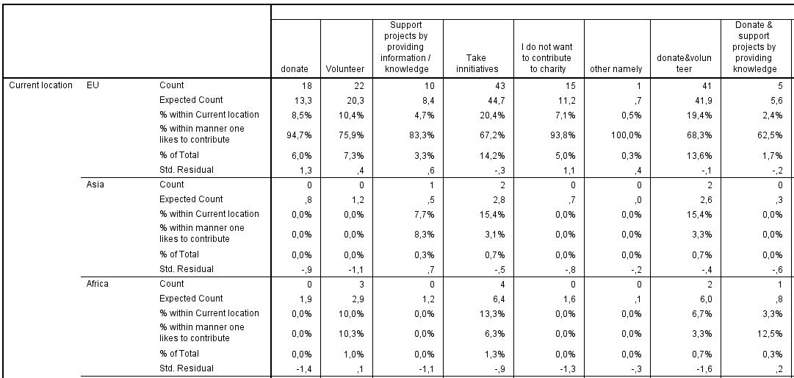
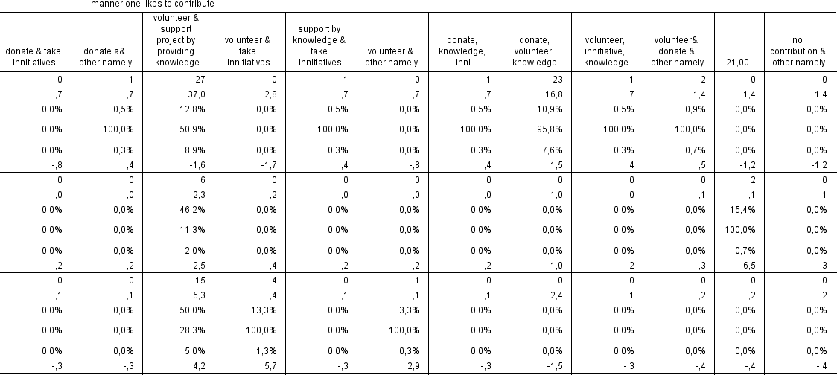
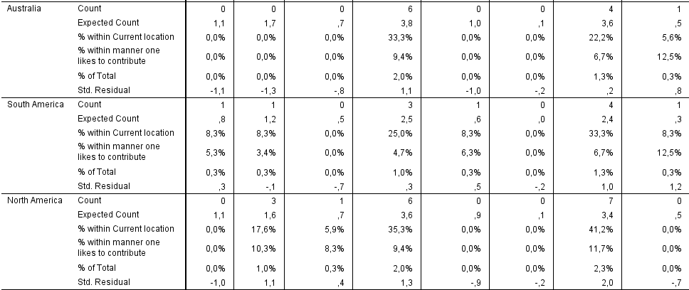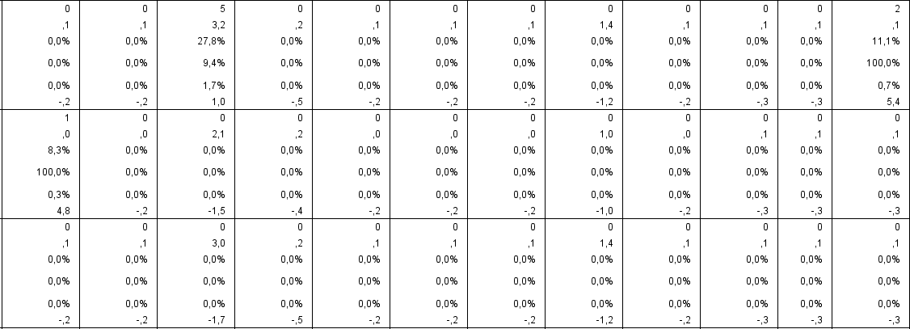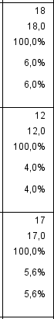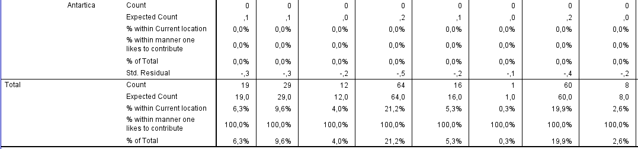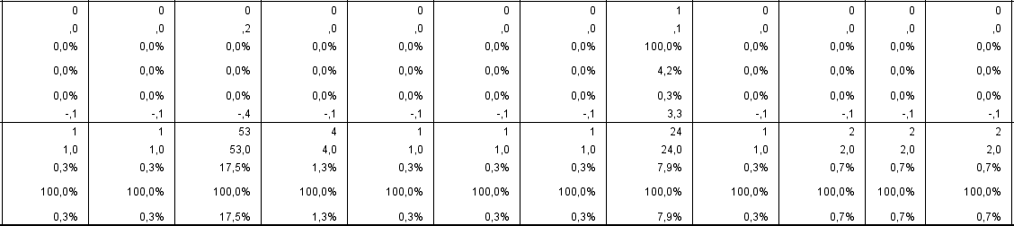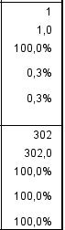

Chi-Square Tests
 | Value | df | Asymp. Sig. (2-sided)
Pearson Chi-Square | 237,227ª | 114 | ,000
Likelihood Ratio | 158,030 | 114 | ,004
Linear-by-Linear Association | ,015 | 1 | ,902
N of Valid Cases | 302
a. 128 cells (91,4%) have expected count less than 5. The minimum expected count is ,00.

Symmetric Measures
 |  | Value | Approx. Sig.
Nominal by Nominal | Phi | ,886 | ,000
 | Cramer's V | ,362 | ,000
N of Valid Cases |  | 302

Current location VS Attitude towards the concept of peace
Case Processing Summary
 | Cases
 | Valid |  | Missing |  | Total
 | N | Percent | N | Percent | N | Percent
Current location * attitude towards the concept | 302 | 98,1% | 6 | 1,9% | 308 | 100,0%

 |  |  |  |  |  |  |  | attitude towards the concept |  |  |  |  |  |  | Total
 |  |  |  |  |  |  |  | yes I like the concept |  | a little you got me curious about the concept |  |  | the concept is not clear | no I do not like the concept
Current location | EU |  | Count |  |  |  |  | 61 |  | 109 |  |  | 19 | 22 | 211
 |  |  | Expected Count |  |  |  |  | 67,8 |  | 105,5 |  |  | 16,8 | 21,0 | 211,0
 |  |  | % within Current location |  |  |  |  | 28,9% |  | 51,7% |  |  | 9,0% | 10,4% | 100,0%
 |  |  | % within attitude towards the concept |  |  |  |  | 62,9% |  | 72,2% |  |  | 79,2% | 73,3% | 69,9%
 |  |  | % of Total |  |  |  |  | 20,2% |  | 36,1% |  |  | 6,3% | 7,3% | 69,9%
 |  |  | Std. Residual |  |  |  |  | -,8 |  | ,3 |  |  | ,5 | ,2
 | Asia |  | Count |  |  |  |  | 5 |  | 5 |  |  | 0 | 3 | 13
 |  |  | Expected Count |  |  |  |  | 4,2 |  | 6,5 |  |  | 1,0 | 1,3 | 13,0
 |  |  | % within Current location |  |  |  |  | 38,5% |  | 38,5% |  |  | 0,0% | 23,1% | 100,0%
 |  |  | % within attitude towards the concept |  |  |  |  | 5,2% |  | 3,3% |  |  | 0,0% | 10,0% | 4,3%
 |  |  | % of Total |  |  |  |  | 1,7% |  | 1,7% |  |  | 0,0% | 1,0% | 4,3%
 |  |  | Std. Residual |  |  |  |  | ,4 |  | -,6 |  |  | -1,0 | 1,5
 | Africa |  | Count |  |  |  |  | 11 |  | 19 |  |  | 0 | 0 | 30
 |  |  | Expected Count |  |  |  |  | 9,6 |  | 15,0 |  |  | 2,4 | 3,0 | 30,0
 |  |  | % within Current location |  |  |  |  | 36,7% |  | 63,3% |  |  | 0,0% | 0,0% | 100,0%
 |  |  | % within attitude towards the concept |  |  |  |  | 11,3% |  | 12,6% |  |  | 0,0% | 0,0% | 9,9%
 |  |  | % of Total |  |  |  |  | 3,6% |  | 6,3% |  |  | 0,0% | 0,0% | 9,9%
 |  |  | Std. Residual |  |  |  |  | ,4 |  | 1,0 |  |  | -1,5 | -1,7
 | Australia |  | Count |  |  |  |  | 8 |  | 6 |  |  | 2 | 2 | 18
 |  |  | Expected Count |  |  |  |  | 5,8 |  | 9,0 |  |  | 1,4 | 1,8 | 18,0
 |  |  | % within Current location |  |  |  |  | 44,4% |  | 33,3% |  |  | 11,1% | 11,1% | 100,0%
 |  |  | % within attitude towards the concept |  |  |  |  | 8,2% |  | 4,0% |  |  | 8,3% | 6,7% | 6,0%
 |  |  | % of Total |  |  |  |  | 2,6% |  | 2,0% |  |  | 0,7% | 0,7% | 6,0%
 |  |  | Std. Residual |  |  |  |  | ,9 |  | -1,0 |  |  | ,5 | ,2
 | South America |  | Count |  |  |  |  | 6 |  | 4 |  |  | 1 | 1 | 12
 |  |  | Expected Count |  |  |  |  | 3,9 |  | 6,0 |  |  | 1,0 | 1,2 | 12,0
 |  |  | % within Current location |  |  |  |  | 50,0% |  | 33,3% |  |  | 8,3% | 8,3% | 100,0%
 |  |  | % within attitude towards the concept |  |  |  |  | 6,2% |  | 2,6% |  |  | 4,2% | 3,3% | 4,0%
 |  |  | % of Total |  |  |  |  | 2,0% |  | 1,3% |  |  | 0,3% | 0,3% | 4,0%
 |  |  | Std. Residual |  |  |  |  | 1,1 |  | -,8 |  |  | ,0 | -,2
 | North America |  | Count |  |  |  |  | 6 |  | 7 |  |  | 2 | 2 | 17
 |  |  | Expected Count |  |  |  |  | 5,5 |  | 8,5 |  |  | 1,4 | 1,7 | 17,0
 |  |  | % within Current location |  |  |  |  | 35,3% |  | 41,2% |  |  | 11,8% | 11,8% | 100,0%
 |  |  | % within attitude towards the concept |  |  |  |  | 6,2% |  | 4,6% |  |  | 8,3% | 6,7% | 5,6%
 |  |  | % of Total |  |  |  |  | 2,0% |  | 2,3% |  |  | 0,7% | 0,7% | 5,6%
 |  |  | Std. Residual |  |  |  |  | ,2 |  | -,5 |  |  | ,6 | ,2
 | Antartica |  | Count |  |  |  |  | 0 |  | 1 |  |  | 0 | 0 | 1
 |  |  | Expected Count |  |  |  |  | ,3 |  | ,5 |  |  | ,1 | ,1 | 1,0
 |  |  | % within Current location |  |  |  |  | 0,0% |  | 100,0% |  |  | 0,0% | 0,0% | 100,0%
 |  |  | % within attitude towards the concept |  |  |  |  | 0,0% |  | 0,7% |  |  | 0,0% | 0,0% | 0,3%
 |  |  | % of Total |  |  |  |  | 0,0% |  | 0,3% |  |  | 0,0% | 0,0% | 0,3%
 |  |  | Std. Residual |  |  |  |  | -,6 |  | ,7 |  |  | -,3 | -,3
Total |  |  | Count |  |  |  |  | 97 |  | 151 |  |  | 24 | 30 | 302
 |  |  | Expected Count |  |  |  |  | 97,0 |  | 151,0 |  |  | 24,0 | 30,0 | 302,0
 |  |  | % within Current location |  |  |  |  | 32,1% |  | 50,0% |  |  | 7,9% | 9,9% | 100,0%
 |  |  | % within attitude towards the concept |  |  |  |  | 100,0% |  | 100,0% |  |  | 100,0% | 100,0% | 100,0%
 |  |  | % of Total |  |  |  |  | 32,1% |  | 50,0% |  |  | 7,9% | 9,9% | 100,0%
Chi-Square Tests
 |  |  |  | Value |  | df |  |  | Asymp. Sig. (2-sided)
Pearson Chi-Square |  |  |  | 17,253ª |  | 18 |  |  | ,506
Likelihood Ratio |  |  |  | 23,258 |  | 18 |  |  | ,181
Linear-by-Linear Association |  |  |  | 1,331 |  | 1 |  |  | ,249
N of Valid Cases |  |  |  | 302
a. 16 cells (57,1%) have expected count less than 5. The minimum expected count is ,08.
Symmetric Measures
 |  |  |  |  | Value |  | Approx. Sig.
Nominal by Nominal |  | Phi |  |  | ,239 |  | ,506
 |  | Cramer's V |  |  | ,138 |  | ,506
N of Valid Cases |  |  |  |  | 302

Current location VS requirements

Case Processing Summary
 | Cases
 | Valid |  | Missing |  | Total
 | N | Percent | N | Percent | N | Percent
Current location * requirements that need to be mett in order to let an individual organize a Peace Pod | 301 | 97,7% | 7 | 2,3% | 308 | 100,0%

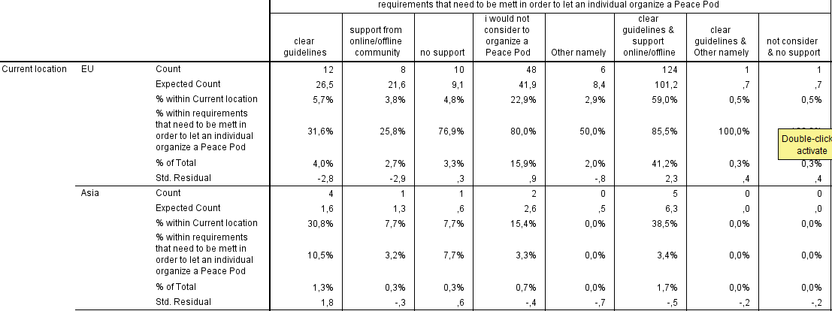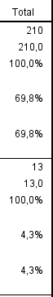
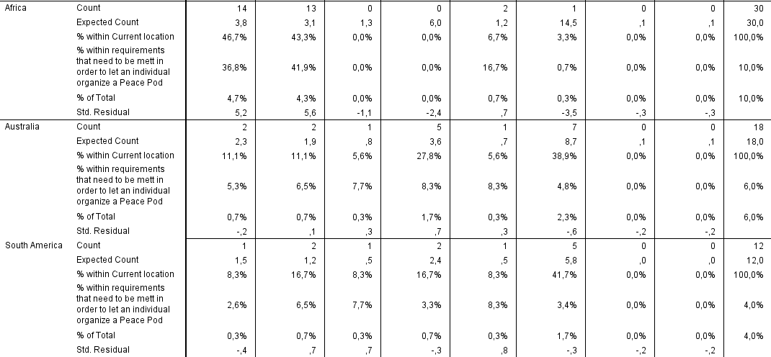
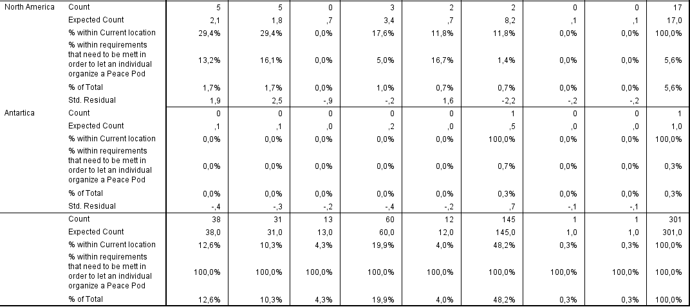

Chi-Square Tests
 |  | Value |  | df |  | Asymp. Sig. (2-sided)
Pearson Chi-Square |  | 130,470ª |  | 42 |  | ,000
Likelihood Ratio |  | 124,536 |  | 42 |  | ,000
Linear-by-Linear Association |  | 35,596 |  | 1 |  | ,000
N of Valid Cases |  | 301
a. 44 cells (78,6%) have expected count less than 5. The minimum expected count is ,00.
Symmetric Measures
 |  |  | Value |  | Approx. Sig.
Nominal by Nominal | Phi |  | ,658 |  | ,000
 | Cramer's V |  | ,269 |  | ,000
N of Valid Cases |  |  | 301

Current location VS willingness to organize a Peace Pod
Case Processing Summary
 | Cases
 | Valid |  | Missing |  | Total
 | N | Percent | N | Percent | N | Percent
Current location * Willingness of the individual to organizat a Peae Pod | 302 | 98,1% | 6 | 1,9% | 308 | 100,0%

 |  |  | Willingness of the individual to organize a Peace Pod |  |  |  | Total
 |  |  | Yes, I would organize a Peace pod | Maybe this would depend on the amount of support provided | No, I would not organize a Peace Pod | Other namely
Current location | EU | Count | 31 | 87 | 90 | 3 | 211
 |  | Expected Count | 37,0 | 88,0 | 75,5 | 10,5 | 211,0
 |  | % within Current location | 14,7% | 41,2% | 42,7% | 1,4% | 100,0%
 |  | % within Willingness of the individual to organize a Peace Pod | 58,5% | 69,0% | 83,3% | 20,0% | 69,9%
 |  | % of Total | 10,3% | 28,8% | 29,8% | 1,0% | 69,9%
 |  | Std. Residual | -1,0 | -,1 | 1,7 | -2,3
 | Asia | Count | 3 | 7 | 0 | 3 | 13
 |  | Expected Count | 2,3 | 5,4 | 4,6 | ,6 | 13,0
 |  | % within Current location | 23,1% | 53,8% | 0,0% | 23,1% | 100,0%
 |  | % within Willingness of the individual to organize a Peace Pod | 5,7% | 5,6% | 0,0% | 20,0% | 4,3%
 |  | % of Total | 1,0% | 2,3% | 0,0% | 1,0% | 4,3%
 |  | Std. Residual | ,5 | ,7 | -2,2 | 2,9
 | Africa | Count | 8 | 16 | 2 | 4 | 30
 |  | Expected Count | 5,3 | 12,5 | 10,7 | 1,5 | 30,0
 |  | % within Current location | 26,7% | 53,3% | 6,7% | 13,3% | 100,0%
 |  | % within Willingness of the individual to organize a Peace Pod | 15,1% | 12,7% | 1,9% | 26,7% | 9,9%
 |  | % of Total | 2,6% | 5,3% | 0,7% | 1,3% | 9,9%
 |  | Std. Residual | 1,2 | 1,0 | -2,7 | 2,1
 | Australia | Count | 3 | 7 | 7 | 1 | 18
 |  | Expected Count | 3,2 | 7,5 | 6,4 | ,9 | 18,0
 |  | % within Current location | 16,7% | 38,9% | 38,9% | 5,6% | 100,0%
 |  | % within Willingness of the individual to organize a Peace Pod | 5,7% | 5,6% | 6,5% | 6,7% | 6,0%
 |  | % of Total | 1,0% | 2,3% | 2,3% | 0,3% | 6,0%
 |  | Std. Residual | -,1 | -,2 | ,2 | ,1
 | South America | Count | 3 | 3 | 4 | 2 | 12
 |  | Expected Count | 2,1 | 5,0 | 4,3 | ,6 | 12,0
 |  | % within Current location | 25,0% | 25,0% | 33,3% | 16,7% | 100,0%
 |  | % within Willingness of the individual to organize a Peace Pod | 5,7% | 2,4% | 3,7% | 13,3% | 4,0%
 |  | % of Total | 1,0% | 1,0% | 1,3% | 0,7% | 4,0%
 |  | Std. Residual | ,6 | -,9 | -,1 | 1,8
 | North America | Count | 4 | 6 | 5 | 2 | 17
 |  | Expected Count | 3,0 | 7,1 | 6,1 | ,8 | 17,0
 |  | % within Current location | 23,5% | 35,3% | 29,4% | 11,8% | 100,0%
 |  | % within Willingness of the individual to organize a Peace Pod | 7,5% | 4,8% | 4,6% | 13,3% | 5,6%
 |  | % of Total | 1,3% | 2,0% | 1,7% | 0,7% | 5,6%
 |  | Std. Residual | ,6 | -,4 | -,4 | 1,3
 | Antartica | Count | 1 | 0 | 0 | 0 | 1
 |  | Expected Count | ,2 | ,4 | ,4 | ,0 | 1,0
 |  | % within Current location | 100,0% | 0,0% | 0,0% | 0,0% | 100,0%
 |  | % within Willingness of the individual to organize a Peace Pod | 1,9% | 0,0% | 0,0% | 0,0% | 0,3%
 |  | % of Total | 0,3% | 0,0% | 0,0% | 0,0% | 0,3%
 |  | Std. Residual | 2,0 | -,6 | -,6 | -,2
Total |  | Count | 53 | 126 | 108 | 15 | 302
 |  | Expected Count | 53,0 | 126,0 | 108,0 | 15,0 | 302,0
 |  | % within Current location | 17,5% | 41,7% | 35,8% | 5,0% | 100,0%
 |  | % within Willingness of the individual to organize a Peace Pod | 100,0% | 100,0% | 100,0% | 100,0% | 100,0%
 |  | % of Total | 17,5% | 41,7% | 35,8% | 5,0% | 100,0%

Chi-Square Tests
 | Value | df | Asymp. Sig. (2-sided)
Pearson Chi-Square | 48,374ª | 18 | ,000
Likelihood Ratio | 50,054 | 18 | ,000
Linear-by-Linear Association | ,253 | 1 | ,615
N of Valid Cases | 302
a. 15 cells (53,6%) have expected count less than 5. The minimum expected count is ,05.

Symmetric Measures
 |  | Value | Approx. Sig.
Nominal by Nominal | Phi | ,400 | ,000
 | Cramer's V | ,231 | ,000
N of Valid Cases |  | 302

Job status VS awareness of Peace projects
Case Processing Summary
 | Cases
 | Valid |  | Missing |  | Total
 | N | Percent | N | Percent | N | Percent
job status * awareness of peace projects | 303 | 98,4% | 5 | 1,6% | 308 | 100,0%

 |  |  | awareness of peace projects |  |  |  | Total
 |  |  | No, I do not know any peace projects | No, not currently but I am aware of some projects in the past | Yes, I could name one | Yes I know many
job status | Employed for wages | Count | 72 | 33 | 12 | 0 | 117
 |  | Expected Count | 32,0 | 41,3 | 34,4 | 9,3 | 117,0
 |  | % within job status | 61,5% | 28,2% | 10,3% | 0,0% | 100,0%
 |  | % within awareness of peace projects | 86,7% | 30,8% | 13,5% | 0,0% | 38,6%
 |  | % of Total | 23,8% | 10,9% | 4,0% | 0,0% | 38,6%
 |  | Std. Residual | 7,1 | -1,3 | -3,8 | -3,0
 | Self Employed | Count | 2 | 19 | 8 | 1 | 30
 |  | Expected Count | 8,2 | 10,6 | 8,8 | 2,4 | 30,0
 |  | % within job status | 6,7% | 63,3% | 26,7% | 3,3% | 100,0%
 |  | % within awareness of peace projects | 2,4% | 17,8% | 9,0% | 4,2% | 9,9%
 |  | % of Total | 0,7% | 6,3% | 2,6% | 0,3% | 9,9%
 |  | Std. Residual | -2,2 | 2,6 | -,3 | -,9
 | Unemployed | Count | 2 | 10 | 4 | 1 | 17
 |  | Expected Count | 4,7 | 6,0 | 5,0 | 1,3 | 17,0
 |  | % within job status | 11,8% | 58,8% | 23,5% | 5,9% | 100,0%
 |  | % within awareness of peace projects | 2,4% | 9,3% | 4,5% | 4,2% | 5,6%
 |  | % of Total | 0,7% | 3,3% | 1,3% | 0,3% | 5,6%
 |  | Std. Residual | -1,2 | 1,6 | -,4 | -,3
 | A student | Count | 7 | 45 | 59 | 5 | 116
 |  | Expected Count | 31,8 | 41,0 | 34,1 | 9,2 | 116,0
 |  | % within job status | 6,0% | 38,8% | 50,9% | 4,3% | 100,0%
 |  | % within awareness of peace projects | 8,4% | 42,1% | 66,3% | 20,8% | 38,3%
 |  | % of Total | 2,3% | 14,9% | 19,5% | 1,7% | 38,3%
 |  | Std. Residual | -4,4 | ,6 | 4,3 | -1,4
 | Retired | Count | 0 | 0 | 6 | 13 | 19
 |  | Expected Count | 5,2 | 6,7 | 5,6 | 1,5 | 19,0
 |  | % within job status | 0,0% | 0,0% | 31,6% | 68,4% | 100,0%
 |  | % within awareness of peace projects | 0,0% | 0,0% | 6,7% | 54,2% | 6,3%
 |  | % of Total | 0,0% | 0,0% | 2,0% | 4,3% | 6,3%
 |  | Std. Residual | -2,3 | -2,6 | ,2 | 9,4
 | Unable to work | Count | 0 | 0 | 0 | 4 | 4
 |  | Expected Count | 1,1 | 1,4 | 1,2 | ,3 | 4,0
 |  | % within job status | 0,0% | 0,0% | 0,0% | 100,0% | 100,0%
 |  | % within awareness of peace projects | 0,0% | 0,0% | 0,0% | 16,7% | 1,3%
 |  | % of Total | 0,0% | 0,0% | 0,0% | 1,3% | 1,3%
 |  | Std. Residual | -1,0 | -1,2 | -1,1 | 6,5
Total |  | Count | 83 | 107 | 89 | 24 | 303
 |  | Expected Count | 83,0 | 107,0 | 89,0 | 24,0 | 303,0
 |  | % within job status | 27,4% | 35,3% | 29,4% | 7,9% | 100,0%
 |  | % within awareness of peace projects | 100,0% | 100,0% | 100,0% | 100,0% | 100,0%
 |  | % of Total | 27,4% | 35,3% | 29,4% | 7,9% | 100,0%

Chi-Square Tests
 | Value | df | Asymp. Sig. (2-sided)
Pearson Chi-Square | 278,115ª | 15 | ,000
Likelihood Ratio | 217,384 | 15 | ,000
Linear-by-Linear Association | 131,480 | 1 | ,000
N of Valid Cases | 303
a. 9 cells (37,5%) have expected count less than 5. The minimum expected count is ,32.

Symmetric Measures
 |  | Value | Approx. Sig.
Nominal by Nominal | Phi | ,958 | ,000
 | Cramer's V | ,553 | ,000
N of Valid Cases |  | 303

Job status VS previous support of Peace
Case Processing Summary
 | Cases
 | Valid |  | Missing |  | Total
 | N | Percent | N | Percent | N | Percent
job status * previous support of the individual | 303 | 98,4% | 5 | 1,6% | 308 | 100,0%

job status * previous support of the individual Crosstabulation
 |  |  | previous support of the individual |  | Total
 |  |  | yes I have supported peace in the past | No I have not supported peace in the past
job status | Employed for wages | Count | 4 | 113 | 117
 |  | Expected Count | 29,7 | 87,3 | 117,0
 |  | % within job status | 3,4% | 96,6% | 100,0%
 |  | % within previous support of the individual | 5,2% | 50,0% | 38,6%
 |  | % of Total | 1,3% | 37,3% | 38,6%
 |  | Std. Residual | -4,7 | 2,8
 | Self Employed | Count | 2 | 28 | 30
 |  | Expected Count | 7,6 | 22,4 | 30,0
 |  | % within job status | 6,7% | 93,3% | 100,0%
 |  | % within previous support of the individual | 2,6% | 12,4% | 9,9%
 |  | % of Total | 0,7% | 9,2% | 9,9%
 |  | Std. Residual | -2,0 | 1,2
 | Unemployed | Count | 1 | 16 | 17
 |  | Expected Count | 4,3 | 12,7 | 17,0
 |  | % within job status | 5,9% | 94,1% | 100,0%
 |  | % within previous support of the individual | 1,3% | 7,1% | 5,6%
 |  | % of Total | 0,3% | 5,3% | 5,6%
 |  | Std. Residual | -1,6 | ,9
 | A student | Count | 49 | 67 | 116
 |  | Expected Count | 29,5 | 86,5 | 116,0
 |  | % within job status | 42,2% | 57,8% | 100,0%
 |  | % within previous support of the individual | 63,6% | 29,6% | 38,3%
 |  | % of Total | 16,2% | 22,1% | 38,3%
 |  | Std. Residual | 3,6 | -2,1
 | Retired | Count | 17 | 2 | 19
 |  | Expected Count | 4,8 | 14,2 | 19,0
 |  | % within job status | 89,5% | 10,5% | 100,0%
 |  | % within previous support of the individual | 22,1% | 0,9% | 6,3%
 |  | % of Total | 5,6% | 0,7% | 6,3%
 |  | Std. Residual | 5,5 | -3,2
 | Unable to work | Count | 4 | 0 | 4
 |  | Expected Count | 1,0 | 3,0 | 4,0
 |  | % within job status | 100,0% | 0,0% | 100,0%
 |  | % within previous support of the individual | 5,2% | 0,0% | 1,3%
 |  | % of Total | 1,3% | 0,0% | 1,3%
 |  | Std. Residual | 3,0 | -1,7
Total |  | Count | 77 | 226 | 303
 |  | Expected Count | 77,0 | 226,0 | 303,0
 |  | % within job status | 25,4% | 74,6% | 100,0%
 |  | % within previous support of the individual | 100,0% | 100,0% | 100,0%
 |  | % of Total | 25,4% | 74,6% | 100,0%

Chi-Square Tests
 | Value | df | Asymp. Sig. (2-sided)
Pearson Chi-Square | 109,051ª | 5 | ,000
Likelihood Ratio | 115,531 | 5 | ,000
Linear-by-Linear Association | 91,481 | 1 | ,000
N of Valid Cases | 303
a. 4 cells (33,3%) have expected count less than 5. The minimum expected count is 1,02.

Symmetric Measures
 |  | Value | Approx. Sig.
Nominal by Nominal | Phi | ,600 | ,000
 | Cramer's V | ,600 | ,000
N of Valid Cases |  | 303
Job status VS manner of contribution towards peace
Case Processing Summary
 | Cases
 | Valid |  | Missing |  | Total
 | N | Percent | N | Percent | N | Percent
job status * manner one likes to contribute | 303 | 98,4% | 5 | 1,6% | 308 | 100,0%

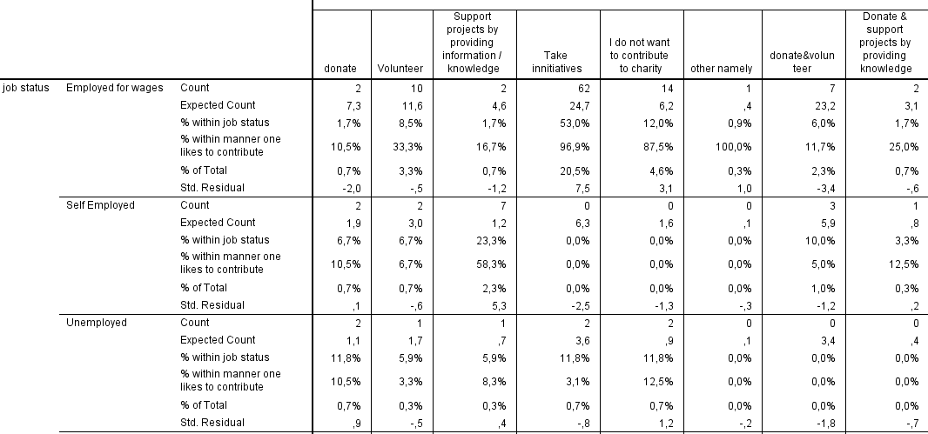
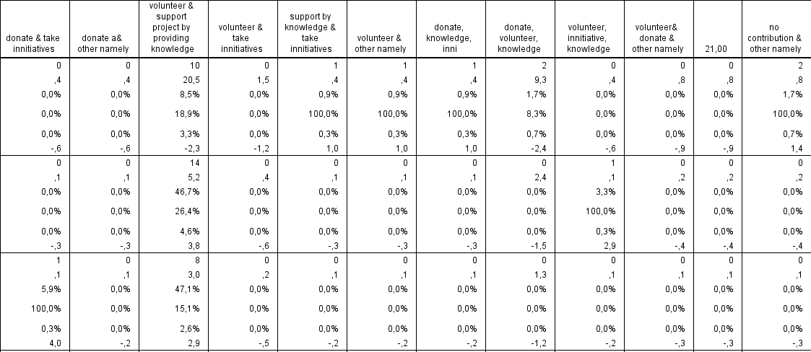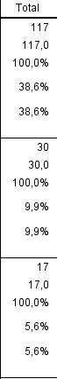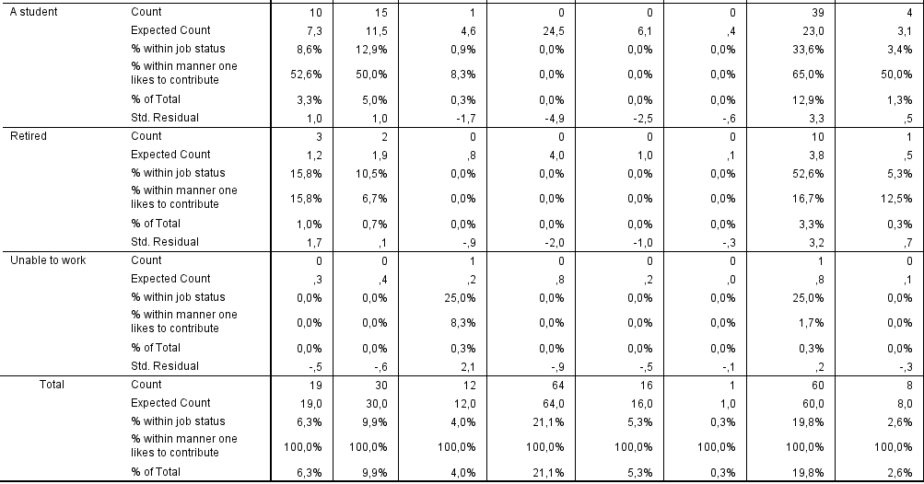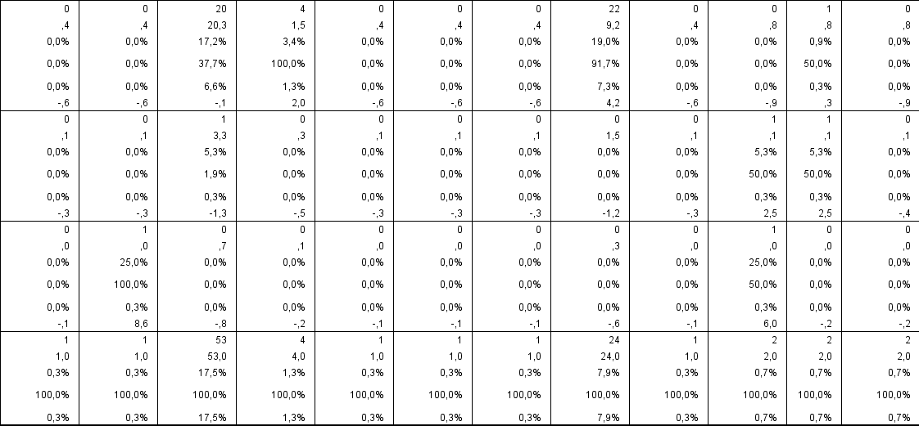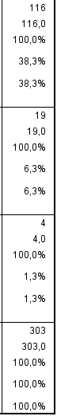
Chi-Square Tests
 | Value | df | Asymp. Sig. (2-sided)
Pearson Chi-Square | 429,111ª | 95 | ,000
Likelihood Ratio | 328,116 | 95 | ,000
Linear-by-Linear Association | 21,336 | 1 | ,000
N of Valid Cases | 303
a. 103 cells (85,8%) have expected count less than 5. The minimum expected count is ,01.

Symmetric Measures
 |  | Value | Approx. Sig.
Nominal by Nominal | Phi | 1,190 | ,000
 | Cramer's V | ,532 | ,000
N of Valid Cases |  | 303

Job status VS attitude towards the concept
Case Processing Summary
 | Cases
 | Valid |  | Missing |  | Total
 | N | Percent | N | Percent | N | Percent
job status * attitude towards the concept | 303 | 98,4% | 5 | 1,6% | 308 | 100,0%
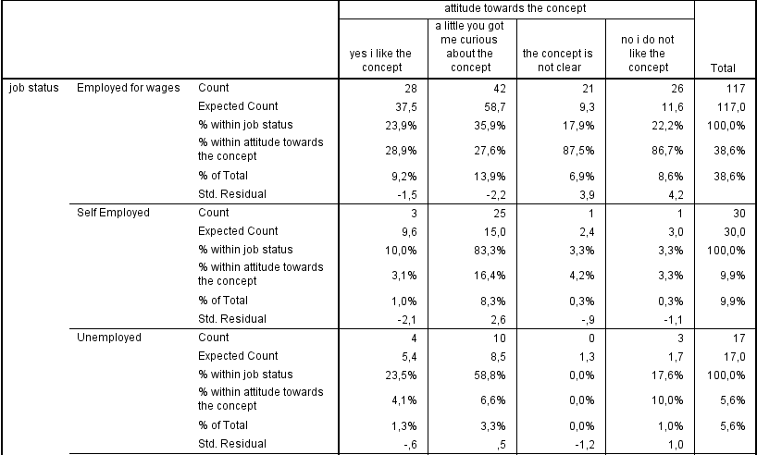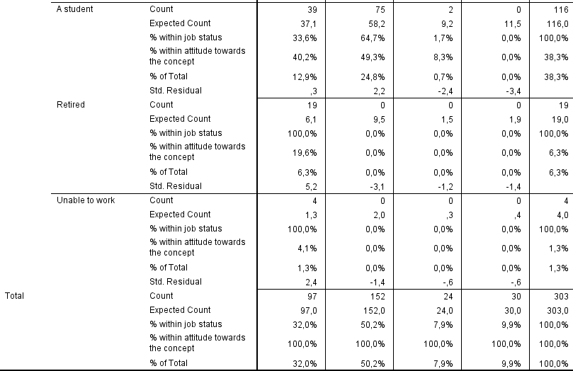

Chi-Square Tests
 | Value | df | Asymp. Sig. (2-sided)
Pearson Chi-Square | 127,068ª | 15 | ,000
Likelihood Ratio | 138,849 | 15 | ,000
Linear-by-Linear Association | 59,400 | 1 | ,000
N of Valid Cases | 303
a. 10 cells (41,7%) have expected count less than 5. The minimum expected count is ,32.

Symmetric Measures
 |  | Value | Approx. Sig.
Nominal by Nominal | Phi | ,648 | ,000
 | Cramer's V | ,374 | ,000
N of Valid Cases |  | 303

Job Status VS requirements
Case Processing Summary
 | Cases
 | Valid |  | Missing |  | Total
 | N | Percent | N | Percent | N | Percent
job status * requirements that need to be mett in order to let an individual organize a Peace Pod | 302 | 98,1% | 6 | 1,9% | 308 | 100,0%
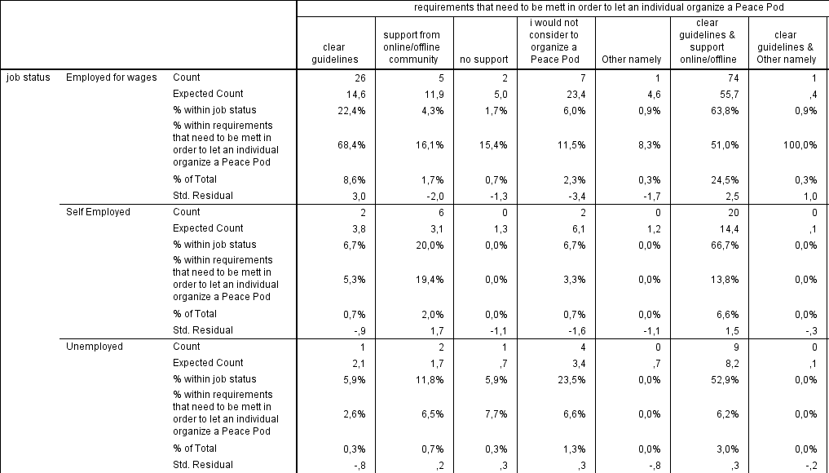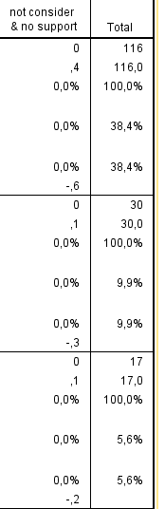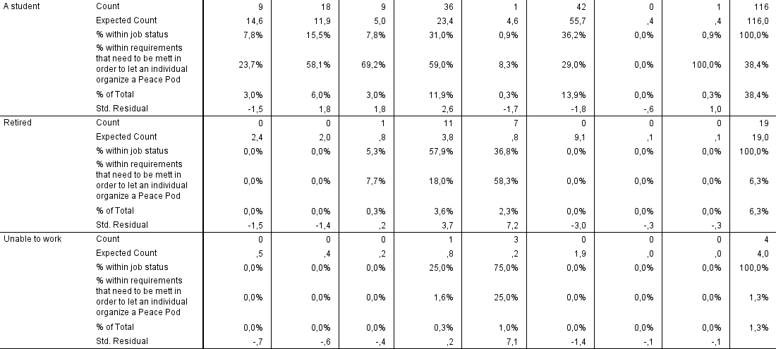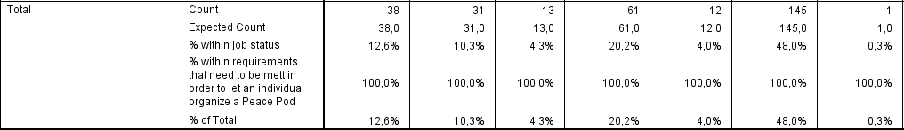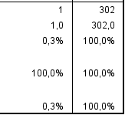

Chi-Square Tests
 | Value | df | Asymp. Sig. (2-sided)
Pearson Chi-Square | 204,641ª | 35 | ,000
Likelihood Ratio | 154,122 | 35 | ,000
Linear-by-Linear Association | 1,935 | 1 | ,164
N of Valid Cases | 302
a. 36 cells (75,0%) have expected count less than 5. The minimum expected count is ,01.

Symmetric Measures
 |  | Value | Approx. Sig.
Nominal by Nominal | Phi | ,823 | ,000
 | Cramer's V | ,368 | ,000
N of Valid Cases |  | 302

Job status VS willingness to organize a peace pod
 |  | Case Processing Summary
 |  |  |  | Cases
 |  |  |  | Valid |  |  | Missing |  |  |  | Total
 |  |  |  | N |  | Percent | N |  | Percent |  | N | Percent
 |  | job status * Willingness of the individual to organize a Peace Pod |  | 303 |  | 98,4% | 5 |  | 1,6% |  | 308 | 100,0%
 |  |  |  |  | Willingness of the individual to organize a Peace Pod |  |  |  |  |  |  |  |  |  | Total
 |  |  |  |  | Yes I would organize a Peace pod |  |  | Maybe this would depend on the amount of support provided |  | No, I would not organize a Peace Pod |  |  | Other namely
job status | Employed for wages |  | Count |  | 2 |  |  | 25 |  | 77 |  |  | 13 |  | 117
 |  |  | Expected Count |  | 20,5 |  |  | 49,0 |  | 41,7 |  |  | 5,8 |  | 117,0
 |  |  | % within job status |  | 1,7% |  |  | 21,4% |  | 65,8% |  |  | 11,1% |  | 100,0%
 |  |  | % within Willingness of the individual to organize a Peace Pod |  | 3,8% |  |  | 19,7% |  | 71,3% |  |  | 86,7% |  | 38,6%
 |  |  | % of Total |  | 0,7% |  |  | 8,3% |  | 25,4% |  |  | 4,3% |  | 38,6%
 |  |  | Std. Residual |  | -4,1 |  |  | -3,4 |  | 5,5 |  |  | 3,0
 | Self Employed |  | Count |  | 1 |  |  | 10 |  | 19 |  |  | 0 |  | 30
 |  |  | Expected Count |  | 5,2 |  |  | 12,6 |  | 10,7 |  |  | 1,5 |  | 30,0
 |  |  | % within job status |  | 3,3% |  |  | 33,3% |  | 63,3% |  |  | 0,0% |  | 100,0%
 |  |  | % within Willingness of the individual to organize a Peace Pod |  | 1,9% |  |  | 7,9% |  | 17,6% |  |  | 0,0% |  | 9,9%
 |  |  | % of Total |  | 0,3% |  |  | 3,3% |  | 6,3% |  |  | 0,0% |  | 9,9%
 |  |  | Std. Residual |  | -1,9 |  |  | -,7 |  | 2,5 |  |  | -1,2
 | Unemployed |  | Count |  | 1 |  |  | 10 |  | 5 |  |  | 1 |  | 17
 |  |  | Expected Count |  | 3,0 |  |  | 7,1 |  | 6,1 |  |  | ,8 |  | 17,0
 |  |  | % within job status |  | 5,9% |  |  | 58,8% |  | 29,4% |  |  | 5,9% |  | 100,0%
 |  |  | % within Willingness of the individual to organize a Peace Pod |  | 1,9% |  |  | 7,9% |  | 4,6% |  |  | 6,7% |  | 5,6%
 |  |  | % of Total |  | 0,3% |  |  | 3,3% |  | 1,7% |  |  | 0,3% |  | 5,6%
 |  |  | Std. Residual |  | -1,1 |  |  | 1,1 |  | -,4 |  |  | ,2
 | A student |  | Count |  | 26 |  |  | 82 |  | 7 |  |  | 1 |  | 116
 |  |  | Expected Count |  | 20,3 |  |  | 48,6 |  | 41,3 |  |  | 5,7 |  | 116,0
 |  |  | % within job status |  | 22,4% |  |  | 70,7% |  | 6,0% |  |  | 0,9% |  | 100,0%
 |  |  | % within Willingness of the individual to organize a Peace Pod |  | 49,1% |  |  | 64,6% |  | 6,5% |  |  | 6,7% |  | 38,3%
 |  |  | % of Total |  | 8,6% |  |  | 27,1% |  | 2,3% |  |  | 0,3% |  | 38,3%
 |  |  | Std. Residual |  | 1,3 |  |  | 4,8 |  | -5,3 |  |  | -2,0
 | Retired |  | Count |  | 19 |  |  | 0 |  | 0 |  |  | 0 |  | 19
 |  |  | Expected Count |  | 3,3 |  |  | 8,0 |  | 6,8 |  |  | ,9 |  | 19,0
 |  |  | % within job status |  | 100,0% |  |  | 0,0% |  | 0,0% |  |  | 0,0% |  | 100,0%
 |  |  | % within Willingness of the individual to organize a Peace Pod |  | 35,8% |  |  | 0,0% |  | 0,0% |  |  | 0,0% |  | 6,3%
 |  |  | % of Total |  | 6,3% |  |  | 0,0% |  | 0,0% |  |  | 0,0% |  | 6,3%
 |  |  | Std. Residual |  | 8,6 |  |  | -2,8 |  | -2,6 |  |  | -1,0
 | Unable to work |  | Count |  | 4 |  |  | 0 |  | 0 |  |  | 0 |  | 4
 |  |  | Expected Count |  | ,7 |  |  | 1,7 |  | 1,4 |  |  | ,2 |  | 4,0
 |  |  | % within job status |  | 100,0% |  |  | 0,0% |  | 0,0% |  |  | 0,0% |  | 100,0%
 |  |  | % within Willingness of the individual to organize a Peace Pod |  | 7,5% |  |  | 0,0% |  | 0,0% |  |  | 0,0% |  | 1,3%
 |  |  | % of Total |  | 1,3% |  |  | 0,0% |  | 0,0% |  |  | 0,0% |  | 1,3%
 |  |  | Std. Residual |  | 3,9 |  |  | -1,3 |  | -1,2 |  |  | -,4
Total |  |  | Count |  | 53 |  |  | 127 |  | 108 |  |  | 15 |  | 303
 |  |  | Expected Count |  | 53,0 |  |  | 127,0 |  | 108,0 |  |  | 15,0 |  | 303,0
 |  |  | % within job status |  | 17,5% |  |  | 41,9% |  | 35,6% |  |  | 5,0% |  | 100,0%
 |  |  | % within Willingness of the individual to organize a Peace Pod |  | 100,0% |  |  | 100,0% |  | 100,0% |  |  | 100,0% |  | 100,0%
 |  |  | % of Total |  | 17,5% |  |  | 41,9% |  | 35,6% |  |  | 5,0% |  | 100,0%

Chi-Square Tests
 | Value | df | Asymp. Sig. (2-sided)
Pearson Chi-Square | 247,340ª | 15 | ,000
Likelihood Ratio | 239,886 | 15 | ,000
Linear-by-Linear Association | 148,577 | 1 | ,000
N of Valid Cases | 303
a. 9 cells (37,5%) have expected count less than 5. The minimum expected count is ,20.

Symmetric Measures
 |  | Value | Approx. Sig.
Nominal by Nominal | Phi | ,903 | ,000
 | Cramer's V | ,522 | ,000
N of Valid Cases |  | 303

Educational background VS awareness of peace
 | Case Processing Summary
 |  |  | Cases
 |  |  | Valid |  |  | Missing |  |  |  | Total
 |  |  | N |  | Percent | N |  | Percent |  | N | Percent
educational background * awareness of peace projects |  |  | 303 |  | 98,4% | 5 |  | 1,6% |  | 308 | 100,0%
 |  |  |  |  |  |  | awareness of peace projects |  |  |  |  |  |  |  | Total
 |  |  |  |  |  |  | No I do not know any peace projects |  | no not currently but I am aware of some projects in the past |  |  | yes I could name one |  | yes I know many
 | Educational background | Never attended school or only kindergarten |  | Count |  |  | 6 |  | 0 |  |  | 0 |  | 1 | 7
 |  |  |  | Expected Count |  |  | 1,9 |  | 2,5 |  |  | 2,1 |  | ,6 | 7,0
 |  |  |  | % within educational background |  |  | 85,7% |  | 0,0% |  |  | 0,0% |  | 14,3% | 100,0%
 |  |  |  | % within awareness of peace projects |  |  | 7,2% |  | 0,0% |  |  | 0,0% |  | 4,2% | 2,3%
 |  |  |  | % of Total |  |  | 2,0% |  | 0,0% |  |  | 0,0% |  | 0,3% | 2,3%
 |  |  |  | Std. Residual |  |  | 2,9 |  | -1,6 |  |  | -1,4 |  | ,6
 |  | Elementary |  | Count |  |  | 2 |  | 3 |  |  | 2 |  | 0 | 7
 |  |  |  | Expected Count |  |  | 1,9 |  | 2,5 |  |  | 2,1 |  | ,6 | 7,0
 |  |  |  | % within educational background |  |  | 28,6% |  | 42,9% |  |  | 28,6% |  | 0,0% | 100,0%
 |  |  |  | % within awareness of peace projects |  |  | 2,4% |  | 2,8% |  |  | 2,2% |  | 0,0% | 2,3%
 |  |  |  | % of Total |  |  | 0,7% |  | 1,0% |  |  | 0,7% |  | 0,0% | 2,3%
 |  |  |  | Std. Residual |  |  | ,1 |  | ,3 |  |  | ,0 |  | -,7
 |  | High school drop out |  | Count |  |  | 4 |  | 1 |  |  | 0 |  | 0 | 5
 |  |  |  | Expected Count |  |  | 1,4 |  | 1,8 |  |  | 1,5 |  | ,4 | 5,0
 |  |  |  | % within educational background |  |  | 80,0% |  | 20,0% |  |  | 0,0% |  | 0,0% | 100,0%
 |  |  |  | % within awareness of peace projects |  |  | 4,8% |  | 0,9% |  |  | 0,0% |  | 0,0% | 1,7%
 |  |  |  | % of Total |  |  | 1,3% |  | 0,3% |  |  | 0,0% |  | 0,0% | 1,7%
 |  |  |  | Std. Residual |  |  | 2,2 |  | -,6 |  |  | -1,2 |  | -,6
 |  | High school graduate |  | Count |  |  | 50 |  | 4 |  |  | 1 |  | 1 | 56
 |  |  |  | Expected Count |  |  | 15,3 |  | 19,8 |  |  | 16,4 |  | 4,4 | 56,0
 |  |  |  | % within educational background |  |  | 89,3% |  | 7,1% |  |  | 1,8% |  | 1,8% | 100,0%
 |  |  |  | % within awareness of peace projects |  |  | 60,2% |  | 3,7% |  |  | 1,1% |  | 4,2% | 18,5%
 |  |  |  | % of Total |  |  | 16,5% |  | 1,3% |  |  | 0,3% |  | 0,3% | 18,5%
 |  |  |  | Std. Residual |  |  | 8,8 |  | -3,5 |  |  | -3,8 |  | -1,6
 |  | College dropout |  | Count |  |  | 6 |  | 4 |  |  | 2 |  | 0 | 12
 |  |  |  | Expected Count |  |  | 3,3 |  | 4,2 |  |  | 3,5 |  | 1,0 | 12,0
 |  |  |  | % within educational background |  |  | 50,0% |  | 33,3% |  |  | 16,7% |  | 0,0% | 100,0%
 |  |  |  | % within awareness of peace projects |  |  | 7,2% |  | 3,7% |  |  | 2,2% |  | 0,0% | 4,0%
 |  |  |  | % of Total |  |  | 2,0% |  | 1,3% |  |  | 0,7% |  | 0,0% | 4,0%
 |  |  |  | Std. Residual |  |  | 1,5 |  | -,1 |  |  | -,8 |  | -1,0
 |  | college graduate |  | Count |  |  | 10 |  | 75 |  |  | 33 |  | 1 | 119
 |  |  |  | Expected Count |  |  | 32,6 |  | 42,0 |  |  | 35,0 |  | 9,4 | 119,0
 |  |  |  | % within educational background |  |  | 8,4% |  | 63,0% |  |  | 27,7% |  | 0,8% | 100,0%
 |  |  |  | % within awareness of peace projects |  |  | 12,0% |  | 70,1% |  |  | 37,1% |  | 4,2% | 39,3%
 |  |  |  | % of Total |  |  | 3,3% |  | 24,8% |  |  | 10,9% |  | 0,3% | 39,3%
 |  |  |  | Std. Residual |  |  | -4,0 |  | 5,1 |  |  | -,3 |  | -2,7
 |  | Advance degree |  | Count |  |  | 5 |  | 20 |  |  | 51 |  | 21 | 97
 |  |  |  | Expected Count |  |  | 26,6 |  | 34,3 |  |  | 28,5 |  | 7,7 | 97,0
 |  |  |  | % within educational background |  |  | 5,2% |  | 20,6% |  |  | 52,6% |  | 21,6% | 100,0%
 |  |  |  | % within awareness of peace projects |  |  | 6,0% |  | 18,7% |  |  | 57,3% |  | 87,5% | 32,0%
 |  |  |  | % of Total |  |  | 1,7% |  | 6,6% |  |  | 16,8% |  | 6,9% | 32,0%
 |  |  |  | Std. Residual |  |  | -4,2 |  | -2,4 |  |  | 4,2 |  | 4,8
 | Total |  |  | Count |  |  | 83 |  | 107 |  |  | 89 |  | 24 | 303
 |  |  |  | Expected Count |  |  | 83,0 |  | 107,0 |  |  | 89,0 |  | 24,0 | 303,0
 |  |  |  | % within educational background |  |  | 27,4% |  | 35,3% |  |  | 29,4% |  | 7,9% | 100,0%
 |  |  |  | % within awareness of peace projects |  |  | 100,0% |  | 100,0% |  |  | 100,0% |  | 100,0% | 100,0%
 |  |  |  | % of Total |  |  | 27,4% |  | 35,3% |  |  | 29,4% |  | 7,9% | 100,0%

Chi-Square Tests
 | Value | df | Asymp. Sig. (2-sided)
Pearson Chi-Square | 246,920ª | 18 | ,000
Likelihood Ratio | 243,172 | 18 | ,000
Linear-by-Linear Association | 104,187 | 1 | ,000
N of Valid Cases | 303
a. 17 cells (60,7%) have expected count less than 5. The minimum expected count is ,40.

Symmetric Measures
 |  | Value | Approx. Sig.
Nominal by Nominal | Phi | ,903 | ,000
 | Cramer's V | ,521 | ,000
N of Valid Cases |  | 303

Educational background VS previous support

Case Processing Summary
 | Cases
 | Valid |  | Missing |  | Total
 | N | Percent | N | Percent | N | Percent
educational background * previous support of the individual | 303 | 98,4% | 5 | 1,6% | 308 | 100,0%

 |  |  |  |  |  | previous support of the individual |  |  | Total
 |  |  |  |  |  | Yes I have supported peace in the past |  | No I have not supported peace in the past
Educational background | Never attended school or only kindergarten |  | Count |  |  | 1 |  | 6 | 7
 |  |  | Expected Count |  |  | 1,8 |  | 5,2 | 7,0
 |  |  | % within educational background |  |  | 14,3% |  | 85,7% | 100,0%
 |  |  | % within previous support of the individual |  |  | 1,3% |  | 2,7% | 2,3%
 |  |  | % of Total |  |  | 0,3% |  | 2,0% | 2,3%
 |  |  | Std. Residual |  |  | -,6 |  | ,3
 | Elementary |  | Count |  |  | 0 |  | 7 | 7
 |  |  | Expected Count |  |  | 1,8 |  | 5,2 | 7,0
 |  |  | % within educational background |  |  | 0,0% |  | 100,0% | 100,0%
 |  |  | % within previous support of the individual |  |  | 0,0% |  | 3,1% | 2,3%
 |  |  | % of Total |  |  | 0,0% |  | 2,3% | 2,3%
 |  |  | Std. Residual |  |  | -1,3 |  | ,8
 | High school drop out |  | Count |  |  | 0 |  | 5 | 5
 |  |  | Expected Count |  |  | 1,3 |  | 3,7 | 5,0
 |  |  | % within educational background |  |  | 0,0% |  | 100,0% | 100,0%
 |  |  | % within previous support of the individual |  |  | 0,0% |  | 2,2% | 1,7%
 |  |  | % of Total |  |  | 0,0% |  | 1,7% | 1,7%
 |  |  | Std. Residual |  |  | -1,1 |  | ,7
 | High school graduate |  | Count |  |  | 2 |  | 54 | 56
 |  |  | Expected Count |  |  | 14,2 |  | 41,8 | 56,0
 |  |  | % within educational background |  |  | 3,6% |  | 96,4% | 100,0%
 |  |  | % within previous support of the individual |  |  | 2,6% |  | 23,9% | 18,5%
 |  |  | % of Total |  |  | 0,7% |  | 17,8% | 18,5%
 |  |  | Std. Residual |  |  | -3,2 |  | 1,9
 | College dropout |  | Count |  |  | 2 |  | 10 | 12
 |  |  | Expected Count |  |  | 3,0 |  | 9,0 | 12,0
 |  |  | % within educational background |  |  | 16,7% |  | 83,3% | 100,0%
 |  |  | % within previous support of the individual |  |  | 2,6% |  | 4,4% | 4,0%
 |  |  | % of Total |  |  | 0,7% |  | 3,3% | 4,0%
 |  |  | Std. Residual |  |  | -,6 |  | ,4
 | college graduate |  | Count |  |  | 9 |  | 110 | 119
 |  |  | Expected Count |  |  | 30,2 |  | 88,8 | 119,0
 |  |  | % within educational background |  |  | 7,6% |  | 92,4% | 100,0%
 |  |  | % within previous support of the individual |  |  | 11,7% |  | 48,7% | 39,3%
 |  |  | % of Total |  |  | 3,0% |  | 36,3% | 39,3%
 |  |  | Std. Residual |  |  | -3,9 |  | 2,3
 | Advance degree |  | Count |  |  | 63 |  | 34 | 97
 |  |  | Expected Count |  |  | 24,7 |  | 72,3 | 97,0
 |  |  | % within educational background |  |  | 64,9% |  | 35,1% | 100,0%
 |  |  | % within previous support of the individual |  |  | 81,8% |  | 15,0% | 32,0%
 |  |  | % of Total |  |  | 20,8% |  | 11,2% | 32,0%
 |  |  | Std. Residual |  |  | 7,7 |  | -4,5
Total |  |  | Count |  |  | 77 |  | 226 | 303
 |  |  | Expected Count |  |  | 77,0 |  | 226,0 | 303,0
 |  |  | % within educational background |  |  | 25,4% |  | 74,6% | 100,0%
 |  |  | % within previous support of the individual |  |  | 100,0% |  | 100,0% | 100,0%
 |  |  | % of Total |  |  | 25,4% |  | 74,6% | 100,0%
Chi-Square Tests
 |  | Value |  | df | Asymp. Sig. (2-sided)
Pearson Chi-Square |  | 119,117ª |  | 6 | ,000
Likelihood Ratio |  | 120,240 |  | 6 | ,000
Linear-by-Linear Association |  | 51,788 |  | 1 | ,000
N of Valid Cases |  | 303
a. 5 cells (35,7%) have expected count less than 5. The minimum expected count is 1,27.

Symmetric Measures
 |  | Value | Approx. Sig.
Nominal by Nominal | Phi | ,627 | ,000
 | Cramer's V | ,627 | ,000
N of Valid Cases |  | 303

Educational background VS manner of contribution
Case Processing Summary
 | Cases
 | Valid |  | Missing |  | Total
 | N | Percent | N | Percent | N | Percent
educational background * manner one likes to contribute | 303 | 98,4% | 5 | 1,6% | 308 | 100,0%

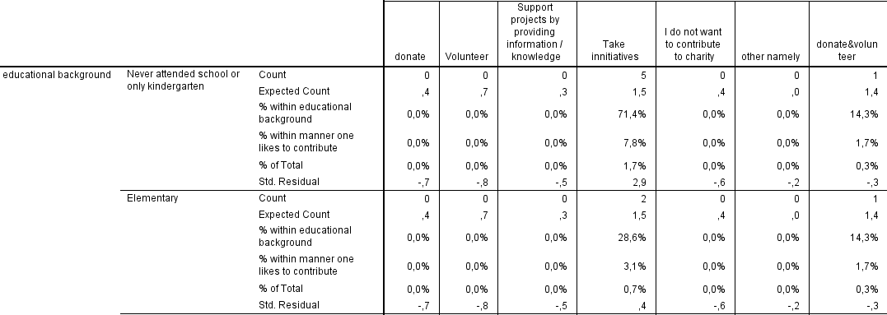
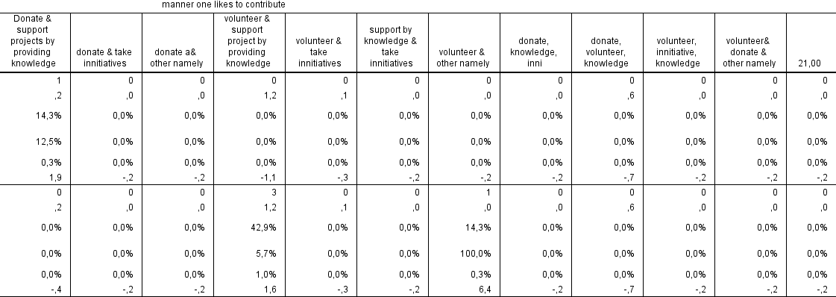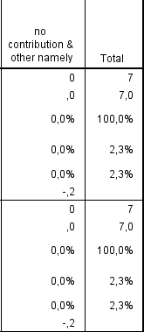
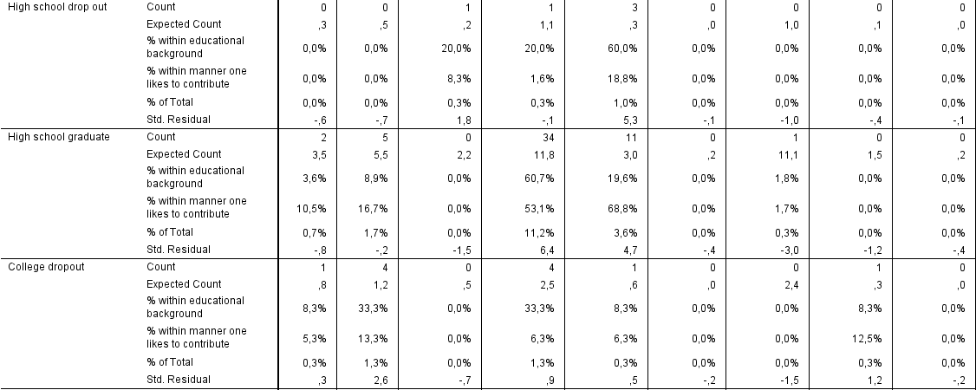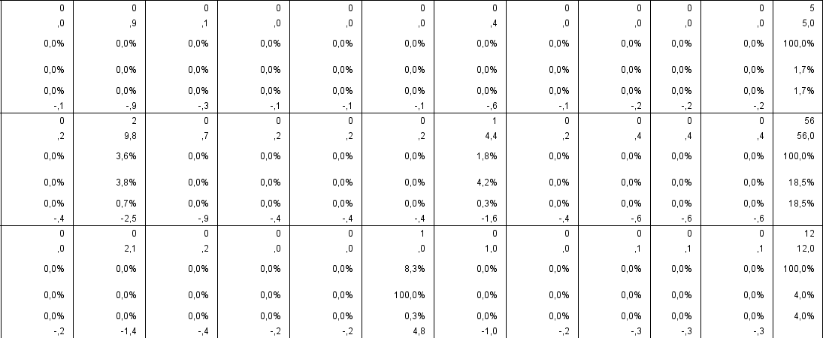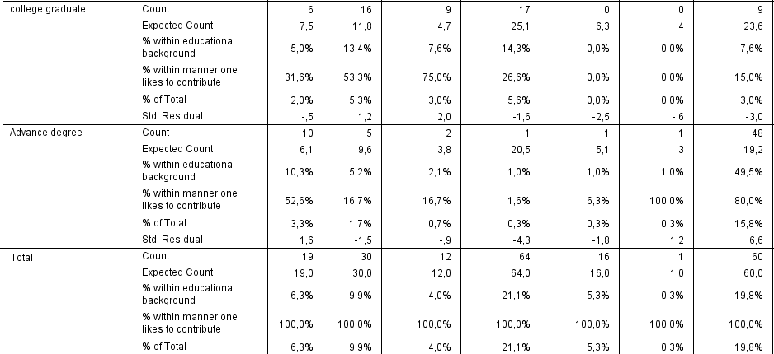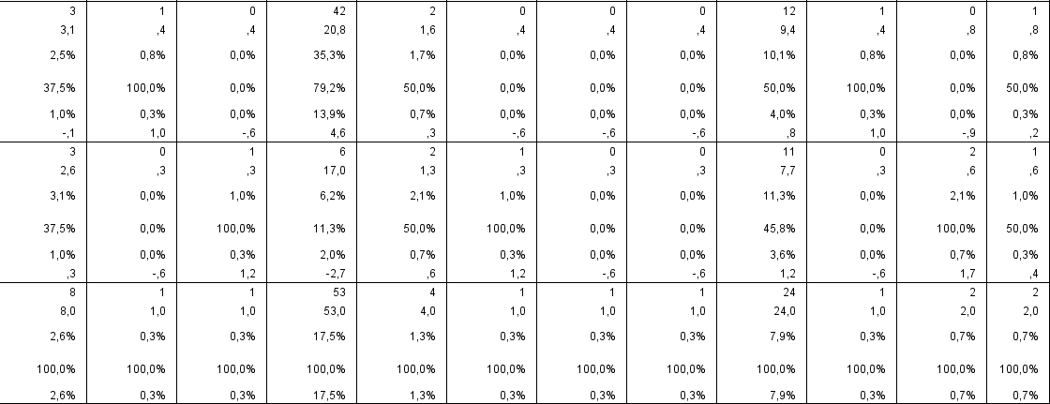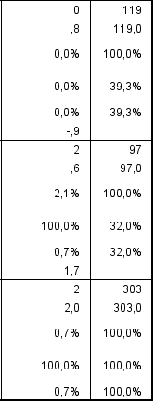
Chi-Square Tests
 |  | Value |  | df |  | Asymp. Sig. (2-sided)
Pearson Chi-Square |  | 368,991ª |  | 114 |  | ,000
Likelihood Ratio |  | 305,238 |  | 114 |  | ,000
Linear-by-Linear Association |  | 18,349 |  | 1 |  | ,000
N of Valid Cases |  | 303
a. 122 cells (87,1%) have expected count less than 5. The minimum expected count is ,02.
Symmetric Measures
 |  |  | Value |  | Approx. Sig.
Nominal by Nominal | Phi |  | 1,104 |  | ,000
 | Cramer's V |  | ,451 |  | ,000
N of Valid Cases |  |  | 303

Educational background VS attitude towards the concept

 | Case Processing Summary
 |  |  |  | Cases
 |  |  |  | Valid |  |  | Missing |  |  | Total
 |  |  |  | N | Percent |  | N |  | Percent | N |  | Percent
 | educational background * attitude towards the concept |  |  | 303 | 98,4% |  | 5 |  | 1,6% | 308 |  | 100,0%
 |  |  |  |  |  | attitude towards the concept |  |  |  |  |  |  |  |  | Total
 |  |  |  |  |  | Yes, I like the concept |  | A little you got me curious about the concept |  |  | The concept is not clear |  | No I do not like the concept
Educational background |  | Never attended school or only kindergarten | Count |  |  | 1 |  | 5 |  |  | 0 |  | 1 |  | 7
 |  |  | Expected Count |  |  | 2,2 |  | 3,5 |  |  | ,6 |  | ,7 |  | 7,0
 |  |  | % within educational background |  |  | 14,3% |  | 71,4% |  |  | 0,0% |  | 14,3% |  | 100,0%
 |  |  | % within attitude towards the concept |  |  | 1,0% |  | 3,3% |  |  | 0,0% |  | 3,3% |  | 2,3%
 |  |  | % of Total |  |  | 0,3% |  | 1,7% |  |  | 0,0% |  | 0,3% |  | 2,3%
 |  |  | Std. Residual |  |  | -,8 |  | ,8 |  |  | -,7 |  | ,4
 |  | Elementary | Count |  |  | 0 |  | 5 |  |  | 0 |  | 2 |  | 7
 |  |  | Expected Count |  |  | 2,2 |  | 3,5 |  |  | ,6 |  | ,7 |  | 7,0
 |  |  | % within educational background |  |  | 0,0% |  | 71,4% |  |  | 0,0% |  | 28,6% |  | 100,0%
 |  |  | % within attitude towards the concept |  |  | 0,0% |  | 3,3% |  |  | 0,0% |  | 6,7% |  | 2,3%
 |  |  | % of Total |  |  | 0,0% |  | 1,7% |  |  | 0,0% |  | 0,7% |  | 2,3%
 |  |  | Std. Residual |  |  | -1,5 |  | ,8 |  |  | -,7 |  | 1,6
 |  | High school drop out | Count |  |  | 1 |  | 0 |  |  | 0 |  | 4 |  | 5
 |  |  | Expected Count |  |  | 1,6 |  | 2,5 |  |  | ,4 |  | ,5 |  | 5,0
 |  |  | % within educational background |  |  | 20,0% |  | 0,0% |  |  | 0,0% |  | 80,0% |  | 100,0%
 |  |  | % within attitude towards the concept |  |  | 1,0% |  | 0,0% |  |  | 0,0% |  | 13,3% |  | 1,7%
 |  |  | % of Total |  |  | 0,3% |  | 0,0% |  |  | 0,0% |  | 1,3% |  | 1,7%
 |  |  | Std. Residual |  |  | -,5 |  | -1,6 |  |  | -,6 |  | 5,0
 |  | High school graduate | Count |  |  | 12 |  | 10 |  |  | 19 |  | 15 |  | 56
 |  |  | Expected Count |  |  | 17,9 |  | 28,1 |  |  | 4,4 |  | 5,5 |  | 56,0
 |  |  | % within educational background |  |  | 21,4% |  | 17,9% |  |  | 33,9% |  | 26,8% |  | 100,0%
 |  |  | % within attitude towards the concept |  |  | 12,4% |  | 6,6% |  |  | 79,2% |  | 50,0% |  | 18,5%
 |  |  | % of Total |  |  | 4,0% |  | 3,3% |  |  | 6,3% |  | 5,0% |  | 18,5%
 |  |  | Std. Residual |  |  | -1,4 |  | -3,4 |  |  | 6,9 |  | 4,0
 |  | College dropout | Count |  |  | 5 |  | 4 |  |  | 1 |  | 2 |  | 12
 |  |  | Expected Count |  |  | 3,8 |  | 6,0 |  |  | 1,0 |  | 1,2 |  | 12,0
 |  |  | % within educational background |  |  | 41,7% |  | 33,3% |  |  | 8,3% |  | 16,7% |  | 100,0%
 |  |  | % within attitude towards the concept |  |  | 5,2% |  | 2,6% |  |  | 4,2% |  | 6,7% |  | 4,0%
 |  |  | % of Total |  |  | 1,7% |  | 1,3% |  |  | 0,3% |  | 0,7% |  | 4,0%
 |  |  | Std. Residual |  |  | ,6 |  | -,8 |  |  | ,1 |  | ,7
 |  | college graduate | Count |  |  | 25 |  | 86 |  |  | 4 |  | 4 |  | 119
 |  |  | Expected Count |  |  | 38,1 |  | 59,7 |  |  | 9,4 |  | 11,8 |  | 119,0
 |  |  | % within educational background |  |  | 21,0% |  | 72,3% |  |  | 3,4% |  | 3,4% |  | 100,0%
 |  |  | % within attitude towards the concept |  |  | 25,8% |  | 56,6% |  |  | 16,7% |  | 13,3% |  | 39,3%
 |  |  | % of Total |  |  | 8,3% |  | 28,4% |  |  | 1,3% |  | 1,3% |  | 39,3%
 |  |  | Std. Residual |  |  | -2,1 |  | 3,4 |  |  | -1,8 |  | -2,3
 |  | Advance degree | Count |  |  | 53 |  | 42 |  |  | 0 |  | 2 |  | 97
 |  |  | Expected Count |  |  | 31,1 |  | 48,7 |  |  | 7,7 |  | 9,6 |  | 97,0
 |  |  | % within educational background |  |  | 54,6% |  | 43,3% |  |  | 0,0% |  | 2,1% |  | 100,0%
 |  |  | % within attitude towards the concept |  |  | 54,6% |  | 27,6% |  |  | 0,0% |  | 6,7% |  | 32,0%
 |  |  | % of Total |  |  | 17,5% |  | 13,9% |  |  | 0,0% |  | 0,7% |  | 32,0%
 |  |  | Std. Residual |  |  | 3,9 |  | -1,0 |  |  | -2,8 |  | -2,5
Total |  |  | Count |  |  | 97 |  | 152 |  |  | 24 |  | 30 |  | 303
 |  |  | Expected Count |  |  | 97,0 |  | 152,0 |  |  | 24,0 |  | 30,0 |  | 303,0
 |  |  | % within educational background |  |  | 32,0% |  | 50,2% |  |  | 7,9% |  | 9,9% |  | 100,0%
 |  |  | % within attitude towards the concept |  |  | 100,0% |  | 100,0% |  |  | 100,0% |  | 100,0% |  | 100,0%
 |  |  | % of Total |  |  | 32,0% |  | 50,2% |  |  | 7,9% |  | 9,9% |  | 100,0%

Chi-Square Tests
 |  | Value |  | df |  | Asymp. Sig. (2-sided)
Pearson Chi-Square |  | 169,469ª |  | 18 |  | ,000
Likelihood Ratio |  | 146,856 |  | 18 |  | ,000
Linear-by-Linear Association |  | 57,409 |  | 1 |  | ,000
N of Valid Cases |  | 303
a. 16 cells (57,1%) have expected count less than 5. The minimum expected count is ,40.
Symmetric Measures
 |  |  | Value |  | Approx. Sig.
Nominal by Nominal | Phi |  | ,748 |  | ,000
 | Cramer's V |  | ,432 |  | ,000
N of Valid Cases |  |  | 303

Educational background VS requirements
Case Processing Summary
 | Cases
 | Valid |  | Missing |  | Total
 | N | Percent | N | Percent | N | Percent
educational background * requirements that need to be mett in order to let an individual organize a Peace Pod | 302 | 98,1% | 6 | 1,9% | 308 | 100,0%
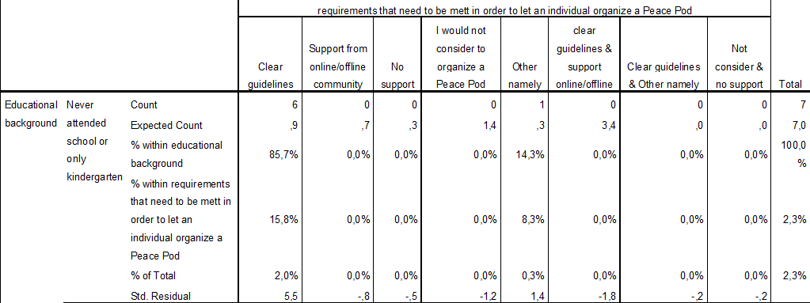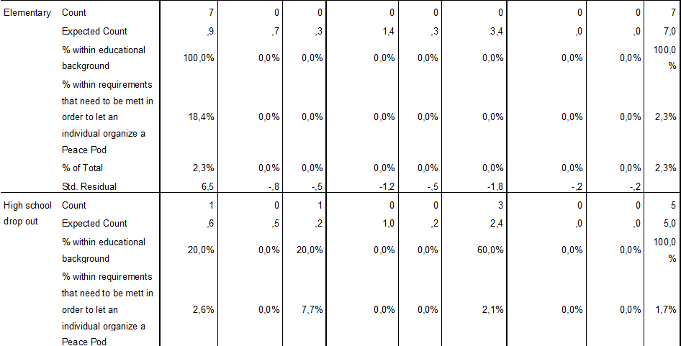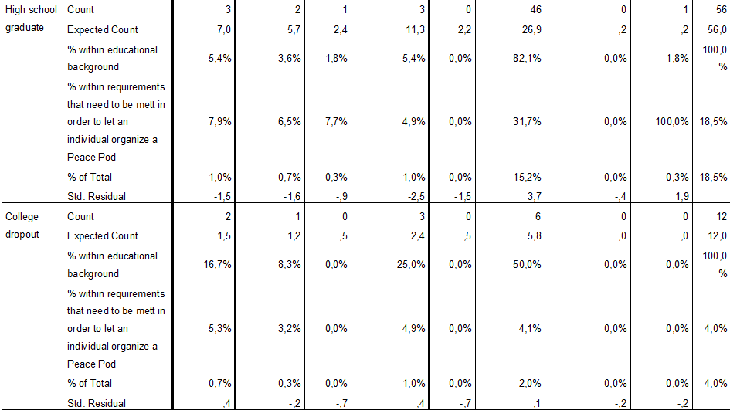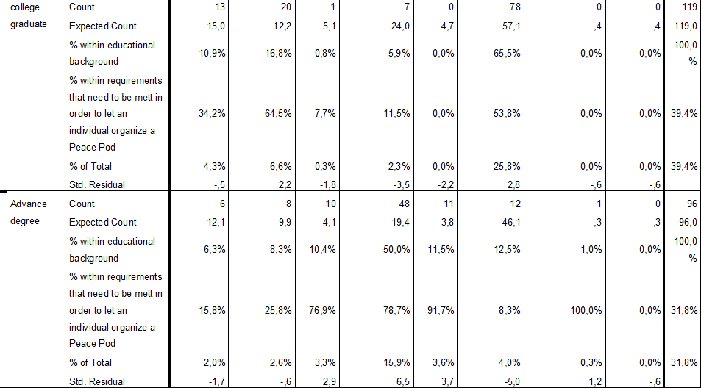
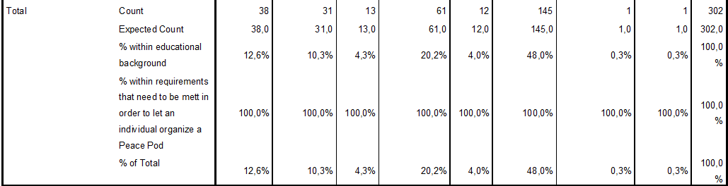
Chi-Square Tests
 | Value | df | Asymp. Sig. (2-sided)
Pearson Chi-Square | 252,014ª | 42 | ,000
Likelihood Ratio | 226,435 | 42 | ,000
Linear-by-Linear Association | ,395 | 1 | ,530
N of Valid Cases | 302
a. 42 cells (75,0%) have expected count less than 5. The minimum expected count is ,02.

Symmetric Measures
 |  | Value | Approx. Sig.
Nominal by Nominal | Phi | ,914 | ,000
 | Cramer's V | ,373 | ,000
N of Valid Cases |  | 302

Educational background VS willingness to organize a Peace Pod
Case Processing Summary
 | Cases
 | Valid |  | Missing |  | Total
 | N | Percent | N | Percent | N | Percent
educational background * Willingness of the individual to organizat a Peae Pod | 303 | 98,4% | 5 | 1,6% | 308 | 100,0%

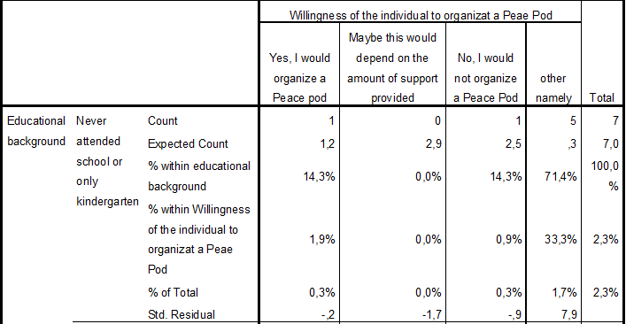
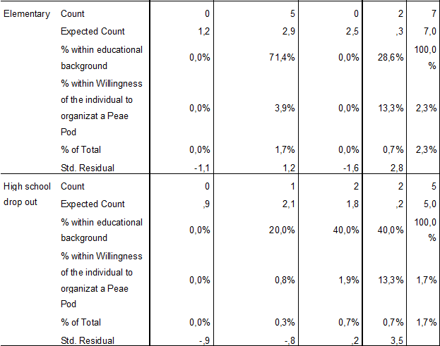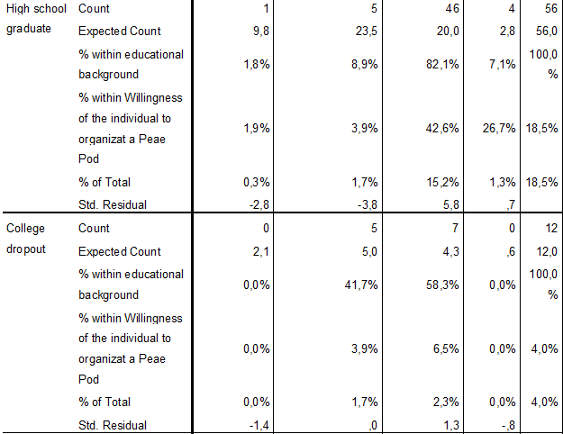

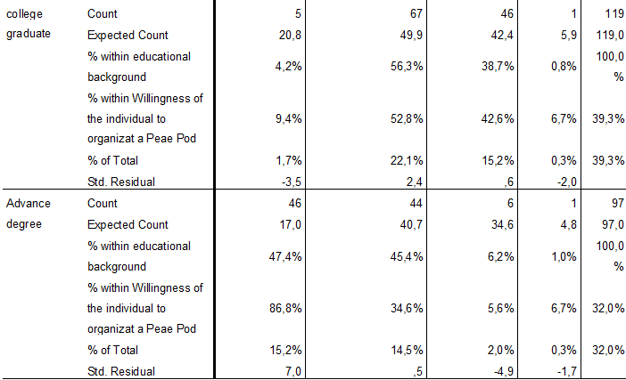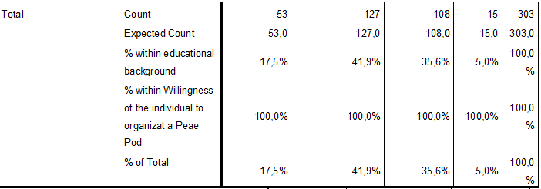
Chi-Square Tests
 |  | Value |  | df |  | Asymp. Sig. (2-sided)
Pearson Chi-Square |  | 253,519ª |  | 18 |  | ,000
Likelihood Ratio |  | 214,450 |  | 18 |  | ,000
Linear-by-Linear Association |  | 102,950 |  | 1 |  | ,000
N of Valid Cases |  | 303
a. 17 cells (60,7%) have expected count less than 5. The minimum expected count is ,25.
Symmetric Measures
 |  |  | Value |  | Approx. Sig.
Nominal by Nominal | Phi |  | ,915 |  | ,000
 | Cramer's V |  | ,528 |  | ,000
N of Valid Cases |  |  | 303

Open questions
Question 7 (if I would / when I contribute to a charity / peace pod project I like to:
Other namely responses:
1.Other namely: I'm not sure how to support, I fear donations could go to corruption. and I don't wish to travel to unsafe area's. military action works some times contra productive.
2.Other namely: art for freedom
3.Other namely: cuddle cute animals, like kittens
4.Other namely: Donation of knowledge
5.Other namely: Depends on the project
6.Other namely: design/artwork
7.Other namely: I would volunteer if it would not cost me any money
8.Other namely: anything as long as I do not have to pay
9.Other namely: Something that does not cost much time or money.

Question 9: what should be in place before you would consider to organize a peace pod?
Other namely responses:
1.Other namely: I have no idea how. but could imagine contributing to a project
2.Other namely: I would be interested in the experiences of other people with a peace pod
3.Other namely: some level of clarity what it is all about?
4.Other namely: what is a peace pod? sounds like cannabis...
5.Other namely: it would have to be a charity for animals. i do not care about people
6.Other namely: Collective ROI and knowledge of the support and team which will be assisting/supproting/helping me
7.Other namely: Church projects
8.Other namely: Clear guideliness help but there should be a need first. At this point i feel comfortable so that would be necessary thing, a need to make changes. The next is time! People are busy so time is necessary
9.Other namely: financial support
10.Other namely: I would like to help but not consider to organize a Peace Pod
11.Other namely: depending on the costs and time it will take me to do so
12.Other namely: Not myself I would support it
13.Other namely: I would support it

Question 10: Would you like to organize a Peace Pod in your area
Other namely results:
1. Other namely: I don't really know how or what it involves
2. Other namely: Not now, maybe later
3. Other namely: Only if people bring me beer
4. Other namely: I cant do it myself but it is a nice idea to orgenize it im the area
5. Other namely: If id be inspired
6. Other namely: I would, but I'd wait until I finished my thesis and have a little more time.
7. Other namely: I would like to help but not organize one
8. Other namely: I want to contribute but not organize
9. Other namely: I would contribute but not organize it myself
10. Other namely: Yes if it would be easy and not time consuming
11. Other namely: Depending on the cost that are involved
12. Other namely: depending on the cost and time it will take me
13. Other namely: No I would support it but not organize
14. Other namely: Together with others I would
15. Other namely: if it is not too time consuming
16. Other namely: offer support

Email experts
The World Peace Foundation and a team of global volunteers are currently trying to develop an initiative called "Peace Pods", a new tool that aims to inspire and empower individuals around the world to develop and support peace projects within their own communities. We are currently looking for experts who have worked for a social cause and are interested to discuss our concept and provide us with their opinions and expert judgment. We are naming this project as Peace Pods and plan to launch the first phase in the African continent in the next 3 months.
It would be great if you could space a few minutes of your time and discuss about this project. Lienke Stam is working on this project and can schedule a quick Skype call for discussion, at a time of your convenience. She can be reached at email lienkestam@msn.com for further details.
If you are uncomfortable or unable to attend a skype meeting there is also an opportunity to share your opinion online by filling in the form you can find by clicking on the link below:
https://nl.surveymonkey.com/s/HQC2S6D
Thanks again for your help. It is because of people like you that we can make the world a better and more peaceful place.

In Peace,

The World Peace Foundation

Item list expert interviews
Item list of the experts interviews
- Trends and developments
- Peace
- Technology
- Concept
- Online platform
- Social media / social media hypes
- Offline platform
- Communication
- Difficulties / opportunities with regards to organization
- Guidelines
- Elements needed
- Motivation of people
- Future involvement

Results expert interviews

Expert Interview
Date: 11 – 2 – 2015
Expert: Mariska van Drimmelen

- Can you tell me something about yourself and the peace activities you have been involved with?

I am currently working for the municipality and supporting projects and initiatives with social goals in the city Dordrecht. The company is called “the connectors”, and I am currently working with this group for about four years now. I am currently busy with a project that is focused on a specific area that does not have a good reputation. For this project we have set up a store which is called the neighbourhood store, it is a place where anyone can go to ask any kind of question one might have.
An example could be my cat has gone missing, but it could also be about financial problems. Depending on the situation the store will provide either advice or help the individual step by step to accomplish a solution. When we are appointed to help a certain area the first thing we do is listen and map all the problems that are playing a role in this particular area. After that brainstorms start to find solutions and actual implementation plans are made. Currently we are trying to let the people solve their issues themselves and take over certain initiatives and involve them with projects. Our role it to support and or develop the initiative together with the neighbourhood but in the end they have to take charge.

- Which peace areas/ topics are most interesting according to you in 2015?

I think the most interesting topic is how to motivate people to take initiative and stimulate people to support and improve their neighbourhood in a fun way. Since the municipality is no longer able to support people the way we were used to because of the economic crisis. I noticed that there are a lot of people who want to take initiatives in each and every area but problems most people do not have the network or miss skills or money and therefore are not able to implement their initiative. It is noticeable that lower educated people have a network which is not as strong as the people who are high educated and that the lower educated people often think short term while higher educated people think in long term goals. This has to do with home situations that are less stable. Think about the Maslow pyramid, they have different priorities and do not want to think that far ahead and are happy to get through the day.

- Would you like to organizing an peace pod in your area, and if so what kind of peace pod would you want to organize? And if not why?
- What kind of difficulties and benefits do you imagine you will face in your particularly area in relation to organizing peace pods?

As we discussed these projects I am carrying out now could be considered a peace pod so yes I would. I think it is important to involve some professionals who can offer their skills and businesses who might be able to offer material and connecters who can make sure that the rules from the musicality are clearly communicated which I think is often a big problem here in the Netherlands. A great example was an old school building that would be taken down by the municipality. We asked the neighbourhood to come up with ideas to stop them from taking down this building and to use it for the area itself. They came up with a project but without connectors it would have been very difficult to get all the rules they had to be met across and to communicate with the municipality as well. There are so many rules and because nothing is one by just one person in the municipality the communication takes up a lot of time.

- What kind of elements do you feel the structure should include to offer support when organizing a peace pod? (think of guideline for finances, guideline for how to gain volunteers for your project, examples of peace pods (to inspire)etc)

I think you have to think about the communication between the people because if you don’t have a specific target group, communication will be a challenge in my experience. You can think about how will you stimulate people to listen and build up on each other ideas and what are the rules so everything will stay civilized. As well as communication between municipalities which is always a challenge at least here in the Netherlands. Furthermore I think it is important to think about promotion which is often a big challenge and to think about the different ways they can support so not only in money but also in supporting by means of using their skills or offering materials they no longer use.

- Do you believe that an online platform like an interactive blog would work to spread awareness ,inspire and create interaction?

An online platform is a great idea I think. We are currently busy with a website called “www.mijnbuurtje.nl” (translated: my neighbourhood) which is I think quite similar to what you would like to do. I think the most important things here are that people can connect and a network can be created. It should be simple and clear for everyone and I think it is important to push them into a positive atmosphere like Facebook also has done by for instance only providing a like button. Also think about google maybe some kind of mix between FB, mijnbuurtje and Google could be created. Look into their business models and organization models.

- Do you believe an offline platform should be created? If so do you have any suggestions?

I think that is not needed if you have the online platform you could even offer them some place where they can arrange offline meetings, but I am speaking from a Dutch perspective. I can imagine for less fortunate countries it might be needed but I can’t really think of a suggestion.

- Do you feel that people would be motivated to become part of such a hub?

The website I was talking about has contracts, so you have to pay to be on the website. This is so that the people who are managing the website are able to live as well and pay the bills so the website is not voluntary based . I think finding people who work fulltime to manage a website will be difficult since everyone needs to be able to pay the bills. I think it will be interesting to look into several options but I do feel that money should come from somewhere to at least be able to pay one or two people to manage the website on a fulltime basis.

- Would you like to be involved with this project in the future? And if so how?

Yes, I am curious what it is you are going to come up with. If I like it I would definitely like to support that community and maybe use it for my projects. Another example which I think will be interesting for you to look at is Livable, this organization manage to give low rent apartment’s to students in exchange for a stated amount of volunteer work.

Expert Interview
Date: 2 – 4 – 2015
Expert: Salim Amin

- Can you please tell us something about yourself and the peace activities you have been involved with?
I am in the CEO of Camerapix as you know. I have been a journalist for many years so I have seen a lot. I have been involved with the conflict in Somalia in the nineties, the war in Sudan in the late nineties I have seen a lot. I think I have seen the worst that you can see, people slaughtering each other just because of the color of their skin or because they are from a different tribe. By telling these stories and taking pictures it becomes a rude awakening for others. People can be so cruel and although we think we are more civilized than animals I have to disagree. Animals only kill when they are hungry we kill for many reason and think about all kinds of ways how to do it.

The World Peace Foundation as mentioned before is currently developing a new initiative called Peace Pods Events.
Peace Pod Events are local events that support local communities and help them to spread peace. These events can involve any kind of content from volunteer project in Africa to stimulating a peace program in a university in Berlin. It is designed to answer the question “What can I do to support world peace?”. One would be supported by a set structure and guidelines to develop such events.
These Peace pods will be connected to a wider base, possibly an online community where one can share their experiences and information and where people can work on content developments and
project execution together.

- Would you like to organize a Peace Pod in your area? If yes, then what kind of Peace Pod? If no, then what information do you need to do so?

I like to contribute to peace as much as I can in as many ways as I can. I think a problem that many of us share is that we do not have much time so this would be something you would have to take into consideration. I would be able to point you in the right direction to the right people but for that I need concrete questions and concrete guidelines so that it would not involve much of my time.

- What kind of difficulties and benefits do you imagine you will face in your area in relation to organizing Peace Pods?

Getting people to talk openly is always something that is very difficult. Especially in developing countries where there is so much potention to do great things people are afraid to talk and open up. I think the great thing about this initiative would be that it offers people the opportunity to start an open dialogue with people they normally would not speak to and gain several different perspectives. It is a great way to educate them about peace and I feel it should be focused on the youngsters because they seem to pick up on these things more easily in my experience.

- What kind of elements do you feel a guideline should include to offer support for organizers of Peace Pod Events?
I think to create a framework or guideline you need to know what you want to get out of it. What is your goal, the guidelines and framework should not be too specific because it might limit the possibilities.
TEDx is a good example but already an established organization so for them they are able to set requirements more easily for you it is important to keep the requirements to a minimum. You are able to think about food, drinks, location, internet access, facilities, way of communication, entry fees, finding sponsors and things like that. I would suggest to adapt these later on after the implementation phase. Speaking from my point of view it is important to protect the people who open up in the less fortunate countries and to make sure that this will not be used against them later on.

- What are your thoughts about an online platform to support these Peace Pods?

Less fortunate countries do have less access to the internet but an online platform can be a great start. I think Asia, Africa and Latin America are easier to reach out to by mobile phones. I believe the mobile phones are the future personally within these less fortunate countries.

- Do you believe an offline platform should be created? If yes, do you have any suggestions?

I think it is important to have offline meetings for organizing such events and it again depends on the sizes you are looking at. Less fortunate countries often have places where people get together but they don’t hold many people, there are often places for about 70 people but the bigger the number the harder it will be to find a venue. You can think of schools and community centers.

- Would you like to be involved with this project in the future? If Yes, in which way?

I love to help were I can but I have a time restriction like many people I imagine. I can help you find sponsors and bring you into contact with the right people, keep me up to date and we will see what I can do.

Expert Interview
Expert: Bala Varadarajan (India national education society)
Date: 24 – 4 - 2015

…(introduction)

If it is okay I will start with telling you a bit more about the initiative.

Sure,

The World Peace Foundation as mentioned before is currently developing a new initiative called Peace Pods Events.
Peace Pod Events are local events that support local communities and help them to spread peace. These events can involve any kind of content from volunteer project in Africa to stimulating a peace program in a university in Berlin. It is designed to answer the question “What can I do to support world peace?”. One would be supported by a set structure and guidelines to develop such events.
The basis of the Peace Pod Events will include an online platform. The online platform will be a place were people can connect with one another, share their experiences and information and where people can work on content developments and project execution together. The online platform will be linked to social media so one can invite their friends and provide the opportunity to grow.

- The WPF would like to know what your professional opinion is about this idea, do you believe that such an online platform would work? Or do you believe an offline platform should be created?

Well, that depends who you are targeting. I mean if you want to approach the younger generation social media is a powerful tool for people under 35. I think in India about 20 % of the people are online all the time and about 50% goes online sometimes but that would be in an internet café so for that emails would work better as communication tool. For the general public you could think about texting and or flyers. It is hard for me to visualize what it is you want to set up as online platform but I believe that for the younger generation that might work. I would suggest that you think about who you want to target.

That makes perfect sence, I will deffinitly have a think about that.

Yes personally I would suggest to focus on the youngsters but it is a challenge to motivate them.
Youngsters will be the ones who will take over eventually and who are open to change.

I will take that into account and have a conversation with my project members.

- What do you feel would be the greatest challenges for the WPF?

Time and cost I think are the greatest challenges. People have limited time and they often don’t want to spend the money.

That is what we found in the survey as well. I think that is deffinitly something we should take into account.

Spreading awareness as well, it is challenging. I think you should start with not just organizing one Peace Pod at the time but organize several all over the world. You could also support this by the online platform and seminars for instance. Maybe have a think about how to get the youngsters online.

Also a lot of people still need to be educated about peace.

Do you feel open communication would be a challenge in India?

No not at all unless you touch up on religions but open communication in general should not be an issue. Especially if you would focus on students they have a broader wordly view.
Actually maybe you can send me a more detailed report about the initiative and everything you have been doing and the research you have carried out and I will have a look if my colleges can activate a few Peace Pods. If you forward me the concrete information about how to do this and what is expected I will forward it to the proffesors who can take it from there.

That would be great thank you so much for the offer. I think that it would be a great idea to give that a go.

Yes anything I can help you with let me know. My students are off till the 8th of June so we would not be able to do anything before that.

Not to worry that will give us the time to finalize the initiative and become more concrete.

Expert interview:
Name: Chip Duncan (Duncan Entertainment group)
Date: 27 – 4 - 2015

…(introduction)

If it is okay I will start with telling you a bit more about the initiative.

Yes go ahead,

The World Peace Foundation as mentioned before is currently developing a new initiative called Peace Pods Events.
Peace Pod Events are local events that support local communities and help them to spread peace. These events can involve any kind of content from volunteer project in Africa to stimulating a peace program in a university in Berlin. It is designed to answer the question “What can I do to support world peace?”. One would be supported by a set structure and guidelines to develop such events.
The basis of the Peace Pod Events will include an online platform. The online platform will be a place were people can connect with one another, share their experiences and information and where people can work on content developments and project execution together. The online platform will be linked to social media so one can invite their friends and provide the opportunity to grow.

- Can you tell me what you find were interesting peace related topics you liked to touch on with films or photo’s in 2015.

Well I like to tell stories about heroes who risk their life to help others and I do not particular focus on one topic or another it depends what I am getting in touch with. People sometimes view things as normal in the less fortunate countries but I believ that those stories have to be told over and over again.

- What do you imagine would be the difficulties and or benefits the WPF will face with this inniative?

I think the hardest part is how to communicate with one another. It is very challenging to set something up which can be used by anyone everywhere. I would suggest to innerline with other organizations like doctors without borders or peace organization. As long as they have the same message they want to send across you might be able to support each other. I am not sure how competitive people are within this topic but have a look and see if there is a way to collaborate with others. View who is sending the same message which partners could be usefull.
Furthermore when looking at the world peace festival which was such a great initiative, it still was missing the follow up, I think that is also something you should take into account how to get this sustainable.

That is great advice I will deffinitly have a look into that.

- What are your thoughts about an online platform to support these Peace Pods?

Well lets say you target ten cities who will all organize pilots I think an online platform would be great as long as there is an opportunity to do something more than creating a dialogue. Make use of stories and photography, not just naming the amount of visitors and the location if that makes sense. I do not believe that a dialogue will be enough these days.
- What are other tools that could help motivate people to make use of the peace pod events according to you?

Well this would depend on the demographic picture you are after. Who are you after exactly. Personally I would focus on the younger generation. Middle age school kids between 10 – 15 years and lock into their group. They are the people who can make this change happen and be there for a longer period so although elderly might be capable to do many things I would focus on the youngsters since they can make the change happen. There would be a bigger change of success and long term sustainability. Think about how you get them invested.
- Would you like to be involved with this project in the future? If Yes, in which way?

Yes If there is anything I can help you with let me know and contact me again. Also if there are no further questions I wanted to aks you if you wanted to have a look at a peace project I am currently working on. It might inspire you, please follow me on facebook and on the facebook page of Duncan entertainment and ask your project members to do so as well.

Sure not a problem we will do. Thank you so much for your time.

